Security Market Team
University of Economics and Business - Vietnam National University, Hanoi

FUNDAMENTAL ANALYSIS IN SECURITY INVESTMENT AND ITS APPLICATION IN VIETNAM

Tran Phuc, Dang

Nhu Ngoc, Nguyen

Phuong Nhung, Nguyen

Specially conducted by Dr. Ton/ Tich Quy

Specially supported by University of Economics and Business

Hanoi 2010
Table of Contents

LIST OF TABLES 3
LIST OF ABBREVIATIONS…………………………………………………… 5
ACKNOWLEDGEMENTS 6
Introduction 7
Chapter I: Fundamental Analysis in Security Investment and Standard & Poor’s Equity Research Methodology. 9
1.1. Origin and Definition of Fundamental Analysis. 9
1.1.1. Fundamental Analysis’s Origin. 9
1.1.2. Definition of Fundamental Analysis. 9
1.1.3. The aim of fundamental analysis to investors. 10
1.2. Standard & Poor’s Equity Research Methodology 11
1.2.1. Macro and Economic Analysis 11
1.2.2. Company Fundamental Analysis 12
1.2.3. Company Valuation Analysis ………………………………………..13
1.2.4. Review 15
1.2.5. Products and Services 15
Chapter II: The Current Situation of Analyzing, Assessing Stock Value by Fundamental Analysis of Analysts and Individual Investors at Security Market, Vietnam ……………………………………………………………………………………15
2.1. Research Methodology 15
2.2. Survey Content. 15
2.2.1. Research results for analysts working at securities firms 16
2.2.2. Research results for individual investors 27
2.3.3. Conclusion drawn from above results 36
2.4. Reason for ineffective application of fundamental analysis in Vietnam stock market 37
2.5. Solution to enhance the efficiency of applying fundamental analysis in investment in Vietnam stock market 38
2.5.1. With regard to State Securities Commission- the official management agency of Vietnam stock market (SSC) 38
2.5.2. With regard to scientific research and securities training center- the sole body in charge of inspecting securities and stock market training in Vietnam (SRTC). 39
2.5.3 With regard to securities companies 39
LIST OF REFERENCES 40
APPENDIX 44

LIST OF TABLES

Number | Tables and Charts | Page
1 | The level of analysts at securities companies | 18
2 | How long have Analysts been working as an analyst in securities investment | 19
3 | Which object do analyses of Analysts often support to | 20
4 | Which analytical method do Analysts often use | 20
5 | How often do Analysts use fundamental analysis in securities investment | 21
6 | How long do analyses of Analysts support to securities in vestment | 22
7 | Have Analysts known and used the Standard & Poor’s Equity Research Methodology | 23
8 | How do Analysts think about the Standard & Poor’s Equity Research Methodology role in your analyses | 24
9 | Have Analysts known and used the special forecasting model of Standard and Poor’s called Forecasting model EPS | 25
10 | Do Analysts have need of studying and researching the forecasting model about business variables such as EPS, ROE, ROA, etc? | 26
11 | How much do Analysts pay attention to the factors of macroeconomics in their stock analysis | 27
12 | How much attention do analysts pay to the factors of trade on their stock analysis | 28
13 | How much attention do analysts pay to the factors related to business on their stock analysis | 30
14 | Qualification of individual investors in securities and securities market | 31
15 | Do individual investors have need of joining training courses about securities and securities market to improve the analysis capacity in investing | 32
16 | How long have individual investors invested in securities market | 33
17 | How much is capital of individual investors current capital investment | 34
18 | Where do individual investors often get information to give decisions on share investment | 35
19 | How do individual investors think about the usefulness of information on which they | 36
20 | How long does investment of individual investors often take | 37
21 | Which group of shares do individual investors often invest | 38
22 | How much do Analysts pay attention to the factors of macroeconomics in their stock analysis | 39
23 | How do Analysts pay attention to the factors of trade on their stock analysis | 40
24 | How do Analysts pay attention to the factors related to business on their stock analysis | 41

LIST OF ABBREVIATIONS

CAPM Capital Asset Princing Model
APT Arbitrage Princing Theory
WACC Weighted Avarage Capital
DCF Discounted Cash Flow
DDM Dividend Discounted Model
FCFE Free Cash Flow to Equity
FCFF Free Cash Flow to Firm
P/E Price/ Earning Per Share
P/B Price/ Book Value
P/S Price/ Sale
P/CF Price/ Cash Flow
EPS Earning Per Share
ROE Return on Equity
ROA Return on total Asset

ACKNOWLEDGEMENTS
We would like to express our gratitude to all those who gave us the possibility to complete this thesis. We have received extensive help, suggestions and encouragements at each step along way, and we are very grateful to these dedicated professors, teachers and friends for their time and expertise.
First and foremost, we would like to thank our supervisor Dr. Ton Tich Quy, Vice Director of Research and Security Training, State Security Department for his whole-hearted guide and help as well as invaluable feedback, which enables us to complete this paper.
Furthermore, during this work we have received remarkable help and encouragement from our beloved teachers and friends, without whom we could not have completed the research.
And last but not least, we are greatly indebted to the University of Economics and Business and the Research, Cooperation and Development Department, for believing and giving us the opportunity to participate in GPAC 2010.

Hanoi, August 2010,
Dang Tran Phuc
Nguyen Nhu Ngoc Nguyen Phuong Nhung

Introduction

Fundamental analysis is the stock investing method, basing on some basic factors, which have a great impact on the changes of stock value. This method is widely used in order to determine intrinsic value of shares in the market. Fundamentals, which should be analyzed involve inside information pertaining to companies, financial statement, business activities, and both international and national economic indicators, especially, microeconomics and macroeconomics. After having studied these, analysts have a duty to make feasible predictions about core elements, such as, earnings momentum, book and tangible book value of shares, as well as give recommendations about buy/sell stocks at the market.
Being considered as bed-rock of security analyzing investment, fundamental analysis plays an extremely crucial role to analysts. This is top-ranking and indispensable method in share analyzing investment. Hence, this can be a fairly solid base, on which we can make investing decisions effectively. There are approximately 90% investors using fundamental analysis (Arshad Khan and Vaqar Zuberi, 1999, Stock Investing for Everyone, page 85). Therefore, two internationally famous programs in analyzing investment (CFA - Chartered Financial Analyst - common in the USA and CIIA – Certificated International Investment Analyst – common in Europe) also consist of nothing in content but fundamental analysis.
Furthermore, as Vietnam Security Investment has just been emerged, imperfectly and erratically fluctuated, applying technical analysis is likely to lack preciseness and effectiveness. Fundamental analysis can be employed to security investment instead. It is very essential, since it helps the investors to choose the good stocks that result in minimizing risks and maximizing return.
With deep study of fundamental analysis in stock exchange in Vietnam, in this paper, we discuss in details the current issues of the application of this method to stock investment in our country. Besides, we also give some recommendations and potential measures to authorities in order to improve efficiency of fundamental analysis in stock investing at Vietnam security market.

Chapter I: Fundamental Analysis in Security Investment and Standard & Poor’s Equity Research Methodology.

1.1. Origin and Definition of Fundamental Analysis.

1.1.1. Fundamental Analysis’s Origin.
Firm Foundation Theory
Often called the “legendary investor Warrent Buffet”, Berkshire Hathaway chairman Warren Buffett is one of the most high-profile proponents of value investing. He stated that: “Stock can be undervalued in comparison with its intrinsic value for a time, but in the long term, stock value depends on its intrinsic value and the essence of value investing is buying stocks at less than their intrinsic value. The tenor in value investing philosophy of Warrent Buffet is similar to Karl Marx’s”.
With the viewpoint of investing value and in order to support his own investment method, Warrent Buffet has developed the theory to Fundamental Analysis Method. By assessing the intrinsic value of stock and compare this to asked price, one can see whether the market overestimate or underestimate the stocks. That enables investors to make predictions of the stock value in the future, and then decide adequate investing strategies. This method has essence of long duration and stability. For the last 25 years, Warrant Buffet has taken his investing strategies in this way.

1.1.2. Definition of Fundamental Analysis.
The figures such as a company’s earnings per share, cash flow, book equity value, and sales are often Fundamentals because they describe, on a basic level, a specific firm’s operations and profits (or lack of profits).
Fundamental analysis presents the examination of these and other accounting statement-based company data used to assess the value of a company’s stock. Information regarding such things as management quality, products, and product-markets are often examined as well. Basing on analyses of company’s financial statement, microeconomic and macroeconomic factors, and the growth rate of the branch, investors can evaluate the potentiality of companies’ listed stock in the Stock Exchange, then make valid investing decisions.
Financial statements of joint stock companies which should be analyzed include: accounting balance sheet, statement of income, statement of cash flows, spreadsheet explanations of financial statements.
Macroeconomic information comprises: The world economic situation, national GDP (gross domestic product), GDP growth rate, inflation rate, monetary policy of central bank and the trend of the world security market...
Microeconomic information consists of: Growth rate, potentiality of branch, import/export issue and the development policy for the branch of the Government.
Fundamental Analysis Method is very popular in the world; and it is applied to various cases of assessing stock value, such as stocks issued at the first time and stocks listed at the Stock Exchange. In the world, there are over 90% of investors who use this method for their stock investing. Moreover, in terms of education, fundamental analysis is the foundation of many internationally famous programs that major in finance and security. Consequently, it is the base for organizations and security companies to make investing decisions as well.

1.1.3. The aim of fundamental analysis to investors.

The aim of fundamental analysis is to determine the true value of every share, then put it in the comparison with the present value. If the intrinsic value is higher than the market price, it is recommended to buy the share. If it is equal to the market price, hold the share; and if it is less than the market price, sell the share. In other words, the method helps investors determine the position of security value, which needs to be analyzed, in relationship with security market (SML). By seeing whether stock value is above or beneath the SML (Security Market Line), investors assess the risk and return of these securities so as to make intelligent investing decisions. In case the stock value stands over the SML, it means that the market is underestimating this stock, so investors will buy the share. Stocks value beneath the SML means overestimating of the market, investors will sell the share. If the stock value is on the SML, it depends on the situation to sell or buy.

Graph presents SML (Security Market Line)
_{E(r)}
₁₆
14
13
Rf
_{SML}
underestimate
* 3

* 2
* 1
appreciate

βm =1
βi == 1,2
M
β

In short, the ultimate purpose of Fundamental Analysis is to help investors to find out the stock that is less than its intrinsic value to buy to maximize return and minimize risks.

1.2. Standard & Poor’s Equity Research Methodology
S&P is the fundamental analysis methodology which is used on a wide scale by most of analysts and investors as well. Below is the content of this method.

1.2.1. Macro and Economic Analysis

When conducting bottom-up Company analyses are expected to incorporate Macro and Economic analysis.

Investment Policy Committee (IPC)
- Meets weekly and is responsible for determining Standard & Poor’s analytical views on investment trends
- Mission: Ensure Standard & Poor’s views are reached through a deliberative, consistent process that involves input from a diverse group of Standard & Poor’s Senior analytic personnel
- Analysis includes:
- Interest rate forecasts
- Market performance forecasts
- Economic, Political and related developments of interest to investment community
- Consensus concerning effect of such development on S&P’s view of financial markets, including recommended percentages asset allocation among stocks, bond and cash.

Sector strategy and Guidance
- Chief Investment strategist provides guidance on past and current sector trends and forecast top and bottom performing sectors
- Group sectors Heads meet regularly with global and Regional Research Directors to incorporate input from equity analysis from all sectors to formulate a collective bottom-up investment strategy. This bottom-up input, in the context of past and current sector trend and macro-economic projections, support S&P’s holistic sector weight strategy and recommendations.

1.2.2. Company Fundamental Analysis
- Step 1: Review public information
- 10K’s
- 10Q’s
- Annual Reports
- Conference Calls
- Step 2: Conversations with management for detailed information
- Establish relationships with new companies
- Most meeting with companies done via phone; Some in-person meetings
- Obtain a better understanding of:
- Trends
- Leverage/margins
- Efficiency programs
- Costs-current, changes
- Step 3: Prepare 3-year preliminary Earning Model
- EPS Growth Rate
- Earning Prospects
- Balance sheet and cash flows
- Step 4: Review financial assumptions with company as appropriate for company guidance (e.g. earnings comparisons)
- Step 5: Assess:
- Management team
- Competitive environment
- Suppliers
- Buyers
- Substitutes
- Barriers to entry
- Regulatory environment
- Step 6: Finalize Earnings Model
- Determine earnings quality
- Evaluate corporate governance
- Project Standard & Poor’s Core Earnings, S&P’s more accurate, proprietary representation of the true performance of the firm’s ongoing operations
- Standard & Poor’s Core Earnings Calculation

Included

Employee stock option grant expense

Restructuring charges from ongoing operations

Write-down of depreciable or amortizable operating assets

Pension costs

Purchased research and development expenses

Merger/acquisition related expenses

Unrealized gains/losses from hedging activities

Excluded

Goodwill impairment charges

Gains/losses from asset sales

Pension gains

Litigation or insurance settlements and proceeds

Reversal of prior-year changes and provisions

1.2.3. Company Valuation Analysis
- Step 7: Analysis uses multiple criteria for valuing a company, including:
- Intrinsic Value Analysis
- Relative Valuation
- Sum of the parts
- Risk Assessment – Analyst in corporate a” risk premium” to derive a valuation
- Step 8: Establish Intrinsic Value:
- Target price over 12 months
- Analyst assigns a Risk Ranking Assessment (high/Medium/low) of projected share volatility and risk of capital loss
- Step 9: Decide STARS recommendation (refer to inside panel for details on S&P’s 5 STARS Ranking System):
- Incorporate risk assessment rating into overall STARS ranking (for more details on S&P’s Risk Ranking Assessment)

1.2.4. Review
- Step 10: Supervisory analyst review for regulatory and compliance purposes

1.2.5. Products and Services
Retail: | Institutional:
Advisor insight | Compustat Data
Custom Newsletters | Equity Insight
Equity Liaison Desk | Industry Surveys
Industry Surveys | Institutional Equity Reports
Market Insight | IPC Notes
Market Scope | Monthly Investment Review
Model Portfolios | Sector Watch
Net Advantage | US Financial Notes

Pocket Guides

Portfolio Advisor

Sector Scorecard

Stock Guides

Stock Reports

The Outlook

Chapter II: The application of Fundamental Analysis by Analysts and Individual Investors at Vietnam’s Security Market

2.1. Research Methodology
We use quantitative analysis by building up a questionnaire system about the research subject. We take items in fundamental analyzing process of S&P as a benchmark. In addition, we apply mathematics-stochastic calculus to analyzing responses from people, who are individual investors and analysts of 6 security companies with different sizes: Thang Long, Sacombank, Hoa Binh, Petrovietnam, Dai Tay Duong and Artex. From 29th June, 2010 to 9th July, 2010, we successfully conducted the survey with the help of other investors and analysts. SPSS software is used to complete analyzing process and the results are presented in form of graphs and tables. By doing this, we estimate the current issues of the application of fundamental analysis to evaluate shares at the security market in Vietnam. With great efforts during the research project, we receive different opinions from 31 analysts and 43 individual investors. It can be recognized that analysts, who were interviewed, are holding variable positions in companies, from managers to staff. Therefore, the research includes representatives of analysts in different security companies, as well as provides correctness of data processing in experimental level. We choose individual investors by the same citeria.
On account of time and ability limitation, we faced challenges to collect a large number of survey responses, which can provide correct features of the real situation.

2.2. Survey Content.
When examining the current application of fundamental analysis, we consider various aspects including qualifications, understanding, purposes, concern levels of investors and analysts about fundamentals. Besides, the survey also seeks information on investors’ capital size, sources of information, and to whom the analysts provide their information.
After all, we make some concrete conclusions about the current situations that are discussed in details below.

2.2.1. Research results for analysts working at securities firms

Chart 1: The qualification of analysts at securities companies
As you can see from the Chart, there are still 6.45% analysts in security companies without practicing certificate. They are mainly newly graduates, so they are not eligible enough to receive practicing certificate Furthermore, 51.62% analysts have certificate of broking and financial consultancy, while there are 29.03% analysts having certificate of financial consultancy.
In contrast, with 13%, the number of analysts having funds management certification is quite tiny.
Through this chart, we understand that the qualification levels of analysts are limited and not all-embracing.
Chart 2: Time of working as an analyst in securities investment

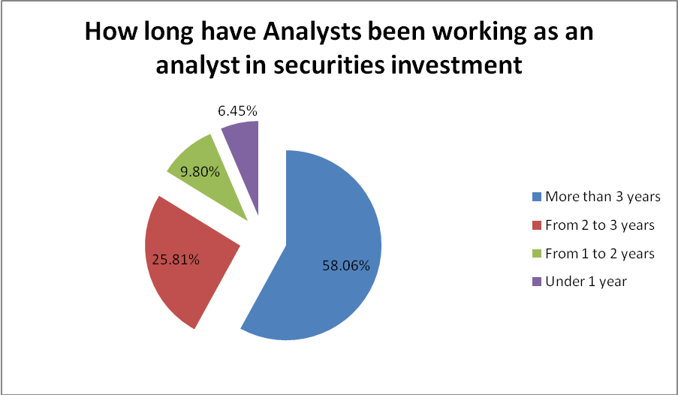
The Chart illustrates experience years of analysts. Most of them are three-year experienced at least, with the proportion of 58.06%; whereas, the quantity of staff who have under 1 year of experience is just 6.45%. They are clearly analysts without practicing certificate.
To sum up, in Vietnam Security Market, people that are employed at Analyzing Departments are experienced.

Chart 3: Which object do Analysts support?

The next Chart clearly shows that almost all analyses target two kinds of customers: investors of different companies (48.39%) and the trading part of companies (38.7%). This indicates higher development of Vietnam Security Market. In the past, analysis mainly appeared in the mass media to improve the public awareness for security companies, while at present, analyzing statements focus on the demand of target customers.
Chart 4: Which analytical method do Analysts often use?
If you look at this chart, you can see that the percentages of analysts using fundamental analysis and combining it with technical one are equal. All analysts interviewed have already used fundamental method, yet no body totally use technical one.
In conclusion, fundamental analysis is currently the most popular method in Vietnam.
Chart 5: How often do Analysts use fundamental analysis in securities investment?
This diagram clarifies that fundamental analysis is a great concern of analysts, with 96.77 %, so they usually apply this method to their analyzing statements. On the contrary, there are about 3.23% analysts, who rarely use fundamental method to employ to their analysis.

Overall, fundamental analysis is considered to be the most important method applied to stock analyzing in Vietnam.

Chart 6: How long do analyses of Analysts support to securities investment?
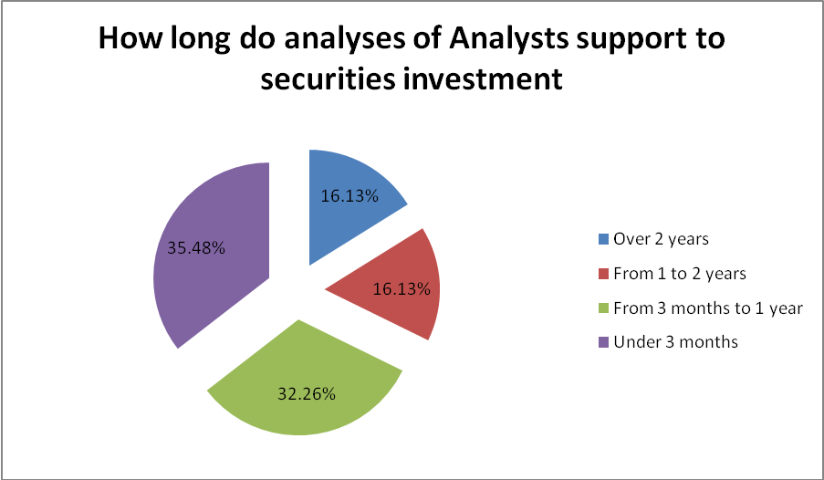

As can be seen from the Chart, in Vietnam, time of investment is not as long as that in other developed markets. It can be easily understood as Vietnam Security Market now is led by major individual investors. Their investing strategies are in short terms or extremely short-terms. As a result, security companies and investing funds have to adapt to this phenomenon. Analysts should follow the trend to serve investment in short, average and long term.

Chart 7: Have Analysts known and used the Standard & Poor’s Equity Research Methodology?

From the Chart, we can see that the number of analysts, whose knowledge about security field is in limitation, is not small. Despite the popularity of stock analyzing process of S&P in the world, there are 25.8% Vietnam security companies’ analysts have never used it, even 6.45% have never known about it.
Chart 8: How do Analysts think about the Standard & Poor’s Equity Research Methodolog’s role in their analyses

This Chart reveals the importance of fundamental analysis in stocks assessment. Experts who have ever used Top – Down stock analyzing process, S&P completely consider this method vital to their analysis; whereas, others - with proportion of 25.8% - who have never applied this seem not care about it and not realize its necessity, either.
Chart 9: Have Analysts known and used the special forecasting model of Standard and Poor’s called Forecasting model EPS?

From this Chart, we can draw a general overview about the approach and use of ESP model of analysts in different security companies. As we researched, no one mention methodology and model of prediction crucial variable, which are as reliable as ESP’s analysis. However, S&P has international reputation in investment with ESP, Sales, and Cost models. That is the reason why we put ESP model into this survey. We observe that a great deal of analysts have not heard of ESP model (61.29%). There are only 12.9% of analysts, who have known and used it.

Chart 10: Do Analysts have need of studying and researching the forecasting model about business variables such as EPS, ROE, ROA, etc?

According to professor Ton, Tich Quy, Vice Director of Securities Research and Training Center (SRTC), State Security Department, at present, in Vietnam, there are not any courses of teaching how to apply ESP to investment. Because of that, we would like to know whether analysts want to study about this method or not. Actually, 93.55% experts have desire to study and know more about ESP model. With this result, we can recommend SRTC open programs to help analysts to enrich their knowledge about security analyzing.

Table 11: At what level do Analysts pay attention to the factors of macroeconomics in their stock analysis?
The Table represents frequency of using macroeconomic information in analysis. These factors are in continuously decreasing order. We can see, among 12 factors, there are 7 ones, that receive much concern of analysts, with 4.581/ 5 marks, comprising inflation rate of the world economy, growth periods of the world economy, the world economic growth rate, GDP and national GDP growth rate, monetary policy of Central Bank, investing activities of international investors and organizations, the fluctuation of huge security variable in the world. 4.226/5 is the mark for governmental policy of exchange rate. Analysts have less concern on other factors: the change in security and security investment laws, another way to money investment instead of securities, structure growth of world economy and corporate income tax law, with the mark over 3, which reflects concern level of analysts on average.
Table 12: How do Analysts pay attention to the factors of trade on their stock analysis?
Table 12 shows that all of eight factors are concerned, however, the degree of difference is inconsiderable. The most interested factors in turn are: the competition of direct rivals, government’s policies of developing the branch, the development stage in the life cycle of product. The least interested factors are: the threat from implicit rivals and the threat from replacement products.
Table 13: How do Analysts pay attention to the factors related to business on their stock analysises?
It can be seen from table 13 that only the factor of the ownership structure gets little attention; the other ones are interested by most of experts, some of them are specially noticed, such as: the action effect ratios of the company in comparison with the average of the branch or with equivalent companies in the same branch, the ratios of market price (P/E, P/B), and the growth rate in revenues and profits of the company in recent years

2.2.2. Research results for individual investors
Chart 14: Qualification of individual investors in securities and securities market
The survey reveals that the individual investors in Vietnam stock market are extremely varied in the level of knowledge about stock and stock market. In general, the level of investors’ knowledge is still limited. In chart 14, there are 48.84% of investors who have never joined in any stock and stock market training course; these people are mainly elderly or semi – professional investors. The proportion of investors participating in less than three training courses is 25.58%. It means that their knowledge about stock and stock market is at the basic level. Finally, 25.58% of investors took more than 3 training courses at SRTC or got university degree in financial specialty. To sum up, the qualification of individual investors is still restricted; most of them just have preliminary knowledge, not to say any idea about stock as well as stock market.
Chart 15: Do individual investors have need of joining training courses about securities and securities market to improve the analysis capacity in investing?

We can see from chart 15 that the proportion of investors who are aware of the importance of advanced courses about stock and stock market and want to participate in those courses is quite low; it just accounts for 48.84%. The amount of investors who do not want to register for any training course about stock and stock market is 51.16% and they think these courses are unnecessary. This shows the lack of knowledge of investors when they underestimate the important role of these courses. The most popular reasons the investors give are: their investment capital is small and they are too old to learn any more.

Chart 16: How long have individual investors invested in securities market?

Chart 16 indicates that there are only 27.91% of investors who have more than three – year experience. The rest 72.09% of investors have investing experiences less than three years. It can be explained by the fact that in the period between 2007 and 2009, a large number of new investors were attracted to the stock market because of its booming. It means that a big part of investors lack experiences; they enter in the market spontaneously.
Chart 17: Individual investors’ current capital investment
Through chart 17, the amount of individual investors owning over two billion VND of investment capital is only 13.95% while the ones owning less than two billion VND of capital accounts for 86.05%. The number of investors having investment of five hundreds millions VND is 51.13%. This points out that a lot of individual investors are amateurs.
Chart 18: Where do individual investors often get information to give decisions on investment
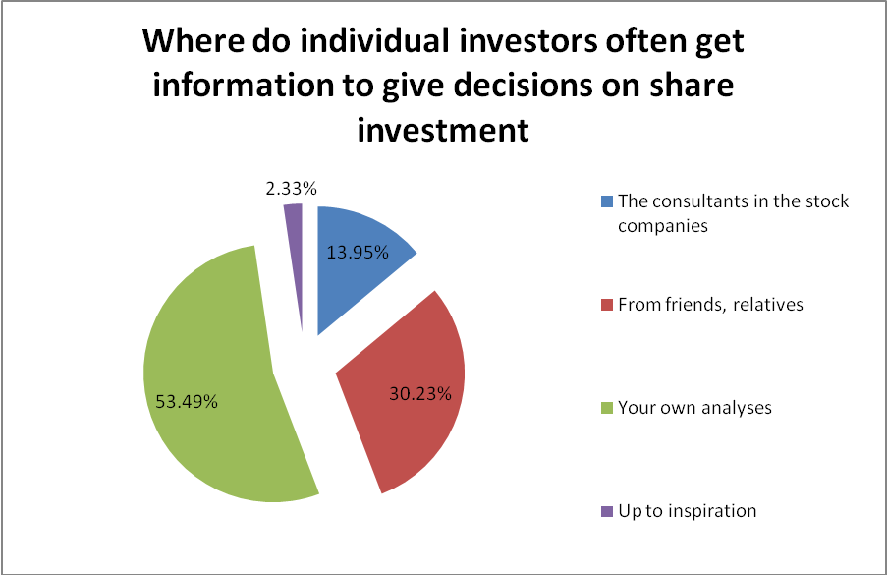
Most of investors depend on their own analyses (53.49%) or their acquaintances’ information (30.23%) to make decisions. The consultancy from stock companies proves disadvantageous position. The reason is partially because investors do not believe in these analyses and also it is difficult for them to get information from the stock companies, especially people with little capital. There are still some investors who make their investing decisions based on their inspiration; however they just account for 2.33%. In conclusion, we can make a point that Vietnam stock market has not really been developed and investors are still unprofessional.

Chart 19: How do individual investors think about the usefulness of information on which they make investing decisions?
It is clear from this Chart that, analysts, in general, rely on the bases of information, from which they can make investing decisions. While there is 27.91% individual investors believe that the foundation is effective and reliable, 37.21% others think they should consider this as a reference. Obviously, this result shows effectiveness and professional of the market, once individual investors seem to be directionless and doubtful about whether it is right or wrong to follow a foundation to invest.
Chart 20: How long does each investment of individual investors often take?
The clearest point in chart 20 is the number of 72.08% of investors keeping shares less than three months, while the amount of over one – year investments accounts for 4.66%. It indicates the first stage in the development of Vietnam stock market: the effectiveness of stock market is still low; the qualification of investors is not high, they are speculating rather than investing and the unstability and unavoidability of the market. All of these factors make the stock market more risky and the ones who bear the worst consequences are investors.
Chart 21: Which group of shares do individual investors often invest

It is a good result from chart 21 when most of investors (74.42%) do not distinguish share “penny chip” and “blue chip” when giving decisions to invest. There are only 25.48% of investors tell apart two kinds of shares for preference.

Table 22: How much attention do Analysts pay to the factors of macroeconomics in their stock analysis?

Table 22 points out investors’ order of interest to the factors is as same as analysts’, however; they pay less attention than analysts. There is only factor “the fluctuation of big and prestigious share indexes” gets the most concern with the mark of 4.163/5, the other factors’ marks vary from 3 to 4. There are three factors getting under 2.605 marks, they are: the growth structure of the global economy; the changes in law of stock, stock market and business income tax. It can be explained by the the low qualificaiton of investors, the effects of the structure change of global economy as well as the unpredictability of Business income taxes on Vietnam companies.

Table 23: How do Analysts pay attention to the factors of trade on their stock analysis?
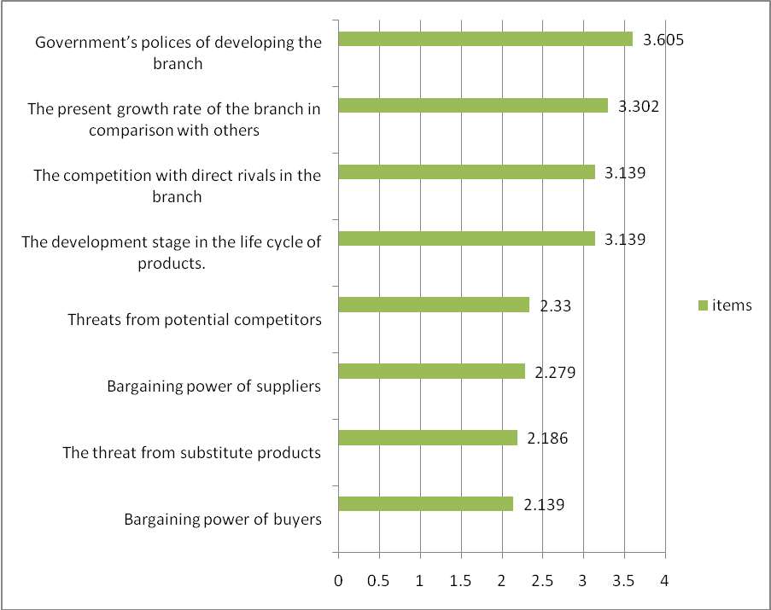
There are four out of eight factors which almost all individual investors ignore, which are: the threat of implicit rivals; the rights of buyers to negotiate; the threat from replacement products; the rights of providers to negotiate. All of them get the mark under 2.33/5 while they are factors which have strong effect on business activities of companies. Four remaining factors get normal attention from investors, and the most concerned factor that is the government’s policies for developing the branch also get an average mark of 3.605/5
Table 24: How do Analysts pay attention to the factors related to business on their stock analysis?
Table 24 proves the fact that individual investors pay more attention to the company than the business line. The interest level of investors is lower than that of analysts because their knowledge, profession and equipment supporting their analyses are not as good as analysts’. The table above points out three most interested factors with the mark over 4/5. The rest of factors have less attention. There is only one factor gets the mark under 3/5, it is “the quality of administration and staff of the company”, which is absolutely opposite to the analysts’ interest on this factor.

2.3.3. Conclusion drawn from above results
2.3.3.1. Application of fundamental analysis by analysts at securities firm
Fundamental analysis has regularly been practiced by most of securities firms’ analysts (up to 96.77%) in their work and has provided a basis for their assessment and recommendations.
Application of fundamental analysis in stock valuation in Vietnam stock market seems to have many shortcomings, almost all analysts work manually without the facilitation of standard procedures, knowledge and up-to-date supporting equipment, which reduces accuracy and persuasiveness of their analysis.
The application of fundamental analysis does not receive proper attention corresponding to its importance.
Variables in fundamental analysis don’t receive appropriate consideration in making standardized analyses.
There are not so many highly-graded analytical reports on stock market which can convince investors.
Assessments from fundamental analysis by analyst are too vague, unspecific and prove a lack of responsibilities.
➔ Fundamental analysis in security investment in Vietnam is not fully exploited by analysts. The efficiency it gains is not so high and not in par with its importance.
2.3.3.1. The application of fundamental analysis in stock analyzing by individual investors.
The majority of individual investors in Vietnam stock market do have employed fundamental elements in their investing decision. The number of investors who make their own analysis is near to nil, they just apply several minor factors to make investing decision like market price indicators (P/E, P/b), variables of world stock index, inflation rate or money supply policy.
Their investing decisions are short-term, lacks of strategy and basic knowledge. They also don’t take analytical reports made by security companies into consideration.
➔ The application of fundamental analysis in investing security in Vietnam stock market by individual investors is still immature, unspecific and without procedures, which results in low efficiency.

2.4. Reason for ineffective application of fundamental analysis in Vietnam stock market
Due to the incompetence in professionalism of analysts and individual investors: most of analysts are previously from banking and other fields, while the number of employees who study securities major is too small. Individual investors are spontaneous and unprofessional in their analysis.
Vietnam stock market has not fully developed as it has just come into operation for nearly 10 years.
Legislation system and inspection by authorities, specifically State Securities Commission, is still fragile and incompatible with the development of stock market.
Training capability of securities and stock market education center seems limited: there is a shortage of proficient specialists, particularly expert in specialized forecasting model. The number of course opened is still small and does not meet the demand.
Education and administration structure and certificate issuance of Securities Commission are complicated with long issuing duration. Each year there are only two examinations.
The analysts and individual investors are not highly aware of research for up-to-date information and knowledge, especially individual investors.

2.5. Solution to enhance the efficiency of applying fundamental analysis in investment in Vietnam stock market

2.5.1. With regard to State Securities Commission- the official management agency of Vietnam stock market (SSC)
SSC should amend its regulations to stabilize and professionalize the stock market as well as enhance fairness among investors. Furthermore, it should improve the law implemetaion of market participants in order to prevent illegal acts such as controlling market, making price or using insider information.
SSC needs to encourage institutional investors to take more part in stock market so as to enhance the market’s professionalism and stability. Mutual Fund and Unit Investment Trust, Securities Investment Fund should be supported to provide individual investors with a new approach of indirect investment which is carried out through these institution to reduce investment risks.
It is essential that SSC have education programs to assist investors, especially individual investors, to improve their knowledge, responsibility and awareness of legal regulations.
SSC should impose strict supervision on information disclosure in stock market, increase information transparency concerning stock market to ensure the equality of investors when obtaining source of information.
SSC should organize more examination instead of two times a year like the present in along with speeding up certificate issuance for candidates.

2.5.2. With regard to scientific research and securities training center- the sole body in charge of inspecting securities and stock market training in Vietnam (SRTC).
SRTC should promote more standardized training program to disseminate, update knowledge for stock market’s participants, especially individual investors who are majority in stock market.
SRTC should open more advanced courses which are instructed by experienced specialists in stock market for analysts, securities company’ s department manager to help them update state-of-art knowledge in their analysis, particularly variables forecasting model in fundamental analysis.

2.5.3 With regard to securities companies
The companies should provide more newsletter, reports and profound standardized analysis in news media for individual investors.
Securities firms should encourage and offer favorable conditions for their analysts to join advanced course about securities and stock market and professional financial programs such as CFA, CIIA, and ACCA.

LIST OF REFERENCES

- CFA Series–Investment Analysis And Portfolio Management (Reilly Brown) 7Th Edt.
- CFA–Corporate Finance, Market, Equity, Alternative Investment, Portfolio Management.
- Stephen A. Ross Fundamentals of Corporate Finance.
- Dr. Ton/Tich Quy: Curriculum analysis and investment securities
- Dr. Ton/Tich Quy: Lecture electronic analysis and investment securities
Website
- http://www.standardandpoors.com
- http://www.bloomberg.com
- http://ssc.gov.vn
- http://cafef.vn
- http://vneconomy.vn
- http://WWW.vndirect.com.vn
- http://WWW.ssi.com.vn

APPENDIX

THE SURVEY OF LEVEL AND STATE IN APPLYING THE FUNDAMENTAL ANALYSIS METHOD TO INVESTMENT SECURITIES (SHARES) IN VIETNAM

Q. A: For analysts at securities companies
Q. B: For individual investors

THE SURVEY OF LEVEL AND STATE IN APPLYING THE FUNDAMENTAL ANALYSIS METHOD TO INVESTMENT SECURITIES (SHARES) IN VIET NAM

Q. A: For analysts at securities companies

I. Personal Information:
(All information given in this part is used for only study purpose. To each question, you are supposed to choose only one answer.)
- Please give some information:
Full name:
Office address:
The present position in company:
The major trained at university:
2. Your kind of practicing certificate issued by SSC
A. Securities investment broker and consultant
B. Business finance consultant
C. Fund management
D. No practicing certificate
- How long have you been working as an analyst in securities investment?
- More than 3 years
- From 2 to 3 years
- From 1 to 2 years
- Under 1 year
- Which object do your analyses often support to?
- The trading part of the company
- Investors
- Mass media
- Your investment decisions
II. Factors impacting on analysis and factors used in experts’ analysis:
- Which analytical method do you often use?
- Fundamental analysis
- Technical analysis
- Combining two above methods
- How often do you use fundamental analysis in securities investment?
- Always
- Often
- Sometimes
- Never
- How long do your analyses support to securities investment?
- Over 2 years
- From 1 to 2 years
- From 3 months to 1 year
- Under 3 months
- Have you known and used the Standard & Poor’s Equity Research Methodology?
- Have done in analyses
- Have ever known it, but haven’t done in analyses
- Haven’t ever known it
- If you have used the Standard & Poor’s Equity Research Methodology, how do you think about its role in your analyses?
- Very important and always was used in analyses
- Important, need was used in analyses
- It only fits in analyses for long investment
- No important
- Have you known and used the special forecasting model of Standard and Poor’s called Forecasting model EPS?
- Have known and used to forecast EPS
- Have ever known it, but haven’t used forecast EPS
- Haven’t ever known it
7. Do you have need of studying and researching the forecasting model about business variables such as EPS, ROE, ROA, etc?
- Yes, it is really necessary.
- No need to study and research
8. How much do you pay attention to the factors of macroeconomics in stock analysis? (Choose ONE answer)
 | Special Interest |  | Interest |  |  |  | No Interest
The development stage in the world economic cycle | 5 | 4 |  | 3 | 2 |  |  | 1
The present growth rate of the global economy | 5 | 4 |  | 3 | 2 |  |  | 1
The growth structure of the global economy | 5 | 4 |  | 3 | 2 |  |  | 1
GDP and the internal GDP growth rate | 5 | 4 |  | 3 | 2 |  |  | 1
Inflation of the internal economy | 5 | 4 |  | 3 | 2 |  |  | 1
Policies about the supply of money from the Central Bank | 5 | 4 |  | 3 | 2 |  |  | 1
Government’s policies about rates of exchange. | 5 | 4 |  | 3 | 2 |  |  | 1
Gold and real estate investment | 5 | 4 |  | 3 | 2 |  |  | 1
corporate income tax law | 5 | 4 |  | 3 | 2 |  |  | 1
The changes in law of securities and securities market  The fluctuation of share indexes in the world (DJ, S&P 500, NIKEI…) | 5  5 | 4  4 |  | 3  3 | 2  2 |  |  | 1  1
Investment activities of the organized foreign investors | 5 | 4 |  | 3 | 2 |  |  | 1
9. How do you pay attention to the factors of trade on your stock analysis? (Circle ONE number)
 |  |  | Special Interest |  | Interest |  |  |  | No Interest
The development stage in the life cycle of products. |  | 5 |  | 4 |  | 3 | 2 |  |  | 1
The present growth rate of the branch in comparison with others. |  | 5 |  | 4 |  | 3 | 2 |  |  | 1
Government’s polices of developing the branch |  | 5 |  | 4 |  | 3 | 2 |  |  | 1
The competition with direct rivals in the branch |  | 5 |  | 4 |  | 3 | 2 |  |  | 1
Bargaining power of suppliers |  | 5 |  | 4 |  | 3 | 2 |  |  | 1
Bargaining power of buyers |  | 5 |  | 4 |  | 3 | 2 |  |  | 1
Threats from potential competitors |  | 5 |  | 4 |  | 3 | 2 |  |  | 1
The threat from substitute products |  | 5 |  | 4 |  | 3 | 2 |  |  | 1

10. How do you pay attention to the factors related to business on your stock analysis?
 | Special Interest |  | Interest |  |  |  | No Interest
The position of company in the branch | 5 | 4 |  | 3 | 2 |  | 1
The quality of administration and staff of the company | 5 | 4 |  | 3 | 2 |  | 1
The ownership structure in the company | 5 | 4 |  | 3 | 2 |  | 1
The financial potential of the company | 5 | 4 |  | 3 | 2 |  | 1
The growth rate in sales and profits of the company in recent years and forecasts in future | 5 | 4 |  | 3 | 2 |  | 1
Absolute sales and profits of the company | 5 | 4 |  | 3 | 2 |  | 1
The liquidity ratios of the company in comparision with the average of the branch or with equivalent companies in the same branch. | 5 | 4 |  | 3 | 2 |  | 1
The performance ratio of the company in comparision with the average of the branch or with equivalent companies in the same branch. | 5 | 4 |  | 3 | 2 |  | 1
The loan management ratios of the company in comparision with the average of the branch or with equivalent companies in the same branch. | 5 | 4 |  | 3 | 2 |  | 1
The profitability ratios (ROS, ROA, ROE) of the company in comparision with the average of the branch or with equivalent companies in the same branch. | 5 | 4 |  | 3 | 2 |  | 1
The growth rate of the company in comparision with the average of the branch or with equivalent companies in the same branch. | 5 | 4 |  | 3 | 2 |  | 1
The ratios of market price (P/E, P/B) | 5 | 4 |  | 3 | 2 |  | 1

Q. B: For individual investors

I. Personal Information:
(All information given in this part is used for only study purpose. To each question, you are supposed to choose only one answer)
1. Please give some information:
Full name:
Job:
The major:
- Your qualification in securities and securities market
- University and higher
- Joining in many courses at SRTC ( more than 3 courses, including Securities Analysis and Investment course)
- Joining few courses at SRTC ( fewer than 3 courses, including Securities Analysis and Investment course)
- Never join in any course
- Do you have need of joining training courses about securities and securities market to improve the analysis capacity in investing?
- Yes, it is really necessary
- No, it is not effective
- How long have you invested in securities market?
- Over 3 years
- From 1.5 – 3 years
- Under 1.5 years
- How much is your current capital investment?
- Over 2billions VND
- From 500millions VND to 2billions VND
- From 200millions VND to 500millions VND
- Under 200 millions VND

II. The most concerns of investors’ decisions: (choose ONE answer)

1. Where do you often get information to give decisions on share investment?
A. The consultants in the stock companies
B. From friends, relatives
C. Your own analyses
D. Up to inspiration
2. How do you think about the usefulness of information on which you depend to give decisions?
A. Very effective and reliable
B. Not completely believable
C. Just for reference
D. Not effective at all.
3. How long does your investment often take?
A. Over 2 years
B. From 1 to 2 years
C. From 3 months to 1 year
D. Under 3 months
- Which group of shares do you often invest?
- Blue chip
- Penny chip
- No difference.

8. How much do you pay attention to the factors of macroeconomics in stock analysis? (Choose ONE answer)
 | Special Interest |  | Interest |  |  |  | No Interest
The development stage in the world economic cycle | 5 | 4 |  | 3 | 2 |  |  | 1
The present growth rate of the global economy | 5 | 4 |  | 3 | 2 |  |  | 1
The growth structure of the global economy | 5 | 4 |  | 3 | 2 |  |  | 1
GDP and the internal GDP growth rate | 5 | 4 |  | 3 | 2 |  |  | 1
Inflation of the internal economy | 5 | 4 |  | 3 | 2 |  |  | 1
Policies about the supply of money from the Central Bank | 5 | 4 |  | 3 | 2 |  |  | 1
Government’s policies about rates of exchange. | 5 | 4 |  | 3 | 2 |  |  | 1
Gold and real estate investment | 5 | 4 |  | 3 | 2 |  |  | 1
Corporate income tax law | 5 | 4 |  | 3 | 2 |  |  | 1
The changes in law of securities and securities market  The fluctuation of share indexes in the world (DJ, S&P 500, NIKEI…) | 5  5 | 4  4 |  | 3  3 | 2  2 |  |  | 1  1
Investment activities of the organized foreign investors | 5 | 4 |  | 3 | 2 |  |  | 1
9. How do you pay attention to the factors of trade on your stock analysis? (Circle ONE number)
 |  | Special Interest |  | Interest |  |  |  | No Interest
 | The development stage in the life cycle of products. | 5 | 4 |  | 3 | 2 |  | 1
 | The present growth rate of the branch in comparison with others. | 5 | 4 |  | 3 | 2 |  | 1
 | Government’s polices of developing the branch | 5 | 4 |  | 3 | 2 |  | 1
 | The competition with direct rivals in the branch | 5 | 4 |  | 3 | 2 |  | 1
 | Bargaining power of suppliers | 5 | 4 |  | 3 | 2 |  | 1
 | Bargaining power of buyers | 5 | 4 |  | 3 | 2 |  | 1
 | Threats from potential competitors | 5 | 4 |  | 3 | 2 |  | 1
 | The threat from substitute products | 5 | 4 |  | 3 | 2 |  | 1

10. How do you pay attention to the factors related to business on your stock analysis?
 |  | Special Interest |  | Interest |  |  |  | No Interest
The position of company in the branch |  | 5 | 4 |  | 3 | 2 |  | 1
The quality of administration and staff of the company |  | 5 | 4 |  | 3 | 2 |  | 1
The ownership structure in the company |  | 5 | 4 |  | 3 | 2 |  | 1
The financial potential of the company |  | 5 | 4 |  | 3 | 2 |  | 1
The growth rate in sales and profits of the company in recent years and forecasts in future |  | 5 | 4 |  | 3 | 2 |  | 1
Absolute sales and profits of the company |  | 5 | 4 |  | 3 | 2 |  | 1
The liquidity ratios of the company in comparision with the average of the branch or with equivalent companies in the same branch. |  | 5 | 4 |  | 3 | 2 |  | 1
The performance ratio of the company in comparision with the average of the branch or with equivalent companies in the same branch. |  | 5 | 4 |  | 3 | 2 |  | 1
The loan management ratios of the company in comparision with the average of the branch or with equivalent companies in the same branch. |  | 5 | 4 |  | 3 | 2 |  | 1
The profitability ratios (ROS, ROA, ROE) of the company in comparision with the average of the branch or with equivalent companies in the same branch. |  | 5 | 4 |  | 3 | 2 |  | 1
The growth rate of the company in comparision with the average of the branch or with equivalent companies in the same branch. |  | 5 | 4 |  | 3 | 2 |  | 1
The ratios of market price (P/E, P/B) |  | 5 | 4 |  | 3 | 2 |  | 1

