What Japan should do to be more competitive in Chinese market in the field of automobile industry?

Keio University
Takemori Shumpei Seminar
International Trade and Investment Group

Introduction

In 2009, the number of automobiles sold in Chinese market reached 13.64 million and has become the biggest around the world, exceeding that in the U.S after the Lehman shock. The automobile market in China is likely to expand as their income levels rises. In this paper, we focus on what Japanese automobile makers should do to get more competitive in Chinese market. In the first half part, we’d like to investigate both Chinese and Japanese automobile industry and introduce you a path to come to the main theme. In the latter part, we examine the current situation more in detail and seek for possible strategies to take.

- Japanese automobile industry

In Japan, there are many famous automobile makers, for example, TOYOTA, NISSAN, HONDA. We can expect that automobile industry is an important industry in Japan. We will see the data about the industry and find what characteristics Japanese automobile industry really has. From these data, we can say that
1. Automobile industry is a leading industry in Japan.
2. Automobile industry is competitive in Japan compared with other countries.
3. Many of Japanese automobile companies produce cars abroad.
Now I’d like to show the data to prove these features.

Leading industry in Japan
Look at the graph1. This shows the ratio of the export price. You can see that, the automobile industry occupies 16.9% of the total export price. This is the highest one. 2nd is electrical machine industry (15.5%). 3rd one is general machine industry (12.0%). Seeing from the point of income, automobile industry is very important in Japan.
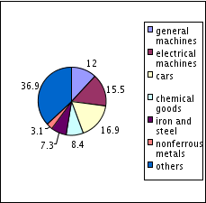

(Graph 1)
Then, see the Graph2. It expresses the ratio of the number of workers. The automobile industry is the 3rd one. It is 10.3% of all the number of workers. This means about one tenth of all the Japanese workers engage in the automobile industry. Also some data shows Japanese makers occupy 34% of all the world market.
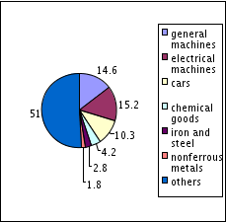

(Graph 2)
From these data, we can say that automobile industry supports the Japanese economy and is the leading industry in Japan.

Competitiveness of Japanese automobiles
Let’s see how competitive Japanese automobile industry is compare to other countries. Chart1 shows the ratio of the sales performance of automobile industry. From this, you can see automobile industry in Japan holds about 10%. Also, you can see competitiveness is increasing.
Chart1

Maybe you will think this number (10%) is small, and Japanese automobile industry is declining. But that is not true. Look at Graph3. This graph shows the global light vehicle sales.

(Graph 3)
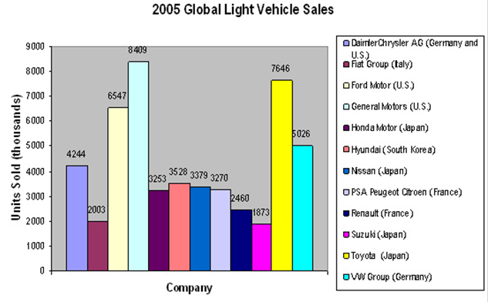

In this graph Toyota is in 2nd place. This shows that Japanese maker is very competitive.

Trend to produce abroad
Graph4 shows the total price of the Japanese investment to the foreign countries of automobile industry. The pink line represents the total price of the year. You can see it increased. That means the number of car produced abroad is increasing. There are two reasons for this increase. first is the decrease of demand in Japan. First reason is an economic recession and the declining number of drivers by age and declining birthrate. Second reason is the expansion of the market.
(Graph 4)
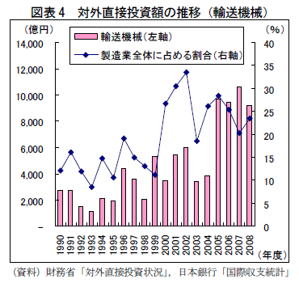

Look at Graph4 the pink part represent the increasing countries demand. The blue part shows that of Japan. From this Graph you could see the rapidly rising countries’ demand. From this graph, if Japan wants to make automobile industry more competitive in the world, it has to gain the advantage in the market of emerging countries like China.

Look at Graph5 the pink part represent the increasing countries demand. The blue part shows that of Japan. From this Graph you could see the rapidly rising countries’ demand. From this graph, if Japan wants to make automobile industry more competitive in the world, it has to gain the advantage in the market of emerging countries like China.
(Graph 5)
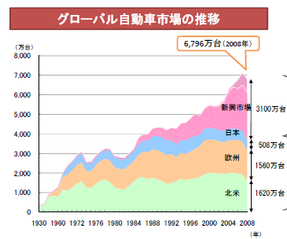

Japanese FDI toward China
If you look at the graph 1 which is based on Japanese finance ministry’s data, we can recognize that 80% of the Japanese firm’s investment towards China is from manufacturing industry. Especially, the manufacturer for appliance products, transportation products is major inverters to China.
In China, motorization has developed and China became world’s second largest market of car selling in transportation products. For example, 9.38million cars were purchased in 2008 in China. Therefore, lots of firms of automobile manufacturers start overseas production in accordance with the fact that investment to China has expanded. Also, car parts and components manufacturers have found a larger market in China.
Because of the background, demand for industrial machinery is expanded to product Japanese automobile.

 | 2006 |  | 2007 |  | 2008
sector | money | share | money | share | money | share | growth
manufacturing industry(total) | 5670 | 79.1 | 4926 | 67.4 | 5017 | 74.9 | 1.8
electric machinery products | 1487 | 20.7 | 940 | 12.9 | 1085 | 16.2 | 15.4
transportation products | 1330 | 18.5 | 889 | 12.2 | 1019 | 15.2 | 14.6
general machinery products | 594 | 8.3 | 667 | 9.1 | 741 | 11.1 | 11.1
iron, meｔal, etc | 309 | 4.3 | 601 | 8.2 | 589 | 8.8 | △2
wood and pulp | 41 | 0.6 | 552 | 7.6 | 105 | 1.6 | △81
(Table 1)
a transition of FDI from Japan to China（unit：a hundred million yen、％）
cf: the ministry of finance

Appearance of Japanese- Chinese joint companies
For feathers of specific cases of Japanese firms’ investment, it can be pointed that they are inclined to strengthen function of selling and research and development.
Honda Motor Co., Ltd. establishes subsidiary company of research and development "Kuangchou Honda train research and development limited company" in Hiroshi east ministry Kuangchou City in April, 2007. Plenty of facilities are constructed including a high-speed test course of the four-wheeled vehicle to research. The company plans to develop a new four-wheeled vehicle in the subsidiary company, and to sell it as an original brand car of Kuangchou Honda in ten years. It is a first attempt for a foreign automobile manufacturer to develop a new merchandise using the original brand of a joint company. The amount of the investment is about two billion yuan (about 30 billion yen, approximately 3,5 billion dollars)
In July, 2007, Toyota Motor established distribution management company "同方環球（天津）物流有限会社" in 天津 City by the capital five million dollars with the first train group company and Kuangchou train group groin limited company. It was the first time to establish the joint company by three companies, and they are attempting to decrease cost and improve efficiency of managing the vehicle and parts together which was done individually by the business unit related to Toyota in China. Moreover, to improve the quality of the distribution business, it will make more efforts.

- Chinese automobile industry

Let me explain about the automobile market in China by using data.
First, the number of cars sold in China. As you can see from graph 5, it is increasing rapidly and became the second largest market in the world. In addition, we could tell that most of the cars sold in China are equal to the cars made in China. However, it does not mean that Chinese corporation makes most of the cars sold in China. The share of Chinese car market is China 40%, Japan 24%, Europe 19%, US 11%, and Korea 5%.
China has potential in expanding its car market by near future. There are five reasons.
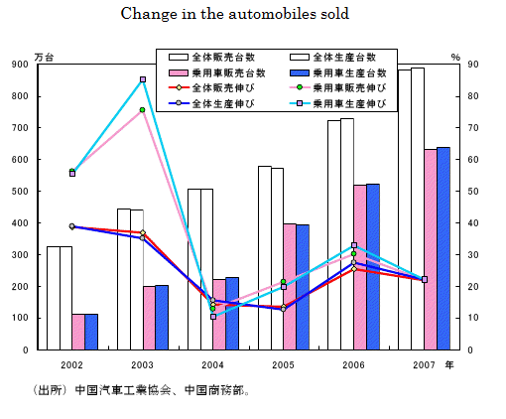
(Graph 5)

Factors contributing to the forecast
First, there is a difference in rate of cars between large cities and local areas. (Graph 6) Second, the number of people who have car is still low. There are only 40 million cars in China compare to its population, which is 13 billion. (Graph 7)
Third, the number of people who has driver’s license is much bigger than the people who own a car. In 2007, there are almost 107,000,000 people who has driver’s license. Fourth, the level of income is getting higher.(Graph 8) The last reason is the maintenance of infrastructure. Substantial infrastructure enhances car usage. (Graph 9) For these reasons, we could estimate that Chinese automobiles market has enough potential to enlarge its scale. After all, Chinese automobile market is huge now, and it is still growing rapidly.

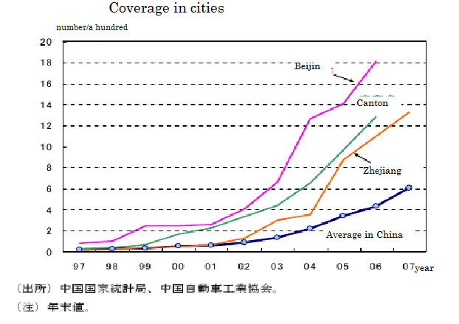
(Graph 6)
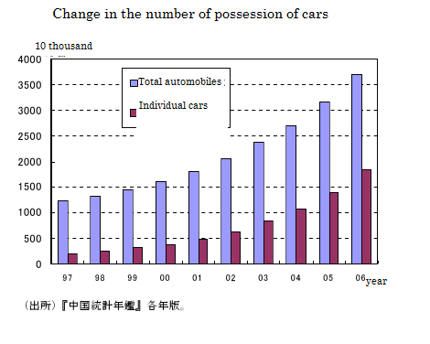
(Graph7)

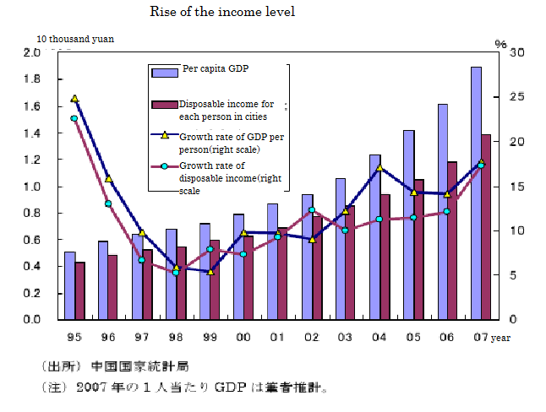
(Graph 8)

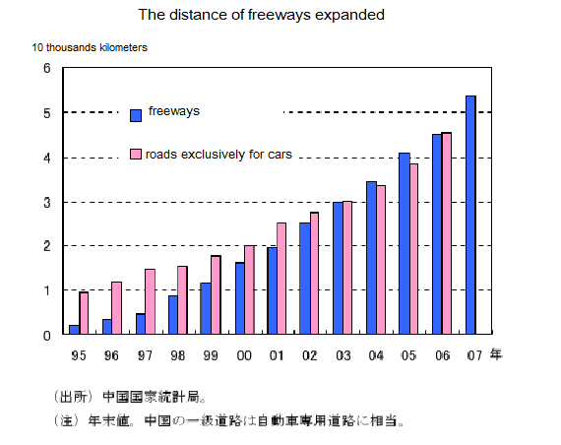
(Graph 9)

3. Strategies to take: concentrating on selling compact cars

Current Market Share Situation
Now let’s take a closer look at Chinese automobile market. As the graph shows, VW occupies the largest share among foreign-affiliated companies, followed by Hyundai and GM. Nissan has 5.5 percent and Toyota and Honda also have around 5 percent market share. The rest of the share is mainly occupied by Chinese local companies. According to Chinese automobile industry association, Chinese companies occupy more than 44 percent of the market share in 2009, which increased by 4 percent compared with last year. Also, the number of new models released in China last year is 221 and among that, Chinese local companies released 120, which could be one of the factors of having increased its share. By announcing new models, Chinese companies are striving to gain more share. Although Japanese companies in total have around 20 percent showing strong presence in China, they have to compete with these growing Chinese local companies if they take the situation into account, and at the same time, watch out what measures other foreign-affiliated companies such as VW and Hyundai would take.

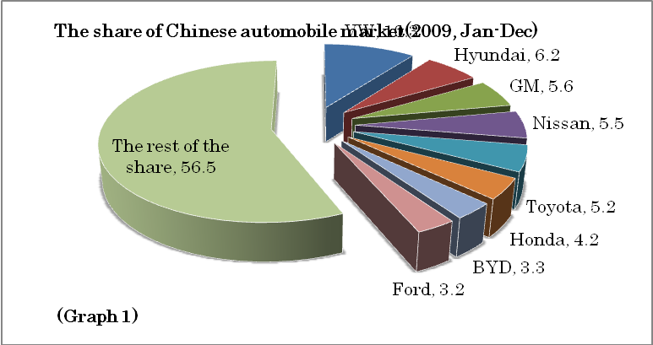

Consumers’ Demand
It’s also important to check what kinds of cars are sold in the market. Automobiles with the amount of exhaust gas less than 1600cc are considered as compact cars or small cars, and the number of these cars sold increased by 44 percent compared with last year in February, 2009. Amazingly, toward the end of 2009, it increased by more than 100 percent. (The black line indicates small cars with the exhaust gas less than 1600cc)(Graph2) The actual number of small cars sold in 2009 is about 7.2 million and that occupies large part of all the automobiles sold in 2009. (Table1)

Total number of automobiles sold | 1346
Cars(excluding truck and bus) | 1033
Small cars | 720
Unit: ten thousand, 2009
(Table1)
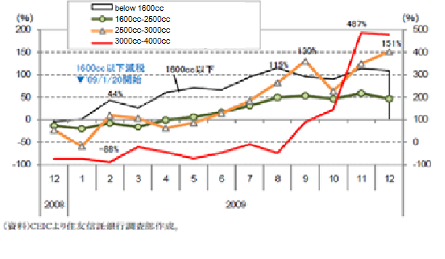

(Graph 2)

One of the main reasons of this dramatic increase is that Chinese government started providing subsidies to those who purchase small cars. Even though this campaign is limited, the demand for small cars is likely to increase in a long term since small cars are cheap and reasonable for the large portion of Chinese people. You can purchase a small car at the price of 30 thousand yuan (about 4500 dollars) if you want the cheapest one. On the other hand, you need at least 80 thousand yuan if you buy a Japanese car. Obviously, price implies the difference of quality but it’s also true Chinese companies are improving its quality these days.

Behind the boom in middle and large cars
In Graph2, the red line at the bottom shows cars with the amount of exhaust between 3000cc and 4000cc, and this increased abruptly after August, 2009. You can see that other than small cars, middle and large cars are well sold. Although the actual number of cars with its exhaust more than 2500cc is about 23 thousands and relatively small to small cars, this phenomenon is interesting to investigate. Graph 3 shows the percentage of the number of cars (more than 2500cc) sold in 2009 compared with last year (red line), and the selling price of real estate in 70 large and middle cities in China.(green line). In the first half of the year, they were both negative but in the latter they both increased rapidly. There seems to be a positive correlation between two and it’s possible that the rise in the assets such as real estate inspired wealthy people leading to the increase of pricy middle and large cars. If this is so, the boost in middle and large cars inclines to be affected by economy and asset price, and focusing on this sector could be dangerous if the price of real estate keeps going up too suddenly.

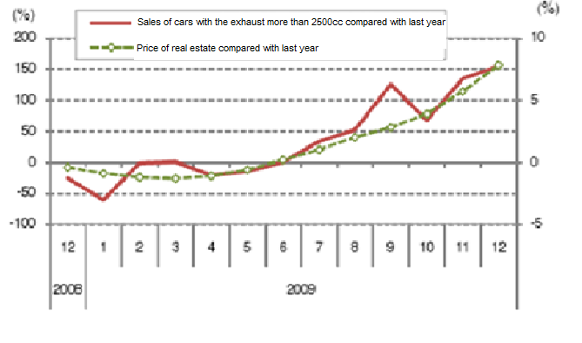
(Graph 3)

Strategy to take
If Japanese companies want to expand its share, therefore, one possible strategy is to focus on small cars and lower the selling price by reducing cost. Cutting cost can be obtained by, for example, increasing the percentage of getting parts and components locally, or employing Chinese parts and components makers. In the latter case, Chinese makers can sell those parts to Japanese companies and at the same time, acquire higher skills and thus, two countries can establish a win-win relationship.

Two main problems
Even though it is necessary for Japanese automobile industry to gain large share of small car market in China, now there are some problems. In this part, we will show you two significant ones.
The first problem is price war. As you can see in the following graph, recently the prices of Chinese cars have constantly declined.
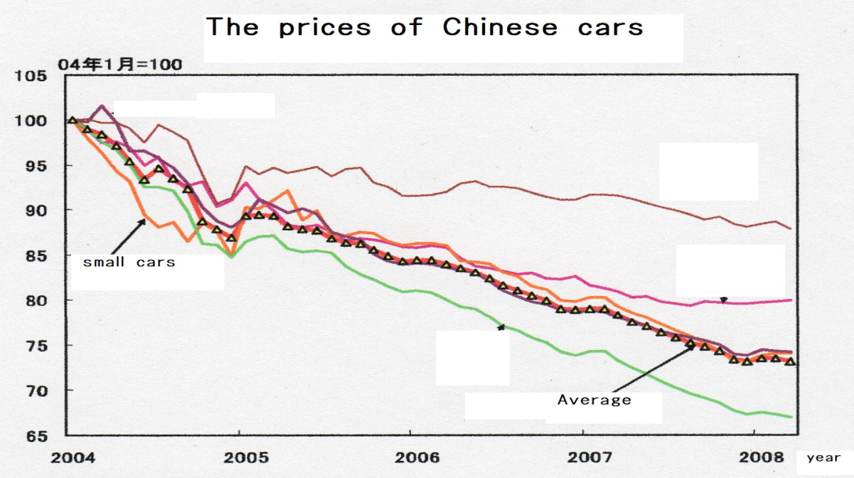

Most of the customers who intend to buy small cars are middle-class people. Although GDP and average income of China have rapidly grown, the standard of their income is still not so high. For middle-class Chinese, the price of Japanese small cars are too expensive. For example, the lowest price of Japanese car in Chinese market is about 80000 GEN (approximately 1120000 YEN). On the other hand, Chinese company has the car called “QQ3” which cost only 33800 GEN (approximately 400000 YEN) Until China join WTO, this price gap is because very high tax to the imported car to some extent, so there was no possibility for foreign companies to join the price wars in Chinese car market. However, after they joined WTO, foreign-affiliated companies became able to make the prices of their cars lower. Actually, a lot of famous foreign companies such as Volks Wagen or GM have begun to reduce the prices of their cars. It is necessary for Japanese companies to cut down the cost and make their car prices lower, more or less.
Also, there is concern about time limit of tax reduction low in small cars. This low was enacted last year and it changed the tax rate of small cars from 10% to 5%. Though it have played large roll in small car market, January 2010 the Chinese government cut its saving rate from 5% to 7.5%. Now many companies are observing how consumers act following this change. This second problem depends on the judgment of Chinese government.

4. Strategy to take: tapping a new market

Another strategy for Japanese companies to take is focusing on EV industry and pioneering the new market. Now let’s focus on the new technology. It is obvious that Japan has a high technology, which Japan can boast to the world. In this chapter we would like to insist that Japan should aim the eco car market in China. We will refer to it from two points. First, we will focus on China’s recent ideas towards environment. Then we will show the Japan’s high technology.

Environment issues in China; responsibility of emitting CO2
Talking about the environment, which is one of the biggest issues in the world; in 2006 China’s CO2 emissions surpassed that of USA and became the world’s largest CO2 emissions country. This reflects the recent rapid growth of the Chinese economy. And of course the fact that Chinese car industry became the world’s largest one is one of the reasons that are causing this problem. Facing this fact, in December 2009, Chinese government announced that they will reduce the CO2 emissions up to 40-45% (per GDP) compared to 2005 by 2020. This was the first time for China to announce a specific figure and it was presented in COP15. Also the Chinese government is raising energy saving and pollutant emissions reduction for a part of national strategy. As we can see from this, the protection of the environment is one of the greatest concerns in China. And to achieve this, the popularization of eco cars is getting attention in China. Now, as China overweighed USA in car sales, the number of cars in China is growing continuously. Therefore unless China takes in newer technologies and circulate environmentally friendly cars, the burden for the environment would be an enormous one. It is said that if the predominance of gasoline and diesel-powered cars continue, China’s passenger vehicles could be responsible for generating as much as 20 percent of global passenger vehicle CO2 emissions. Then let’s see the effectiveness of the eco cars.

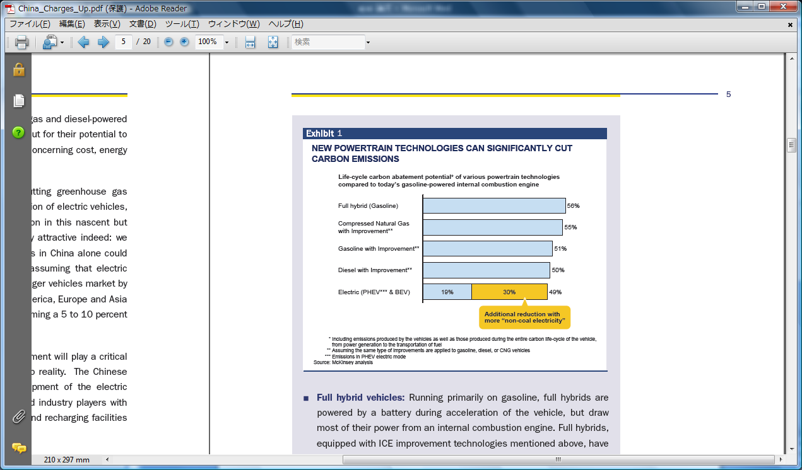

Effects s of introducing eco cars
Please look at the above figure. It shows how much each type of eco cars cut CO2 emissions. As you can see, compared to today’s gasoline powered internal combustion engine, each type of eco cars can cut about 50% of CO2 emissions. Especially, electric vehicles have a possibility to cut about 80%. Moreover, electric vehicles can reduce oil consumptions. Therefore, China should definitely adopt new technology and introduce environmentally eco friendly cars. This means in the near future there would be a huge market of eco cars in China.

Government policies to promote eco cars
There is another evidence eco cars will have a big chance to spread and create a new market in China. The Chinese government started two big projects that are aimed to promote eco cars. The first project started in the beginning of 2009, which is called “ten city one thousand vehicles” project. This is a four year project that would be practiced from 2009 to 2012. The content of the project is that in 10 or bigger and medium sized cities, Chinese government would adopt more than 1000 eco cars. First, the government started in choosing the cities. And for the cities that had been chosen by the government, the government provided subsidies to purchase eco cars and to maintenance related facilities. The subsidies for hybrid cars were up to 50000 Yuan and for EV cars were up to 60000 Yuan. Also, the local government was directed to adopt eco cars in the public buses, taxis, and the official cars. By promoting this project the Chinese government is trying to make the proportion of eco cars up to 10% by 2012.
Another big project which was carried out by the Chinese government was the “Automobile industry promotion plan”. This is a three year plan from 2009 to 2011. This plan consists of market expanding policy, industrial structure management policy, and eco car spreading policy. In detail, China would expand the scale of production of eco cars up to five hundred thousand per year, and make the eco car sales proportion up to 5%. Also Chinese government would support companies 10 billion Yuan in three years, so that they can improve their ability in technological development and be able to develop eco cars and it parts. Looking from these two projects, eco cars have a potential capacities in the Chinese market.

Japan’s leadership in the new market
In the field of eco cars Japanese companies are leading the world. To see that, first, let’s take a look in the world’s hybrid car market. In 2009 world’s hybrid car sales jumped up to 750,000, which increased by 45.8% from 2008. This was mainly achieved because of the renewal of the Toyota “Prius”, which has more than half the share in the market of Japan, USA, and Europe, and the phase in of the Honda “Insight”. We can see this from the next figure which shows the transition of the world’s hybrid car sales, looking by the sales of each maker. We can know that the share of Toyota is 70% and the share of Honda is 21%. Together Japanese makers have 90 % of the world share and we could say that this is an indication of high technology. Also, Looking at the size of each country’s market, Japanese market exceeded the USA market in 2009 and became the world’s largest hybrid car market. This was due to Japan’s policies towards eco cars, which was the reduction of taxes and giving subsidies. However, looking at the penetration rate, it is still 8% in Japan, 3% in USA, and less than 1% in Europe. Each maker is working hard, for example Toyota is planning to take in the new hybrid car of “Lexus” after 2011 and Honda is planning to take in the new hybrid car of “Fit” in 2010. Of course US maker Ford will take in new vehicles and European makers like VW and Daimler would start to join in earnest. Plus, Chinese makers would also be a newcomer in the market. Therefore by 2012, the world’s whole supply will reach up to 1.5 million. It is very important for Japanese makers to maintain its competitiveness under this condition using its high technology and product development power.

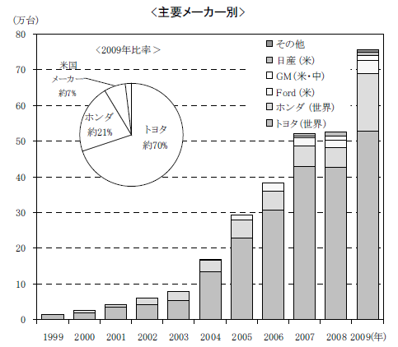

Next we will have a look in the electric vehicles. Also in this field Japanese makers are leading the world. In August 2009 Nissan introduced a new electric car “Leaf”, which is the world’s first medium sized and mass produced all electric car. It will go on sale in late 2010 in Japan, USA, and Europe. Nissan expects an initial annual production of 50,000 cars, which will rise to 200,000 when the car is sold globally in 2012. Also in July 2009, Mitsubishi announced the new electric car "i-MiEV". This was the world’s first mini size mass produced electric vehicle. It is now accepting orders for private customers and it will be delivered after April 2010. As we can see from this Japanese makers are being a pioneer in electric vehicles and they are supposed to lead the world in the future. This is again due to the high technology in Japan.

Brief summary
So far we have shown a new possibility for Japanese makers to acquire shares in China. Japanese makers should use their high technology and develop eco cars and make higher sales in the world. And one fact to support this is the consciousness of China towards the environment. By taking these two things into consideration, Japanese makers should definitely aim on eco cars.

Issues to be concerned
To make Japan more competitive in China’s eco car industry especially electric vehicle industry (since Japan has number 1 share in hybrid-car industry), there are three main issues that need to be considered.

The first issue is the battery technology. Fully charging the battery takes several hours with short mileage. Right now, 97 percent of electric vehicles use nickel-metal hybrid battery. But according to GBI (Global Business Intelligence) researchers, the nickel-metal hybrid technology has reached its maturity, and Li-ion technology is advancing more quickly and offers better overall performance, such as longer life, high energy density, and lightweight. By 2020, it is said that 60 percent of the electric vehicles would have Li-ion battery loaded. Although battery technology advances, the problem with the cost appears. Loading Li-ion battery would cost at least $20,000 even with the subsidy. It is a stiff price in a country where the annual average income is less than $10,000.

The second issue is recharging infrastructure. Even though this Li-ion technology is developing right now, electric vehicles won’t get far without recharging infrastructure. Installing a widely available recharging infrastructure is a key factor for China to take-up electric vehicles. But installing these recharging facilities costs a lot of money. It is said that it will cost 5 to 10 billion reminbi to have enough recharging facilities in China. Unless the government guides infrastructure sector to build these facilities, electric vehicles industry will never be a competitive sector.
The third issue is that Chinese government is aiming electric vehicles to be their original homegrown industry. Since 2006, Chinese government tried to make an “independent innovation” to pull China up the value-added ladder. This policy encompassed number of initiatives to promote investment in research and development across several strategic sectors, including the automobile industry. By government’s policy, automobile industry would evolve its technology from hybrid electric to plug-in hybrid electric vehicles in the near future and the pace of the transition will be much faster than expected. According to GBI researchers, this shift will provide a huge sales growth opportunity for advanced batteries in electric vehicles, like Li-ion batteries in particular. The GBI researchers estimate that global plug-in vehicles sales will reach 1 percent of the light-duty vehicle market by 2015 and 5.3 percent by 2020. That could translate into a global plug-in vehicle battery market of $17.3 billion by 2020.

China’s challenge to lead EV industry
China has built a large and rapidly growing automobile industry by government’s push, but it still substantially lags other countries in the development of existing power train technologies. Japanese and US firms dominate the traditional gasoline-powered vehicle sector while Europeans rule the diesel sector. Japanese firms such as Toyota and Honda lead in the hybrid vehicles market. But in electric vehicle industry, no country has yet emerged as the clear leader.
The development of the battery technology to Li-ion battery will be a great opportunities for countries with advanced battery technologies, such as China, Japan and Korea. Today, these three countries dominate 98 percent of the advanced battery manufacturing. From chart 1, we could see that Japanese manufactures have more than half of the global advanced batteries production in 2009. Although Japanese manufacturers still mark 55 percent, the numbers decreased from 2002. On the other hand, China’s roll in this production rose to 25 percent in 2009.

Chart 1
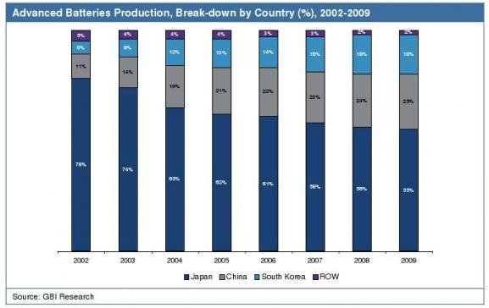

China has advantages in the market by government’s strong incentives and cheap labor. These advantages lead manufacturers to replace a conventionally capital-intensive, using automated production lines with a labor intensive one that relies on people-power in its production lines. For example, Tianjin-Qingyuan Electric Vehicle Company is building a factory that will produce 20,000 electric vehicles a year, which half of them is for export. Shenzhen-based BYD, the world’s leading manufacturer of rechargeable batteries, has announced it will launch a plug-in hybrid electric car at the end of 2008, and it plans to launch a battery electric car by the end of 2009. Chinese automobile parts suppliers gain the benefit greatly from the potential boom in electric vehicle manufacturing. In addition, demand rises for the most important components in electric vehicle, such as batteries, electric motors, generators, as well as non-powertrain parts such as air-conditioning systems. Some Chinese companies have become active players in the global supply chain for electric vehicle batteries. Thunder Sky Energy Group, a Shenzhen-based lithium-ion battery manufacturer, supplied batteries that are used in electric buses in the US, Japan, and Finland.

Brief summary of those issues
There are some issues that China’s government has to face such as battery cost and infrastructure in order to make electric vehicle a major market. For Japanese automobile industry, joining the electric vehicle industry in China right now would not be so effective in order to be more competitive in China’s automobile industry. With government’s incentives, in the near future, there would be many electric vehicles riding in China. But as electric vehicle starts to spread in China, China would have its own manufacturing process with enough technology. With Chinese government’s incentive to make electric vehicle industry to be a homegrown industry, there is no opportunity for Japanese automobile industries to be competitive in electric vehicle sector.

Conclusion

As we’ve discussed in chapter one and two, automobile industry has a great significance for Japanese exports. Nowadays, decreasing domestic demand and the coming of aging society encourage Japanese companies to look more at foreign countries. When considering this fact, the dramatically growing market in China can surely be a target Japan has to focus on. Rapid economic growth and rise in income level enable more and more people to be able to possess a car. Amazingly, Chinese local companies hold a large share of the market and Japan has to compete not only with foreign-affiliated companies, but local companies, meaning required both high quality and low price. As we’ve explained in this paper, there are two strategies to take to get more competitive in Chinese market; concentrating on small, compact cars, and electric vehicles. In the short term, efforts to cut cost and sell compact cars that are suitable for local people are inevitable to increase the share. In the process, further FDI and R&D are required. In the long term, Japan also has to strengthen the competitiveness of EV. At this moment, there are many problems to overcome such as battery or infrastructure, but Japan should not withdraw her eyes from China. Chinese government is eager to strengthen EV industry, reflected in policies they are taking in several years. As a conclusion, we suggest Japanese companies should focus on both compact cars and electric vehicles.

