Keio University
International Economics Team
Midori Fujioka
Ayaka Nakamura
Junichi Namaita
Kohei Odo
Jihye Park
Mao Tomita
Marin Tsuchiya
Keita Yoneda

Can Japan Follow the Footsteps of Korea?
--Japanese FTA Strategy--

Abstract

In Japan, Free Trade Agreement (FTA) is not enough concluded. Particularly, Japan has only one FTA with developed country (Japan-Switzerland FTA). On the other hand, Korea has concluded many FTAs recently. There are some reasons for this difference. In both countries, the FTAs with developing countries are not going well. Japan has Foreign Direct investment (FDI) problem, and Korea also has a problem that Korean enterprises are not regarding them as the beneficial FTAs. However, the FTAs with developed countries are in different situation in each country. Japan has been failed to conclude the FTAs because of high agricultural tariff and the “global standard” problem. The “global standard” problem is that, some countries like US and EU regard Japan as the competitor, not the FTA partner. Whereas Japan is struggling with those problems, Korea has succeeded to conclude FTA with EU and the US. Korea is more eager to conclude FTAs than Japan, and its markets are growing fast. Those growing markets can have great benefit from the FTAs with developed countries, and they are beneficial for the developed countries, too. Japanese markets are growing slower than those of Korea, so it is difficult to conclude FTA without lowering the tariff of agricultural tariff. Therefore, it is clear that the situation of Japan and Korea is different from the beginning. Japan should seek out the original FTA strategy, not just following after Korea.

Now, we are living in“Global World”.
Without international trading, we cannot achieve the economic growth.
Japan; takes time to conclude FTAs, Korea; does it smoothly…
What is the difference between Japan and Korea?
What should we do?
We try to think about Japanese FTA strategy!

1, Definition of WTO and EPA
2, Japan's history of signing FTA/EPA
3, Japan's difficulties; Agricultural tariff and FDI
4, Korea's strategies; FTAs with Chile, ASEAN, US, and EU
5, Comparison and analysis of Japan and Korea

The wave of forming FTAs among countries is now at a peak. Many countries are willing to find its FTA partner and not let a chance fly past. In this report, we will focus on the status quo of Japanese free trade agreements and compare the effort with Korea. First, we will look at how FTA had formed after the rise of WTO. Secondly, we will look at how Japan had formed FTA and dealt with the problem of agriculture, although Japan is not doing so well compared to a neighboring country, Korea. Thirdly, we will analyze how Korea had implemented FTAs successfully with developed countries. At last, we will see the possible problems of Japan for not being able to conclude as many FTAs as Korea successfully did. Also, we will consider if Japan could perform better even after knowing the problems, and see how Japan can learn from its mistakes, and if they can catch up to the trend of forming FTAs.

1, Definition of WTO and EPA

The World Trade Organization (WTO) is the only international organization dealing with the global rules of trade between nations. Its main purpose is to open trade for the benefit of all nations by ensuring that trade flows as smoothly, predictably, fairly and freely as possible. It ensures this by administering trade agreements, acting as a forum for trade negotiations, settling trade disputes, reviewing national trade policies, assisting countries to develop in trade policy issues, and by cooperating with other international organization. The WTO consists of 153 members, accounting for over 97% of world trade and the ecretariat is based in Geneva, Switzerland.
After the Second World War, the General Agreement on Tariffs and Trade (GATT) was established and its last round－the 1986-94 Uruguay Round－created the WTO as the successor to the GATT in 1995. The WTO’s rules are the result of the Uruguay Round negotiations which included a major revision of the original GATT, so GATT is now the WTO’s principal rule-book for trade in goods. The Uruguay Round also created new rules for dealing with trade in services, relevant aspects of intellectual property, dispute settlement, and trade policy reviews.

Free Trade Agreement (FTA) is the agreement which lays down cuts and reductions of systems that restrict trades like tariffs and non-tariff barriers. FTA’s purpose is to make free trade between countries which enact FTAs and to expand trade and investment by eliminating tariffs and non-tariff barriers. FTAs are usually established between two countries, so it covers much smaller areas than WTO. Therefore, FTAs are used to supplement areas which WTO can’t cover. For example, WTO consists of 153 countries, so it can’t deal with each country’s problems and situations. On the other hand, FTAs are concluded between a few countries, so it can take each problems, situations and conditions into consideration. Up to January 2010, about 180 FTAs have been established all over the world (Table 1). Among the regions of the world East Asia was not active in establishing FTAs until recently. Indeed, until 2002, when Japan-Singapore FTA was enacted, ASEAN Free Trade Area (AFTA) was the only major FTA in the region. Many East Asian economies started showing a strong interest in FTAs toward the end of the 1990s (Table 2).
Table1. Changes of the number of FTAs

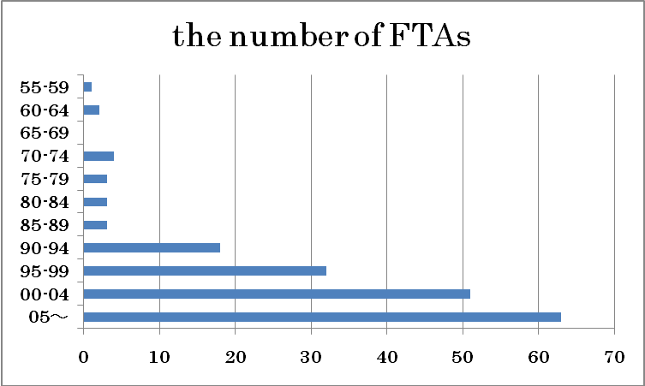
Number of FTAs/ Year
Source: http://rtais.wto.org/UI/PublicMaintainRTAHome.aspx

Table2. The number of FTAs by areas
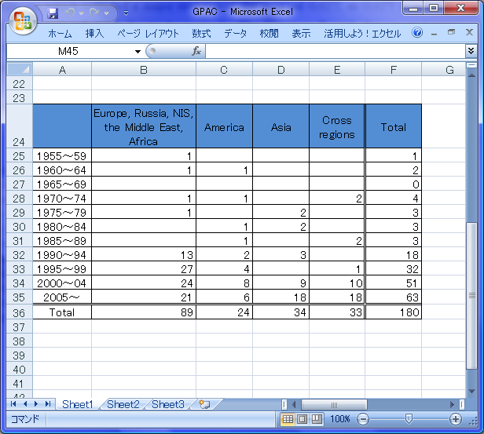
Source: http://rtais.wto.org/UI/PublicMaintainRTAHome.aspx

While FTA deals with only tariff and liberalization of trade, Economic Partnership Agreement (EPA) covers various elements beyond tariff elimination, such as customs procedure cooperation; technical regulations, standards, and conformity assessment; investment; trade in services; movement of natural persons; energy and mineral resource development cooperation; intellectual property rights; government procurement; and control of anti-competitive activities.
We can say, therefore that EPA covers much wider areas and it includes FTA.

２Japan’s history of FTA/EPA signings and status quo.
As shown in Table 3, as of 27 July 2010, Japan has 10 bilateral FTAs in effect with Singapore, Mexico, Malaysia, Chile, Thailand, Indonesia, Brunei Darussalam, Philippines, Viet Nam, and Switzerland. In addition to those bilateral FTAs, Japan has entered into a multilateral FTA with ASEAN. Specifically, the Japan-ASEAN EPA included Singapore, Lao People’s Democratic Republic, Viet Nam, and Myanmar in December 2008; Brunei Darussalam was added in January 2009. With the ASEAN-Japan EPA, bilateral and multilateral FTAs coexist between Japan and Brunei Darussalam, Indonesia, Malaysia, Philippines, Singapore, Thailand, and Viet Nam. Therefore, a Japanese exporter has the option to choose one preferential tariff among them.
Basically, FTA is considered that it pushes world economy to grow more and more and that is the one of the reasons that Japan chose FTA as a trade policy. Many people in Japan thought that FTA would be effective for their economy. It is very important to understand how FTAs affect Japan’s economy and we will analyze that by showing three examples of Japanese concluded FTA.

Table3. Summary of EPAs and FTAs involving Japan as of 27 July 2010
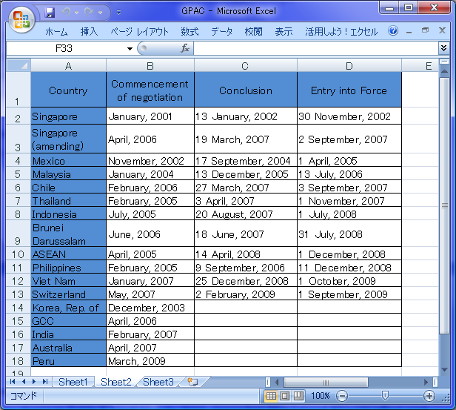
Note: ASEAN = Association of Southeast Asian Nations; GCC = Gulf Cooperation Council (UAE, Bahrain, Kuwait, Oman, Qatar, Saudi Arabia)
Source: Compiled from the Website of Ministry of Foreign Affairs, Japan.
Before we see the examples, we want to show the meaning of having FTA. It is regarded as one of the solutions to set off the less for setting off the less vital economy which was made as the aging society grew. After the WWII, the US and international organizations such as GATT and OECD made Japan go through structural change. However, the liberalization with WTO wasn’t expected and at the same time, US had an economic boom so they didn’t apply pressure on Japan to open market. As external pressure disappeared, Japan lost functions to change their structure. Under such situation, FTA is considered as a new function to change the structure and brings success to EU and NAFTA, which they gave a good effect on member nations, was the stimulus for focusing on FTA.
Three Japanese concluded FTAs are Japan-Singapore (2002), Japan-Mexico (2005), and Japan-Switzerland (2008) and these are shown in chronological order. However, it is easier to understand the effect of FTA by showing in different order as we showed below.
Signing FTA means as same as removing the trade barriers, and it can help companies to expand their business in foreign country. Needless to say, it is important for Japanese competitive companies to expand their business in foreign market, and Japan-Mexico FTA is a good example.
Japan-Mexico EPA was concluded in April, 2005. The reason why Japan signed EPA with Mexico, which is a member of NAFTA and has high dependent on trade and investment with US, was that Japan was forced to compete under the disadvantageous situation. Mexico set higher import tariffs than foreign countries, but they concluded
NAFTA with US and Canada in 1994, and then concluded FTA with EU in 2000. Since they opened their market to concluded FTA or NAFTA partner countries, Japan was excluded from Mexican market. For that reason, Japan wanted to enter the market by overcoming such situation, and finally Japanese competitive companies requested their own government to sign the EPA with Mexico.
It doesn’t mean only Japan wanted to have EPA with Mexico, but also Mexico was interesting in signing EPA with Japan even though both of them had strong agricultural sector, and it was almost impossible to have EPA without cutting tariffs. Japan compromised by cutting tariffs completely on their sensitive goods, tomato, onion, garlic, beans, grapefruits, turkey other than lever, processed foods other than beef and pork. Additionally, beef has 30% tariff with terms and orange has 16% tariff with terms², and these are lower than other countries. We can understand from these data that Mexico is treated well. On the other hand, Mexico had an iron, steel, and cars as sensitive goods. They promised cutting tariffs on iron and steel completely by 10 years, and for cars, they set the allotment and promised to cut tariffs completely within 7 years. By setting both compromises, this EPA was succeeded to conclude. Japan-Mexico EPA is covering many sectors such as goods which we mentioned above, safe guard between two countries, investment, services, movement of people, supporting between two countries, and equipment for business environment.
Japanese competitive companies have interest in signing FTA with East Asia because there are still high import tariffs and investment barriers. Liberalization is in progress in East Asia and Japanese electronic industries are raising their productivity by expanding their production and distribution network. For more liberalization in trade and investment, they need to have FTA with East Asia especially in constructing relationship which subsumes East Asia. Basically, FTA promotes Japan a structural change and expanding their business chances in the foreign market and they can get both merit and profit. The partner country can also get resemble effect as Japan, so if the expansion of East Asia economy succeeds, it means they can expect to get more profit.
Japan had a high motivation with signing FTA with East Asia for a long time, so Japan-Singapore EPA was the first commemorative EPA for Japan. They have almost no barriers with signing EPA because Singapore had few agricultural goods to export, and that means Japan could protect their agricultural goods, sensitive goods. Thus they succeeded earlier than they expected. Originally they promoted a free trade, and they have already reduced tariffs before they signed with EPA, so there are no big changes in reducing tariffs. This EPA is also covering as many sectors as Mexico such as goods, movement of people, liberalization in services, supporting between two countries, and notable sector is investment. Usually, the investment protection agreement that Japan signs with is for protecting the activity after the investment, but in this EPA, they added the new rule that the country which receive the investment should give advantageous treatment than the own investor or the company for the partner country. Moreover, they prohibited other rules such as request for export, localize, performance which is listed in measures in investment of WTO.
In the near future, it is possible to happen for making rules on competitive policy or investment in WTO or other international organization, and Japan-Singapore will be shown as the one of the model case.
These two, Mexico and Singapore, countries are, if anything, categorized as a developing countries. Japan has been trying to sign FTA or EPA with many countries, but they couldn’t make with developed countries for a long time. Having many conferences over and over, Japan succeeded signing FTA with Switzerland in 2008. Both countries could get benefit by cutting tariffs on agricultural goods except rice, wheat, etc., and also Japan cut the tariffs on mining and manufacturing goods. Japan has the high tariff on milk, dairy foods, rice, wheat, barley, sugar, starch, chocolate, and so on. Although Japan cut the tariffs on refined sake, miso, and bonsai. On the other hand, Switzerland has the high tariff on grain, fruits, vegetables, sugar, meat(beef and pork), etc. They abandoned the request for putting Swiss as a director in corporation. Such compromises, even the sector is different, are formed between two countries and they admit each requests, so this EPA reached to succeed in conclusion. The merit for Japan to have FTA with Switzerland is not only trade, but also movement of people in EU areas. Because Switzerland has already concluded the agreement with EU, the movement of people and goods are liberalized toward EU so the access became more efficient. The head office in Switzerland is expected to have important role as a center of the EU areas.
These FTA and EPA with each country that we mentioned in this section have notable features, so that will be valuable information for considering Japan’s strategy for the next FTA or EPA in the future.

3, Japan's difficulties; Agricultural tariff and FDI

Why Japan cannot conclude FTA smoothly? What do foreign countries ask from Japan through FTA?
Japan potentially has difficulties which they face when signing FTA or EPAs. The main two of them are agricultural tariff; to protect the internal agriculture sector, and the cap of FDI.
The first problem is “agricultural tariff”. The Japanese industrial tariff rate is already low (industrial component parts are almost free). So, developing countries do not expect that industrial tariff will be cut. What they hope is to abolish or cut down the Japanese agricultural tariff.
Now, even without FTA, we can see a lot of imported vegetables and fruits in Japanese super markets and these imported agricultural products are often cheaper than Japanese ones, even though they contain agricultural tariffs. To protect the domestic agriculture sector, particularly rice farms, Japanese government import agriculture products with high rate tariffs. For example, burdock 20% (WTO rate 12%), rye flour 25% (WTO rate 15%), and rice is one of the highest, 420 yen per kg.
For Japan, agricultural tariff is one of the most important means(effective way) to protect domestic agriculture, so we cannot remove this easily even if Japan ties FTA with foreign countries who ask for abolishment of agricultural tariff. This disagreement between Japan and foreign countries’ strategies makes a barrier to FTA.
If Japan refuses to abolishment or cutting down agricultural tariff, developing countries will not get any benefit from FTA, because industrial tariff is low enough to trade without FTA. This will rather give only good effect to Japan, expanding the market particularly in the industrial sector. If Japan compromises and removes agricultural tariff, the price of import agriculture products will become much cheaper than now. This must cause a shock and stagnation of Japanese agriculture, because its prices cannot remain competitive with imported ones from developing countries which have cheap labor cost, in price war(competition). So we will have to depend on imported food if Japan allows a FTA including the agriculture sector which will cause a decline of self-sufficiency ratio and will weaken Japan’s diplomatic power.

The second problem is “the cap of FDI”. The Japan-Thailand FTA is a good example. In this case, Japan as successful in tying FTA. They compensated its weakness by increasing FDI (foreign Direct Investment) to Thailand. FDI refers to long term participation by one country into another.
The Japan-Thailand FTA was tied on April 3, 2007. In this FTA Thailand planned to abolish tariffs of almost all of the steel parts that are used to compose an automobile within 10 years and also announced not to strengthen the regulation on foreign investment in the manufacturer industry and to loosen the regulation on foreign investments in the service industry. This made Japan FDI easier to conduct. On the other hand, Japan determined to cooperate developing the steel and automobile industry and the agriculture industry of Thailand.
When there is a FDI from a developed country to a developing country both sides can receive several merits. For example, if Toyota made a factory in Thailand and exported the parts to the factory and hired local workers to assemble and complete the automobile, Toyota will have three benefits. First, the cost of making an automobile will drop because the wages of the workers are cheaper than Japan. Second, they could sell the completed car in the Thailand market without paying the high tariff (80%) imposed on completed cars. Third, they can sell completed cars to other developing countries around Thailand easier. On the other hand Thailand has four benefits. First, a demand for local employment will be created. Second, technical skills will be imported. Third, advanced foreign managing will be imported. Last, Thailand would be able to produce products which they originally imported and that would improve their current account deficit. Considering all these benefits, it could be said that increasing FDI can be one approach to compensate the weakness of the agriculture industry. There are, however, problems of FDI as well.
The problem of FDI is that the benefit, we can receive, is not sustainable. There are four reasons. First, there are limits for foreign investments. Developing countries set a limit to foreign investment, so if too much capital is accumulated it would be impossible to increase investment even if it is demanded. Second, the exchange rate would influence the profit. For example, if Barts go high it would be a disadvantage for Japan when they import the products they made in Thailand. Third, the industry of Japan will weaken. If we transfer the producing industry too much to the developing countries the same part in our own country will become weak. Last, the wages will gradually become high as the country develops. To sum up, there is an end in gaining profit from direct investment. Actually, according to a questionnaire research conducted by UNCTAD, in 2006, 41% of the corporations answered that the profit rate in Thailand is higher than the average profit rate of their corporation. However, in 2007, only 34% of the corporation answers so. Similarly, 54 corporations answered that they are satisfied with the profit rate in Thailand but 77 corporations answered that they are unsatisfied. What we can say is that Thailand’s profit rate is still high but it is certainly growing down.
To conclude, increasing FDI could be one alternative to solve the problem of the weakness in the agriculture sector. However, its profit is not sustainable so it is not an absolute solution. To reach a sustainable solution we may have to think of another way including this FDI approach as a choice.
Because of these potential barriers, Japan usually prevent from smooth conclusions of FTA or EPAs. Without solving these problems, it is difficult to utilize FTA or EPAs for economic growth.

4, Korea's strategies; FTAs with Chile, ASEAN, US, and EU

Korea is one of the major countries in the world that is growing at a rapid speed. The data below shows the growth rate of GDP compared with Japan and the World average. As easily seen, Korea’s growth rate since 2000 has been higher than Japan and the world average. Next table shows the history of Korean FTA that is implemented. To see how EU-Korea FTA was a successful one, in this section we compared with Chile, ASEAN, the United States, and EU. At first Chile was not a successful FTA due to Korea still being a beginner in promoting FTA. It only covered small sector which both countries did not gain full merit of signing a FTA. In the next three years, Korea learned how to sign a better FTA with Singapore. By the time when signing a FTA with ASEAN, Korea had become a professional in signing FTA. This led to the promotion of signing a FTA with a country or a group of countries which has a powerful economic effect to the world, such as the United States and EU in this case.
Table 1
Country Name | 2000 | 2001 | 2002 | 2003 | 2004 | 2005 | 2006 | 2007 | 2008
World average | 4.13 | 1.50 | 1.89 | 2.68 | 4.09 | 3.48 | 3.96 | 3.84 | 1.70
Japan | 2.86 | 0.18 | 0.26 | 1.41 | 2.74 | 1.93 | 2.04 | 2.39 | 0.70
Korea, Rep. | 8.49 | 3.97 | 7.15 | 2.80 | 4.62 | 3.96 | 5.18 | 5.11 | 2.22
Source: World Bank

Table 2
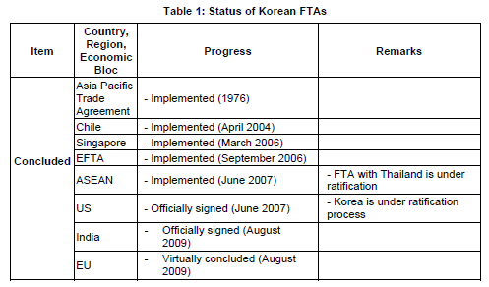
Sources: Korea Ministry of Foreign Affairs and the ADB Asia Regional Integration Center FTA database (data as of April 2009)

The Korea-Chile FTA was implemented in April of 2004 and it was the first to be concluded between Asian and South American countries. To give some background information, Korea was ranked 5th on Chile’s export at the end of year 2006. Korea was receiving deficit from trading with Chile because Chile’s 70% of exports consists of raw material such as copper, wine and pork. On the other hand, Korea exports cars and electronics; turning the deficit to surplus by an adding value. This leads to a meaning of mutual complement between the two countries.
Evaluating the 6 years of this FTA, in the year of 2009 the whole amount of trade decreased but overall amount increased and the trading disproportion became less. By this FTA, the market share of both countries increased in each other. The average tariff of 5.31% dropped and the free trade items increased to 75.3%. However, Chile had concluded a FTA with Japan and China making the market share decrease for Korea.
FDI of Korea to Chile increased but Chile to Korea had not increased as much and the transportation of human resources in both countries is still at a low level. Since the drop of the whole trade amount in 2009, both countries will add some more items on a free trade list to expect the whole trading amount to rise.
The problem of this FTA for the Korean side appeared when an earthquake struck in Chile in February of 2010. This natural disaster made Chile’s economic growth slowed down and Korea had to correspond to such drop. For a solution to this problem, Korea is seeking to expand its trading area in South America by using Chile as a hub.

Korea-ASEAN FTA was implemented in June 2007. In both countries, their economical environments are very similar because both areas had grown by taking similar characteristics of economic development strategy as in foreign intended industries, such as depending on export. Both areas needed to pioneer new business field due to the rise of China, who is influencing the world’s economy today, and the stagnation of world economy from the financial crisis. Before the FTA was signed, Korea had a one-sided surplus to ASEAN. After the FTA was signed, both countries increased their trading and opened new market by technological support from Korea. Both countries were able to cooperate in constructing a system of expanding investment and trade in East-Asia.

The success towards the Korea-EU FTA cannot be told without the Korea-US FTA. Korea-US FTA was officially signed on June 2007, 2 years before the Korea-EU FTA. This FTA was signed because Korea wanted to be an economic partner with the United States and there are five possible reasons for this. First reason was that the United States consists of the world’s 20% of GDP which means it’s an economically powerful country. Second reason is that United States has a wide range of promoting the FTA. Normally, larger the economic magnitude of its country is, the wider the range of FTA is and the affect of the FTA will be more efficient. Third reason is the timing. Korea needed to expand its FTA range at that time, making the United States as the best choice to sign a FTA with. The number of FTA signed around the world has been growing at that time. Countries without the FTA were at an unfair position so more companies in such country will promote its government to conclude more FTAs. Fourth reason is that to expand the economic effects and make it more matured in the areas of economics, trading systems, and tourism. From these growing areas, Korea can raise its trading quality level. Fifth reason is to make the service industries progress and make it strong enough for global competition.
Similarly, the United States had some reasons to promote this Korea-US FTA. The first reason is that Unites States has a highly positive stance to conclude FTA with larger areas (ex. North Atlantic FTA). The second reason is that United States had evaluated Korea’s already concluded FTAs high. The Unite States saw Korea as experienced with signing FTAs since Korea had already concluded with Singapore, EFTA, and ASEAN. These FTAs suggested that Korean government has a high motivation in promoting more FTAs. The third reason is a political issue. At the end of 2005, the Bush administration was thinking to promote a FTA and already had achieved a Trading Progress Agreement from the Congress. With many conditions to fill, such as the possibility of human resource to conclude the FTA within time, whether its team is experienced with policies, and the will to promote a FTA, Korea and Malaysia were the only two that had fulfill these criteria.
However this FTA had several problems. One is in the Korean side, where Korea did not develop a safety-net towards the unemployment and to the farmers. Unemployment appeared due to people moving from weaker industries to growing industries after this FTA had concluded. Also, the government did not give a financial support to the agriculture sector. Second problem is the trading balance between the US and Korea. Korea has a developed car industry and in this FTA, the trading of cars consisted of 15% of the whole trade. From this FTA, Korea will have a trading surplus to the United States who does not prefer it. On the other hand, agriculture consists of only 3% but due to quarantine beef was not a smooth one to trade.
After all, this FTA had spread a motivation around the world to conclude more FTAs. As a result, Korea-EU FTA had followed up this Korea-US FTA and initiated Japan to perform an agriculture revolution to benefit in signing FTAs.

Korea-EU FTA was signed on 2009 and is one of the significant FTA that both developed countries concluded. In this passage, there are four points that needs to be discussed when talking about Korea-EU FTA. First of all, Korea-EU has a rivalry meaning towards other developed countries. Second of all, Korea-EU has been a stimulus for other developed countries to sign more FTAs among Asian and developed countries. This Korea-EU FTA will become a role model for future coming FTAs. Third of all, there is a mutual complement between Korea and EU. Korea covers the manufacturing sector of EU. EU covers the agriculture sector of Korea. Last not but least, the political issues between Korea and EU are very stable that even by concluding this Korea-EU FTA, both countries will not face with immigration or agricultural problem as signing with other countries. From these four points, Korea-EU FTA has made both countries to perform better.
Now, for the first part, the meaning of rivalry is EU sees the United States as a rival in developing new market in Asia; as for the opposite, Korea sees China and Japan as rivals in conducting new market in EU. Korea-EU FTA is one of the fastest FTAs that are to be concluded between developed countries. There was not a case like this before. From this FTA, both countries will have large benefits. The market access of the two countries will increase simultaneously. EU can widen its export by making Korea as its hub. This system is sometimes called as a “Hub-and-Spoke.”
Secondly, the Korea-EU FTA stimulates other FTAs to be conducted. Since the FTA with United States, Korea was trying to get in tact with EU. Therefore, Korea was able to conclude a FTA with one of its major trading partners, the EU. From this point, more developed countries will come in to get the FTA going with other Asian countries. This EU-Korea FTA will be become a role model for future FTAs.
Thirdly, mutual complement in trade between EU and Korea is achieved by this FTA. Korea covers the manufacturing sector of the EU, meaning Korea exports displays and cars to EU market. On the other hand, EU covers the agricultural sector of Korea. EU sends wine and pork to Korea. Korea is very strict on agriculture sector; they tend to block all coming Rice and almost all coming Wheat. In addition, EU enters Korean financial market and provides services.
Lastly, the political issues between EU and Korea do not exist as much as signing among other countries. After concluding a FTA with countries, in some cases there happens to be an immigration problem. For example, when EU and Philippine signs a FTA, many Filipinos will move to Europe in order to search for high salary jobs. However, in case of Korea and EU, since both countries are already a developed country, there does not seem to be an immigration problem. Another issue is that Korea does not want its agriculture sector to perform worse by this FTA due to much agricultural imports from EU.
From these four points: rivalry among developed countries, stimulus forming by concluding EU-Korea FTA, complementary to each other, and overcoming political problems, EU-Korea FTA had many contributions to the world. The reason why this FTA came to a conclusion is that both EU and Korea were the best partner for each other. EU was searching a new trading partner in Asia. For EU, China was its 1st choice because of the trading large capacity, but China had many inner conflicts occurring. Second choice for EU was Japan however Japan was stricter on agriculture sector than EU thought. Thus, EU selected Korea as a trading partner.
To conclude, Korea had been enthusiastic in forming FTA with many countries in last decade. Korea succeeded in concluding a FTA with EU making both countries have more merit and profit. The road to FTA with EU was not an easy way but Korea was able to form a professional team and receive a positive result. From the first FTA with Chile, Korea found its way to benefit the most by concluding with a big economic countries or group of countries. The FTA with Singapore gained a chance to form a FTA with the US. Indeed Korea did not get behind among the rush of FTAs and was very successful.

５Comparison and analyses of Japan and Korea
Through the analysis of Japanese FTA, it became clear that Japan has two obstacles.
First difficulty is a structural one that doesn’t depend on who the FTA partner is. Las discussed in section 3, Japan is conservative in the agricultural sector. The government tries to exclude the agricultural sector from the contents of FTA in order to protect it. Moreover, in Japan, the tariffs for the other sectors are low. The trade with Japan is nearly “free trade” for every country even without FTA. Therefore, the partner countries don’t think that they have to conclude FTAs with Japan. These problems are the structural one which is being the obstacle for Japanese FTAs.
Second difficulty is the non-structural one that depends on the FTA partner. Like we have mentioned the example of Thailand in section 3, if the FTA partners were the developing countries, there is a problem of FDI. In Thailand, the rate of FDI should be under 49 percent of the total capital. Japan has already been putting 49 percent to Thailand, so it is impossible to put the additional FDI any more. This means that one of the merits for the developing countries to have FTAs with Japan has disappeared. On the other hand, Japan also has a problem with FTAs which partners are developed countries. We have mentioned the case of EU and the US (see section 3). For Japan, it is difficult to conclude FTA with EU and the US because they are all rivals which aim to conduct the world markets. These countries regard Japan as the competitor, not as the partner for FTAs. Japan was able to conclude Japan-Switzerland FTA, but this was the only FTA that Japan could conclude with developed country (see section 2). Because of these difficulties, Japan has some problems to conclude FTAs with both developing countries and developed countries.
Then, how about the Korean FTAs? Like we have said in section 4, Korea concluded many FTAs recently. However, the paper of Cheong and Cho showed that the FTAs that are already implemented in Korea are said to be “beneficial only to some enterprises.” In contrast, the paper showed that Korean enterprises had deep interest towards FTAs with big economic blocs such as the US and EU. The FTA with EU was concluded in 2009. Korea was able to conclude this FTA because the products they wanted to trade met EU’s demand. Koreans are thinking that they can introduce some high-tech machineries and the high technology itself by having FTA with the developed countries such as EU. This is why Korea is eager to conclude FTA.
Now, we would like to compare the Japan’s and Korea’s FTAs. In both countries, the FTAs with developing countries are not going well. In Japan, there is a problem of FDI, and in Korea, Korean enterprises are not regarding them as the beneficial FTAs. However, the FTAs with developed countries are in different situation in Japan and in Korea. Because of the tariff problem and “global standard” problem, Japan has been failed to conclude the FTAs with developed countries. Whereas Japan is struggling with those problems, Korea has succeeded to conclude FTA with EU and US. This is because Korea is more eager to conclude FTAs with those countries than Japan. Also, n Korea, the rate of GDP growth is higher than Japan (see section4). This means that Korean markets are growing faster than that of Japan. Those Korean markets can have great benefit from the FTA with developed countries, and from the developed countries’ point of view, they can also benefit from the FTA with Korea. Because most Japanese markets are growing slower than Korea, it is difficult to conclude FTA without lowering the tariff of agricultural sector.
Through the analyses of Japanese and Korean FTAs, we found that the status quo of Japan and Korea are different from each other. Therefore, we would like to conclude that Japan should think of original FTA strategy, not only following after Korea. One of the solutions for Japan is to promote its service industry. For example, Japan is suffering from lack of nurse recently¹. It is possible for Japan to emphasize that there are still some places to work in Japan and attract foreign workers. Besides, Japan is strong in trade of service sector. This can be the Japan’s advantage and the hope for the successful FTA. It is crucial for Japan’s future to consider the way to promote FTA in original way.

Reference

Urata Shujiro, Koichi Ishikawa, Ryo Mizuno. 2007. Pg.9.FTA Guide Book Chawin Leenabanchong.East Asia FTAs: ASEAN Perspectives November 17th, 2007.Pg.140.Nikkei Business. Tomoyoshi Nakajima.March,2006.Pg.10-13, vol.68.ERINA REPORT.
Cheong, I., and J. Cho. 2009. The Impact of Free Trade Agreements (FTAs) on Business in the Republic of Korea. ADBI Working Paper 156. Tokyo: Asian Development Bank Institute. March 2009 NIKKEI Healthcare “外国人看護師・介護士が現場に配属 言葉の壁の克服に様々な工夫” http://www.adbi.org/files/2009.10.15.wp156.impact.fta.business.korea.pdf 한미FTA경제효과평가- 韓・米FTA経済的効果評価 2007.4.30. 정인교 Ingyo,Jeong） （http://www.seri.org/kz/kzBndbV.html?ucgb=KZBNDB&no=10012&cateno=4、2007） (韓－チリFTA6周年評価、2010.4.1.韓国貿易協会） 税関（関税率2010.04） http://www.customs.go.jp/tariff/2010_4/index.htm

