Macroeconomics and the global economy – Keio University Seniors

Member: Jun Iwasaki, Tasuku Koda, Yutaro Sakata, Eunjeong Kim, Yusuke Taguchi, Yoshifumi Miyake

Will there be another Asian financial crisis?

Introduction
Developing Asian countries including China got into the limelight after the financial crisis of 2008. While developed western countries terribly struggled with the treatment of the financial system, those Asian countries started to recover the first in any other region. There is no doubt that the economic recovery of the world in 2009 was led by Asian countries.
The “Economic Outlook 2010” from the “Asian Development Bank” expects that the GDP growth of developing Asian countries will be 7.5% which is a strong acceleration from 5.2% in 2009. They have surely attracted a great deal of developed countries after the world wide slump in 2008.
However, the economic history told us that extreme expectation to one particular region would sometimes be the alarm of the future dangerous. We have to be very care about such as the risk of inflation, the interest rate, and the exchange rate. This paper will investigate those risks behind the recovery of Asian region.

Purpose and construction
The purpose of this paper is (1) to demonstrate the latent risks that Asian countries have (2) to forecast whether the “Asian Currency Crisis in 1997” would happen again or not.
This paper will examine these two key questions by the two different kind of point of view. We have supposed that the cause of Crisis can be widely divided into two. One is that the temporary huge shock to one particular country expands to the huge crisis (such as Asian Currency Crisis in1997). The Second is that the mixture of various factors leads the collapse of the bubble (such as the IT bubble in 2001). This essay will examine these two different types of the risks separately in the main body.

Recovery of emerging Asian countries
Before getting into the main body, this part will demonstrate that the recovery of Asian countries is true. The “Economic Outlook 2010” clearly shows that the expectation of the GDP growth in 2010 has increased from 2009 in most of the countries. As a whole Asian region, the GDP growth is expected to be 7.5% in 2010. The countries which made the average higher are such as Hong Kong which increased by 7.9 point from the previous year, and Malaysia by 7.0, Taipei by 6.8, Thailand by 6.0 and Korea by 5.4 respectfully. The inflation rate is also expected to increase to 4.0% in 2010, and to 3.9% in 2011, but these numbers are sustainable under the appropriate policy.
Source: Asian Development Bank
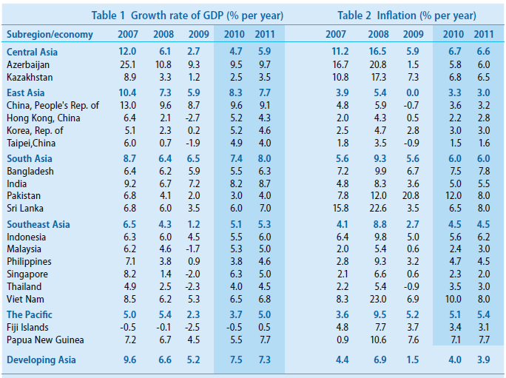

This expectation of Asian recovery has got a strong support by the paper published in July 2010 from the Asian Development bank. The ADB revised upwards the ordinary GDP growth forecast to 7.9%, up from the 7.5%. This quick recovery was driven by the buoyant exports, strong private demand and sustained stimulus policies effect. The graph below shows that the upwards revision has done in all the Asian regions.

Source: Asian Development Bank
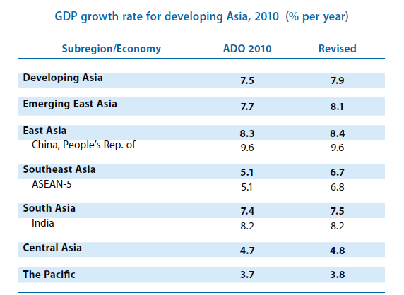

Downside risks ?
The Asian recovery has been showed clearly. However, we have to be very care of the downsides risks. For instance, the surplus of the current balance of Asian region has reduced to 4.9% in 2009 from a recent peak of 6.5% in 2007. It is also forecasted to narrow to 4.1% in 2010, and 3.6% in 2011. This situation is similar to what had happened in the Asian Currency Crisis in 1997.

To answer the question of whether the Asian Crisis would happen again or not, we now have to look at more details about the situation of 1997 and the trigger of the Currency Crisis. The next chapter will explain the Asian Currency Crisis.

Part 1
The Asian Currency Crisis of 1997: Its causes and structure

The Asian Currency Crisis of 1997 was not just a cause of sudden shocks, but it is rather a combination of structural problems (underlying causes) and Initial triggers. In this part, we will first discuss of the structural problems which had resided in South East Asia prior to the crisis. Then, we will examine which were the Initial Triggers that lit up this crisis.

- Underlying Causes of the Asian Crisis
There were basically 5 main underlying causes which had been accumulating during the years prior to the crisis. They are: 1) Unsustainable Current Account Deficits, 2) Over-Dependence on Short-Term Foreign Funds 3) Poor Regulations of the Economy 4) Over-Inflated Asset Prices 5) Macroeconomic Policy: Fixed Interest rates.

1. Unsustainable Current Account Deficits
Most of the South East Asian economies had large current account deficit, which was financed by inflow of foreign, and often short-term capital. This was due to a rapid liberalization of capital in the region, which has already been warned by some academics that immature opening of the capital would increase the economy’s vulnerability to external shocks (Sebastian Edwards, Capital Controls, Exchange Rates and Monetary Policy in the World Economy).

2. Over-Dependence on Short-Term Foreign Funds
Due to the lending boom in the South East Asian countries, domestic banks dashed to foreign funds to finance the lending. This was in part motivated by the idea that they could take advantage of fixed exchange rates. Excessive leverage in foreign liabilities had taken place. Also, the fact that most of these loans had been of a short-term was the problem. Around 60% of outstanding loans in the Asian tigers had been of a short-term, which asked for the banks’ accounts to be very liquid. The domestic banks had overlooked the problems and risks that reside for depending so heavily on foreign-short-term debts.

3. Poor Regulation of the Economy
Poor business regulations in the Asian developing countries possibly led to the development of corrupt relationships. For example, “chaebol”, which is a term that refers to Korean conglomerates, usually had a banking sector in them, which typically led to “connected lending” between the group companies. This caused a lack of risk examination in lending, which in part fueled the investment boom.

4. Over-Inflated Asset Prices
The rapid, or too rapid increase of money supply, had driven the asset prices to an unrealistically high level. Since the real economy was not able to absorb all of the increase, the excess credit that occurred had fueled speculative booms in many areas. Over-Inflated asset prices had made the firms look more sound than they actually were.

5. Macroeconomic Policy: Fixed Exchange Rates
Fixed exchange rates, or dollar-pegged rates, had basically made people mistake their real values. People had misunderstood that these countries’ fixed exchange rate was a guarantee of exchange value, and overseen the possibility of devaluation against the dollar. This has led to increase in foreign currency exposure, leaving them more vulnerable foreign exchange risks.

B. Initial Triggers of the Events in South East Asia
The 5 Structural problems we have noted above was not something that would render us suddenly fleeing in herds from the Asia region. There were some triggers which ignited the uneasiness in us about those countries to explode. There were basically three kinds of those triggers: 1) Changed sentiment amongst investors in South East Asia 2) Speculation by participants in the currency markets 3) contagion

1. Changed Sentiment amongst Investors in South East Asia
Sudden shift in investor sentiment had fast and cumulative effects. Similar effect had also been seen in 1994 crisis of Mexico.

2. Speculation by Participants in the Currency Markets
Excessive speculation by market participants had a negative effect in the lead up to the crisis. Since international investors such as commercial banks, investment banks and hedge funds had taken short positions against the baht, it was viewed by the market as providing a one-way bet considering weak fundamentals and other negative facts.

3. Contagion
Contagion or the spillover effect was a factor that is needed to explain its wide spread around the world. The scale of this spillover had never been seen. This was, in part, due to the irrational reactions in financial markets, where people did not see asian countries by their underlying economic situations but saw those asian tiger countries as a group and irrationally fled from them all.

Although there were many structural problems that mostly occurred from Asymmetric Distribution of Information, preventing periodical financial turmoil is an “if” story. However, preparing to react fast to the early stages of financial crisis and to subside it before it gets worse, is a very much needed means of damage control.
Thus, there is a strong rationale for the International Lender of Last Resort. Especially during the 1997 Asian Financial Crisis, central banks of the developing countries were not able to provide enough funding support so that lending channels could re-open. IMF was not able to act as they were expected to, which later called for a need of Asian-IMF and other measures to provide an international lender of last resort. The problem is that it takes many difficult negotiations by the Asian countries, and is hard to actually materialize. It would take much more time than we expect to see the foundation of Asian-IMF, if it actually does reach that stage.

Part 2
Crisis prevention measures and its outcome: the case of Korea

In this part, we will look at Korea as an example of how the severely damaged countries from the 1997 crisis, or the so called Asian Tigers, implemented measures to prevent the next crisis and how they are performing. We will focus on Korea, which ran into a near crisis again in 2008, to talk about how the most important measures for preventing another currency crisis in Asia has not yet been introduced.

・Backgrounds of the Asian Currency Crisis of 1997
In a retrospective view, we are now able to acknowledge that Korea’s crisis in 1997 was not just a matter of shock transmission from other Asian countries, but it had more to do with its own structural problem. In the couple of years that led up to the crisis, Korea’s productivity has been in a decline, due to reasons such as rise in wages or stagnant technology development, etc.

・Korea: After the Crisis
After the crisis, Korea introduced reform plans in Financial/Corporate/Public sectors, which turned around GDP growth from -6.7% in 1998 to 10.9% in 1999, and 8.8% in 2000. They have also paid off the $1.95 billion rescue financing by the end of 2001, and while it had $18 billion of total foreign liabilities in 1997, since 1999, they have turned into a pure creditor nation.

Reform in the Financial Sector
Objective of this reform was to restore the markets confidence towards Korean financial systems and to develop them as a international industry through improving its competitiveness. To start with, the government introduced a policy to meet the international “Best Practice”. The idea was that transparency would work to improve the supervisory functions of financial markets, which would help introduce more strict accounting standards.
Before the eruption of the crisis, supervision of financial institutions had been in charge by two different authorities: Banks by the Authority of Bank supervision, and general financial institutions by the finance and economy division. To be able to take more comprehensive control measures, Financial Supervision Committee has been built in 1998to take over those roles.
The government has taken sound financing measures such as capital injections for disposing non-performing loans, management reform, company mergers, etc., to improve the soundness of domestic commercial banks, which only 13 out of 25 banks were able to satisfy the BIS’s requirements of 8% Capital Adequacy Ratio. In doing so, authorities had closed down non-performing banks through transfer of bank’s assets and liabilities.

・Main features of the Financial sector reform
-Government-lead reforms
Korean financial sector is traditionally controlled by government authorities.
-Increase in the foreign investment ratio
This could also be said about other countries such as Thailand and Indonesia
-Increase in unemployment
As a side effect to the drastic reform, unemployment rate increased to 8.7% in 1999

- Liberalization of the Capital Market
Government acknowledges the need to unite domestic markets and international markets, thus acting to develop the Capital Market via 2 related measures. Since liberalization of the capital market would directly improve the access to foreign assets/technologies, and also because enlargement of the market is thought to improve the efficiency of capital market management, government started a program which focuses on rapid liberalization of the capital market. The details of this program includes: abolishment of stock purchase limitations against foreigners, abolishment of foreigners’ limitation against investments in securities/short-term-financial-assets, etc. The government was also active in promoting direct investment that M&A was liberalized and foreign currency exchange limitations have also been alleviated. Also to note, domestic real estate market was opened to foreigners.

Reform in the Corporate (Chaebol) Sector
・8 basics to corporate sector reform
1)Transparency of corporate management 2)Resolving of mutual liability assurances 3)Drastic improvement of fiscal structure 4)Designating of core division 5)Reinforcement of management responsibility 6)Improving management structure in the sub-financial sector 7)Restraining circulate investment 8)Shutting out illegal internal transaction

- Main points of the Chaebol Reform

・Lowering the high liability rates and improving the fiscal structure.
Korea’s conglomerates, known as “Chaebols”, had been depending too much on external funding such as political finance to help out their expansion. For that reason, they were under high liability rate and possessed a weak fiscal structure prior to the crisis. The total liability ratio of 30 large chaebols combined in 1998 was up to 519%. But by dispersing some assets/subsidiaries, combined with lay off acts to shrink the size to an adequate level, the number had finally gone down to 174%. These kinds of reforms and the chain reaction bankruptcies of particular chaebols took its toll on mainly the middle-sized-chaebols, which eventually led to the concentration of economic power to the 4 large chaebols.

・ “The Big Deal”: dissolving excess diversification and “Concentration on Core Competence”
Under the guidance of Korean government, “The Big Deal”, or the large-scale industry reform/concentration plan had gone under way. As a result, rolling stocks and electricity generation facilities had become controlled by monopolistic company, and other industries such as semiconductor or aircrafts had been controlled by oligopolistic companies, which held a risk of the market being competition restrictive. Also, while trying to resolve the excess diversification, industries where the government established a general corporation to manage their business had born unclearness in the management which eventually led to a labor dispute.

・Reinforcement of corporate governance to strengthen management supervision

To stop the arbitrary acts by large stockholders and make corporate management more transparent, small stockholders’ rights had been strengthened. Also, the government acted to reinforce the powers of the board of directors, focusing on restraining dictatorial decision making by the group leader. They made an effort to introduce and expand outside board member system, and finally included them in the law, forcing listed companies to designate at least one person, and more than half the board members in companies with 2 trillion won or larger assets from outside of their company. And the government also progressed on working to improve management transparency and disclosure by making companies to release combined financial statements.

・Résumé of the reform
The government had implemented many new programs from 1997. They were mainly focusing on problems such as resolving of mutual debt assurances, improvements about transparency, reinforcement of stockholder rights, improvement in shareholders’ equity, strengthening of cooperation between large and small-to-medium firms, etc. Also, the largest goal of the Corporate Sector Reform was the reorganization of mega-company groups through employee lay-offs. In 1998, management of 5 chaebols took care of this matter, by orchestrating large-scale business swaps which are now called “The Big Deal” so that each industry would be concentrated to one group, allowing them to slim-down the number of employees in these core competence. “The Big Deal” was a suitable way of concentrating their power on core competence and slim down the excess production capacity and redundant investments, building a highly efficient management structure.

Reform in the Public Sector
Since the inefficiency in the labor market had been nagging the whole economy and its competitiveness, government had concentrated on preparing a social safety net, while attempting to improve the flexibility of the labor market at the same time. By the passing of the revised Labor Standard Law, the labor market had increased its flexibility, which allowed the corporate sector to lay-off some of its employees and instead strengthen their competitiveness. Although this has increased unemployment in Korea and that the government is planning to take care of them via social safety net, it has to understand that eventual reform of the customs between the labor union is necessary. The government seems to acknowledge this matter, and that there resides a large and deep distrust between the two sides, since they have started a labor-management board which consists of members from the employees, management, and the government.

Overall
Korea’s GDP growth plunged from 5.0% in 1997 to -6.7% in 1998, but incredibly united Korean citizens had realized an unbelievable economic recovery, which raised growth rates to 10.9% in 1999. There is couple of lessons to be learned from Korea’s experience. First of all, we should remind ourselves of the stability in external balance. Increase in external deficit was one large factor which hurt the trust for Korea, leading to rapid outflow of money and the eventual crisis. Secondly, although non-performing companies have been taken care of and financial institutions were able to continue on after government injected money into them, both the Corporate and Financial Sector must improve their profitability in the long run and hold high competitiveness. Lastly, we should not underestimate the power of social unity on restructuring. Korean citizens’ strong unity and vitality during the first stages of the crisis had definitely helped restore trust towards Korea. Episode of people giving up their assets like gold and giving it to the government so as to help them improve the lowering foreign reserve tells us how united and focused they were.

Korea: near-Crisis of 2008
In this section, we will discuss about the near-crisis state that Korea fell in, following the Lehman Shock in 2008. Although Korea had taken the above reforms and measures to recover from the shock, and has actually retrieved their high growth rates, those measures itself had brought another structural problem to the Korean economy.

- Causes and Consequences of the Liquidity Crisis

  - Structural Weaknesses of the non-financial sector
Heavy dependence on export markets makes Korea vulnerable to global trade shrink. One weakness is that there is a wide-spread perception that Korea is bound to see its potential growth falling off, and lose its share of the global export market. Another weakness is that Korea’s exports are concentrated to limited number of manufactures and producers. 57% of total exports were shipped out by four industries ( automobiles, ship building, electronics, chemicals) in 2007. Global demand for manufactures is more income elastic than other categories of exportables and hence more sensitive to cyclical fluctuations. This is one reason why once the full recovery began Korean output growth had dramatically accelerated.

  - Deterioration in Financial Indicators
A major reason why foreign investors herded away from Korea was the deterioration in some financial indicators.
- Rise in foreign short-term debt
At the end of 2008, Korea’s short-term foreign liabilities had increased to 97% of foreign exchange reserve in BOK. It is close to overstepping the G-G-S rule, which claims adequate reserve proportion is the same amount of total short-term foreign liabilities. This also shows in the increase of loan-deposit ratio, which had risen to 125% by the time the crisis erupted. These changes indicated a sharp deterioration in maturity mismatches in the foreign assets and liabilities of bank balance sheets, borrowing short from international financial markets and lending long to domestic borrowers, making them vulnerable to the drying up of US dollar liquidity.
Moreover, increase in maturity mismatch had been accompanied by a rise in the currency mismatch. One reason to this currency mismatch was brought by undisciplined capital account liberalization. The amount of foreign currency liabilities in the Korean banking sector at the end of 2005 was $83,429 million, but it had more than doubled to $194,045 million in two years. Non-bank financial institutions were equally active in borrowing from abroad, that their external debt had jumped from $88,920 million at the end of 2005 to $134,808 million two years later. This has been due to the effect of deregulation of capital outflows, which the government implemented to help cut the rising cost of sterilization. It resulted in the massive outflow of capital in the form of portfolio investments in foreign securities. Korea’s total portfolio investments abroad had stocked up to US$16.7 billion in 2005. It has continually increased, and the amount had doubled to US$31.3 billion in 2006, and near double again to US$56.4 billion in 2007.
As a result, the demand for US dollars and other foreign currencies grew rapidly, and at the same time, Korea’s policy authorities continued sterilization operations. This had added another $50 billion to the central bank reserve, which has made the availability of US dollar liquidity to shrink in the local foreign exchange market. This would usually result in the weakening of the currency, but the excess demand of US dollar had been met with the capital inflows as banks and other financial institutions financed major parts of their foreign investment by external borrowings, and as previously noted, especially in the form of a short-term debt.
This would not have been much of a problem under normal circumstances where enough liquidity would enable them to rollover those debts, but during the period of liquidity crunch that followed the Lehman Shock, they were not able to roll them over. Also, those statistics stood out as a risky indicator to the foreign investors. While they were deleveraging and fleeing for quality, some of the large global players must have concluded that Korea was a riskier place than other developing countries in East Asia, followed by other players that just simply joined his herd.

-Deterioration in the soundness of the banking sector
While the financial market was under serious maturity and currency mismatches, there also came a large drop in bank profits during 2008. This was brought by a substantial increase in non-performing loans and the funding cost at commercial banks. Since the Asian crisis, Korean banks had shifted their target of lending to households and small and medium sized firms, away from the chaebol affiliated companies which were sitting on large amount of cash reserve and could not look for high interest. The total volume of household loans by all financial institutions had extended to 73% of the GDP, almost double from the 40% when Asian crisis broke out. Large part of those household debts went towards the financing of housing during the 2005-06 bubble periods, but the performance started to deteriorate in the following years. The share of substandard loans in total commercial bank lending had doubled between 2007-08, and although the share of non-performing loans were not so much alarming compared to September 1999, when there was a surge in non-performing loan ratio, foreign investors seemed to have took it as a sign that there was a serious deterioration in bank profits and soundness.
Also, ever since the government introduced financial market deregulation after the Asian crisis, increasing number of deposit customers had fled to the short-term money market to seek for high yields. This left banks to rely much more on high cost wholesale funding through the issuance of financial instruments. This move resulted in the rise of the loan-deposit ratio and a decline of net interest rate margin, which cut into bank profits. After tax bank profits had declined to less than half of what they were in 2007. These statistics definitely did not help in stopping the foreign investors’ sentiments to move away from Korea.

2. Economic Downturn and Liquidity Crisis: August 2007-June 2009
In retrospect, although Korean economy had been on a down turn since 2007, effects of the American sub-prime crisis did not reach them until the third quarter of 2008. During the first three quarters of that year, consumption and investment demand did not show much sign of recovery, but the exports had be driving the economy as it grew by 23.1 % and 27.0% in second and third quarters respectively. However, once the global recession starts in October, exports started to contract. It had fallen by 19% in November, and 18% in December compared to the same months of 2007. It was becoming evident that weak domestic demand, which had been largely affected by the governments tight stance of monetary and fiscal policy, and the drop in export would put Korea in a deeper than expected recession.
However, it was first seen that Korea must be well braced for deflecting or adjusting to the crisis without too much damage. They did have a large amount of foreign exchange reserve, which was up to $260 billion at the end of 2007, which was thought by many at the time that the amount was greatly excessive. Also, authorities were expecting for the flexible exchange rate system to provide a first line of defense, unlike the situations of 1997 Asian crisis. Yet, Korea was not able to steer away from the US dollar liquidity crunch, which provoked a series of speculative attacks on Won for six months following October 2008. It did not come to an end until they secured additional foreign currency liquidity from the central banks of Japan and China.
The crisis was sparked off by basically panic and herding among international financial market participants, which seems to have been exacerbated by some of the structural weaknesses of the financial sector, as we have already noted. One of the information which probably stimulated the international financial market participants was the rapidly dropping stock prices and their high volatility, combined with a sharp depreciation of the interest rate.

3. Maturity and Currency Mismatches
One of the similar points about the 1997 and 2008 crisis in Korea was that both had been a result of suffering from mismatches in the financial sector. As it is widely known that 1997 Asian crisis occurred due to currency mismatches. However, the 2008 crisis had its weight more on the maturity mismatches, and currency mismatch came as an effect of maturity mismatch. When emerging countries such as Korea open up their financial markets and start to suffer from maturity mismatches, it invariably accompanies currency mismatches, which just creates more serious systemic risk.
As we have been discussing maturity mismatches as something of a serious problems, but what we have to acknowledge is that all banks must somehow engage in maturity mismatches, as banks offer themselves as a efficient way of bridging the gap between the maturity structure where individuals have a preference for liquidity while profitable opportunities takes long time to pay off. Especially in the recent years, financial market deregulation in emerging economies have created a large variety of short-term money market instruments, which attracts and lures bank depositors with its high yields, meaning banks must now gather liquidity from the wholesale funding markets.
As banks and other financial institutions’ dependence on wholesale funding increases, so does the risk of not being able to roll over short-term funding. When there is a squeeze in the short-term market under those highly dependent situation, banks must liquidate their assets whether it is not preferable profit wise. And when that is not enough, they would ask for help to the central bank, in this case the Bank of Korea. BOK would be able to inject liquidity to those institutions in most cases, but when the banks are in need of US dollar liquidity, they can only inject limited amount, or the same amount as the foreign currency reserve. This is how both maturity and currency mismatch runs up at the same time.
Preventing those mismatches is quite a difficult task. There are basically two ways to prevent them: private precautionary measures, or regulatory restrictions by the government. The former includes plans such as liquidating their foreign assets, or securing contingent lines of credit from foreign banks, but Korean financial institutions did not have many foreign assets in the first place because funding costs were high for a developing country like Korea, and contingent line costs too would be of high cost that will harm their competitiveness. As for regulatory restrictions, too much restriction would limit the actions of even the well performing banks and financial institutions, impeding their access to international financial market. This could be said about other emerging economies as well. They must face a dilemma between high crisis risk high growth, or mitigated risk but low growth.

<Need for Global Lender of Last Resort>
It has been said of the needs since the 1997 Asian crisis, but there is still not much improvement regarding foundation of a new Global Lender of Last Resort. Like the case of Korea’s crisis in 2008 subsided after swap agreements with Unite States, Japan and China, panic would not seize until market is assured that the country would be supported by some kind of lender of last resort. In this case, swap line with the United States was basically working as a de facto standard global central bank, which was instrumental in turning around the pessimistic outlook. In most emerging economies, the central bank might not be able to supply enough foreign currency liquidity to stop a run on their financial system. A large amount of foreign reserve might do, but there is currently no way of defining the adequate level of reserves a central bank must keep. We could notify what it means by looking at this crisis in Korea, where they amassed $260 billion foreign currency reserve which was often criticized to be too large of an amount prior to the crisis.
Thus we must consider founding a Global Lender of Last Resort, or at least a regional version of it to help the development of Asian developing countries. In that context, we could note of the CMIM, or Chiang Mai Initiative Multi-lateralization. It was created as a regional mechanism for liquidity support and policy coordination by the ASEAN countries and Korea, China, Japan after the 1997 Asian crisis. It has since been restructured into a reserve pooling arrangement known as the CMIM. It has been agreed under determination by the member countries to offer assistance to members suffering from a short-run balance of payment problems, but it is not working as it was originally intended to be. Its reserve pool has increased to $120 billion, but the complicated process of lending and decision making makes the mechanism hardly noticed by the market. The mechanism’s development process will be in a halt unless Japan and China, the two largest members of CMIM, will be on the same page and demonstrate strong leadership in development measures such as enlarging the pooling of reserves or speeding up the disbursement process. Without those kinds of improvements, CMIM will be long forgotten by the market.

As we have observed through the experience of Korea from the 1997 post crisis era to the new crisis in 2008, it gives us a lesson that it is highly difficult for developing countries to totally negate the risks of another financial turmoil, as long as they’re seeking for strong economic growth. Korea was a good example of a developing country which altered many structural problems after the 1997 crisis, again pursuing and materializing strong and rapid economic growth. But as we have repeatedly mentioned, finding/creating a new Global Lender of Last Resort would be a key to mitigating financial crisis risks, and promoting financial liberalization in developing countries to pursue their growth. In a highly and complicatedly connected international financial market, any kind of sudden asset flights could give severe shocks to developing countries’ financial markets. We should strongly keep in mind of the risk of another financial crisis, and pursue ways of risk-hedging such as finding a new Global Lender of Last Resort.

Is the bubble forming in Asia now?
So in this part, we will testify either Asian countries are in danger of forming bubble, or in a stable economy. In the first part, we will give some economic trends in the Asian countries. And then we focused on three countries, South Korea, Thailand, and China. We chose China first, because its economy has been bolstering up and so attracting the world. Now, it is a clear fact that Chinese economy has been triggering the world economy and therefore a key country. Then we chose Thailand and South Korea because they have experienced both Asian currency crisis and similar danger in the year 2008. As we have described in the former paragraphs, we concluded that those countries are still not fully ready for another bubble yet. Considering this, if there is a sign of a bubble in those three countries, there will be an immediate policy change or some protections. Next we will define why we chose these three indicators for judging whether there is a bubble or not. The first indicator we chose was the change in the housing prices of each country. The financial crisis that started in the United States was due to the fact that real estate was the prime target of investment. The bubble bolstered the total of every house in the United States by 30%. It is obvious that an overheated real estate sector will produce a bubble. The second indicator is the inflation rate. The inflation rate is indispensible to economic growth. But too much of it will produce trouble in the economy. If the inflation rate is higher than the interest rate, the liabilities will decrease, leading to too much investment. And the last indicator is capital inflow. We chose this because the excessive capital inflow into a country is one of the causes in the past financial crises. Preventing an overflow will be important in maintaining a healthy financial sector. Now let’s see the overall situation in East Asia.

Current Situation in East Asia
Inflation: Developing Asia has successfully recovered from the economic turmoil due to its efficient fiscal stimulus packages, while other area such as Europe and America are still struggling. However, these packages have a secondary effect, an inflation pressure. ADB 2010 projects that there are mild inflation of 4% in 2010 and 3.9% in 2011, relatively high with 1.5% in the previous year.
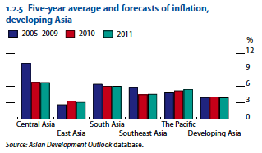
There are mainly two reasons for the high inflation rate. First, unusual high interest rate relative to those of other industrial counties is attracting foreign investors and thus letting huge capital inflows. Second, is simply the rise in commodity prices.
Non-oil commodity prices such as food and energies are increasing mostly triggered by the recovery of emerging markets. The prices once dropped sharply after July 2008 due to the crisis, but it has robust quickly. The speed of increase in such prices are much faster the than average of that during 2005-2007, just before the catastrophe. In the first quarter of 2009, energy commodity price index has risen 57% from a year earlier, the metals and minerals price index has also increased 46% in January 2010, compared to the same period last year. Quick recoveries of Developing Asian countries are triggering the demand for industry activity and further price index increases are expected. Although the gap between demand and supply is large, inflation is still under control in most countries. In developing Asia, huge output gap let to a sharp decline in inflation. Most of the East Asian countries record flat in inflation rate, PRC and Taipei recording deflation. Current inflation has almost stopped in South Asia and Pacific, Southeast Asia decelerated by around two-thirds. Central Asia seems to have a high inflation rate of 6%, but it is the lower than the average of the past 5 years.
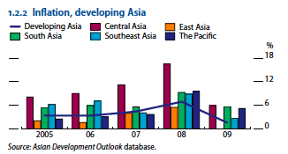
Therefore, there is a little concern about inflation in developing Asia, but if commodity prices keep rising up at the current speed, producers will limit the export in names of protecting those commodities and this will lead to a inflation pressures.
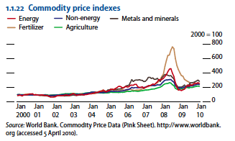
Thus, Asian policy makers must watch carefully on these index.
Capital inflows: when developing Asian countries conducted a successful policy change, such as putting interest rate at lowest level, in order to get recovered from the crisis aftermath, those counties has sucked in a huge amount of capital inflows. Those inflows were mostly brought by banks, especially in Hong Kong, China, Korea and Taipei, reaching about $46 US billion.
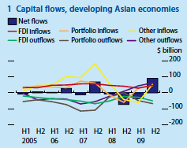
Huge capital inflows were caused by both low interest rate and currency revaluation expectations. Continuous capital inflows will bring huge risks to ones countries, including excessive liquidity, economic overheating, asset bubble and of course, the fragility of financial stability. Central bank can hedge this risk by limiting the inflows, but this might cause an overvaluation in real exchange rate in the further future. Asset price such as property and stocks has been already rising up in China and Hong Kong. In Haikou and Sanya, China, property prices have been increasing at around 50% in just over a year. Hong Kong also marks 28% rise in a same period. Moreover, MSCI Asia Pacific index has risen 78% from March 2009 to March 2010. There is a sign of appreciation of exchange rate in some countries including Indonesia, Korea and Thailand. However current intervention in the market has well functioning to limit the degree of appreciation.
Now, we will focus on three countries.
China
China is leading the Asia-Pacific region in the recovery from the global financial crisis in the past recent years. But the monetary easing implemented to give the economy a boost has also helped real estate prices and other asset prices to rise as well. Will this trend create another bubble, and consequently another financial crisis, this time starting in the Far East? This section will look at the recent trends in the Chinese markets.
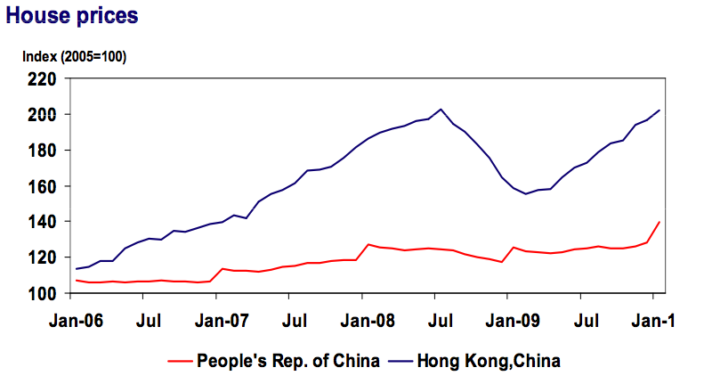
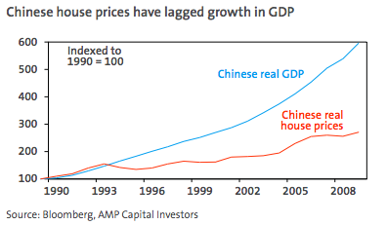
As shown in the above graph, the housing prices in China as a whole has risen up to a level close to that of the index before the Lehman Shock occurred. But when you compare the growth rate of the GDP with the house prices in the lower graph, one can see that the housing prices have a much lower growth rate than the GDP. In contrast, the Australian housing prices rose by 13.6% while the GDP growth rate was near zero. Looking at the housing price only, the signs of a new bubble are not present.
Besides, even if the Chinese real estate market was a bubble, it differs from that of the Japanese and the Americans. While the latter two countries suffered from the rocketing prices from the commercial real estate market in a slowing economy, the Chinese are looking at price increases for the residential houses in just a few cities.

What about inflation? With bold stimulus packages executed by the government, the Chinese market has been marking annualized inflation rates of up to 4% for the past six months, just near the average of developing Asia. This could be seen on the graph below. But the rate is not unmanageable at this stage. Tightening the monetary policies designed to combat the financial crisis will help keep the market in check. But tightening the policies will face opposition that insists for more growth in the economy. So even at this point, the collapse of China is not imminent yet.
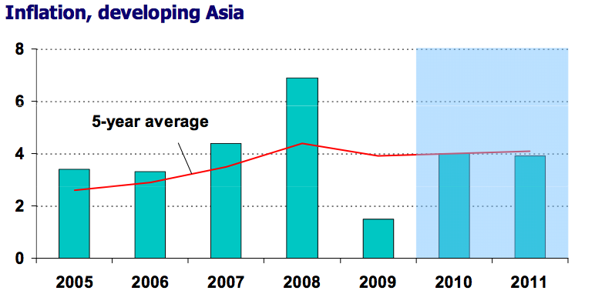

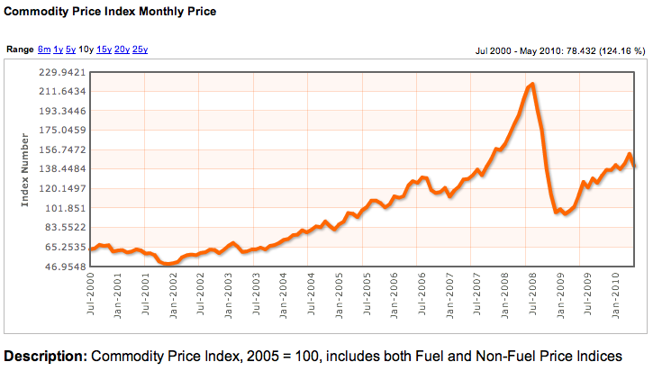
The above graph shows the commodity price index for the past ten years. With the quick recovery of Asian countries, the commodity prices are likely to rise even more, nearing the levels before the crisis. This factor, along with the recent pressure for wage increase could cause the inflation rate to rise to unmanageable levels.
Thailand
Due to the political unrest along with the global recession, the economy of Thailand contracted by 2.3% in 2009. As with other South East Asian countries, the decline in export and foreign investment leads to the stopping of the economy. The former was caused by the global downturn, the latter by the political unrest.
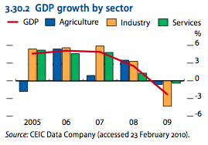
Source: Asian Development Outlook 2010

As seen on the graph above, the decline in the industrial sector is critical compared to the other sectors. In the first half of 2009, exports fell by nearly 25% compared to the previous year. But now that the export has been on the rise since late last 2009, the economy will be able to get back on track in 2010. As the economy recovers and capital flows in from all over the world, questions about a new bubble pop up. This section will look at the possibilities of a new bubble in Thailand.

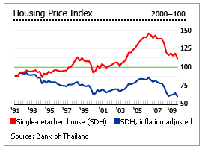
Source: Global Property Guide

The above graph shows the housing price index for the past 20 years. As one can see, the price of housing has not yet recovered to the level before the Lehman Shock. One-fifth of the housing price was knocked off when the global recession occurred. In fact, the only country in the region that has their real estate prices higher than the peaks before the Lehman Shock is China. The region as a whole is still suffering from the recession. According to Global Property Guide, “political turmoil has made Thailand significantly less attractive to buyers, especially to foreign buyers. CBRE reported that foreign demand for residential properties had dropped by up to 90% by June 2009. Real house prices in Thailand were 34.2% below their 1992 peak, as of Q2 2009.” But ever since the turmoil has ended this year, the amount of capital inflow has picked up again, as $2.17 billion flowed in June 2010. This will put pressure on inflation, which has been negative ever since the Lehman Shock occurred in 2008. The decline in the inflation rate can be seen on the graph below. The Asian Development Bank forecasts that the inflation in Thailand is going to rise to 3.5% in 2010, due to rise in fuel and food prices. If the Bank of Thailand raises the interest rates, a bubble will not appear in the near future.

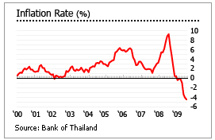
Source: Global Property Guide

To conclude, as the above indicators show, the economic situation in Thailand hasn’t reached the point where people can call it a bubble. Full-scale recovery has just begun and the government doesn’t need to tighten the grip on the economy yet. But as the recovery progresses, too much capital inflow will put risks on the economy. China is facing this stage, and the government is being put to the test to balance growth and safety at the same time.

Republic of Korea
Korea is one of the few countries that recovered from the global recession at the earliest stage. Fiscal stimulus plan and dramatic increase in export drives their economy, which is expected to go on during 2010 as well. After performing lowest output in the fourth quarter of 2008, Korea marked a strong recovery since 2009. GDP grew by 0.2% in the year, much better than other countries, which are hitting negative growth.
Inflation: Although excluding the external conditions such as oil price, the consumer price index decreased from the previous year’s 4.7% to 2.8% in 2009,due to the decline in commodity demands. The Bank of Korea has set up its inflation target between 2.5% to 3.5% during its mid-term inflation target period (2007-2009) and real inflation was within the range, 3.3%. thus, the actual inflation rate after the global financial crisis was rather higher than its range, and now it is within the it. Even though the yearly average marked 2.8%, when looking at by quarterly data, there are gaps. the inflation rate of the first quarter was 3.9%, keeping still high range. This was affected by the rise in won-dollar exchange rate and agricultural product prices. The average of the latter quarters was 2.4%, relatively compared to the first quarter owing to a base effect following a increase in international oil prices during the same period of 2008. Korean inflation target policy and some external conditions have been helping the rate to keep stable recently, however, in the other way around, this proves that it could be a hard fluctuation in a short period of time. There are both internal and external facts that Bank of Korea needs to watch out carefully as market speed and volatility is much faster and bigger recently. Asset bubble: real estate market has been very stable in the recent periods due to the effects of the crisis and appropriate policy at an appropriate time, conducted by the government. The housing price was rising up 3.1% in the year 2008, but its speed fell to 1.5% at the end of the last quarter in the same year. During this time, Korean government has enforced tighter mortgage loan regulations. GDP during the year 2008 was 2.3%, and to nip the bubble bud, government usually has to control the growth of the housing price under its GDP growth rate. This was probably why the government has strengthened its regulations. However, housing rents rose by 3.4% during the same period, increased 1.7% from the year 2008 as the imbalance of demand and supply especially in the centre of Seoul.
Capital inflow: capital account has hugely changed over the year 2008-2009, the former year has recorded a deficit of $50.1 billion to a surplus of $26.5. this was due to a large capital inflow for foreigners stock investment.

Conclusion
This paper went over the possibilities of another bubble in Eastern Asia this year by comparing the situation with the Asian Currency Crisis, which happened a little over ten years ago.

Part 1 went through the 1997 Asian Currency crisis by looking at the underlying causes and the triggers, which brought the whole region in to panic. The globalization of capital has made it easier to mover money to and from countries. The Asian Tigers, which showed great potential for growth was the target for international investors to put short-term funds into. Poor macroeconomic policies along with the over-reliance on foreign fund created the foundation for a currency crisis.

Part 2 saw how countries tried to prevent future panics and how it performed against the recent financial crisis by looking at the case of South Korea. South Korea set forth several large policies to turn around their economy. Reforms in the public and private sectors were done in order to rely less on foreign funds and to regain confidence in the financial sector.

Finally, the last part, Part 3, looked at three countries and their possibilities for another bubble this year. By analyzing the housing prices, the inflation rate, and the commodity price, we determined whether another bubble will occur or not in the near future.

In conclusion, none of the three countries that this paper looked at has a high possibility of another bubble coming this year. China still has the power to grow it’s way out of trouble, Thailand has still yet to recover from the political unrest, and South Korea . But although these countries don’t have to fear an imminent bubble, they still need to be careful about their policies.

Bibliography
Asian Development Outlook 2010 by Asian Development Bank

Asia Pacific Property Digest by Jones Lang LaSalle

Asian Perspectives by PIMCO

Arcadia Market Commentary by Arcadia Financial Services

Asian Property Markets by Deutsche Bank Research

2010: Year of the Tiger or Asian Bubble? by Wells Fargo

Is China a Bubble that’s about to Burst? by AMP Capital Investors

Asia Capital Markets Watch by Asian Development Bank
Yung-Chul, Park. “Global Economic Recession and East Asia: How Has Korea Managed the Crisis and What has it Learned?”, Bank of Korea Working Paper
Karunatilleka, Eshan. “The Asian Economic Crisis”, House of Commons Research Paper 99/14
Hiroshi, Akama. Kunihisa, Noro. Hiroko, Tada. “On Korea’s Financial Sector Reform” Bank of Japan International Department Working Paper Series 02-J-3.
Mishkin, Frederic S. “LESSONS FROM THE ASIAN CRISIS”, NBER working paper series, Working Paper 7102

Special Note “Developing Asia’s Recovery Gains Momentum” July 2010, Asian Development Bank, http://www.adb.org/documents/books/ado/2010/ado-special-note-2010.pdf

