Forecasting Economic Bubbles

GPAC 2010, Vietnam
Seoul National University
Macroeconomics Team

Kyounghoon, Yoo
Youjin, Ahn
Sunyoung, Ahn

Contents

Ⅰ. Introduction 1
Ⅱ. Forecasting failure and patterns with three economic bubble cases 2
1. Summary of three economic bubble cases 2
2. Bubble Patterns 8
3. Predictors who forecasted right or wrong 9
Ⅲ. Reasons making accurate economic forecasts harder 12
1. Human irrationality 12
2. Unpredictable government policy 13
Ⅳ. Suggestions 14
Ⅴ. Conclusion 15

Ⅰ. Introduction
In 2008, there was great fear around the world because of the financial crisis triggered by housing bubble bursts in US. Forecasting bubble in right direction is important because countries are linked in many ways especially in financial system. With wrong prediction, there can be huge losses and suffers all in the world as we saw in the recent global financial crisis. In this paper, analyzing three bubble cases will be followed by the reasons why forecasting was failed and better forecasting suggestions.

Ⅱ. Forecasting failure and patterns with three economic bubble cases
Three recent bubble cases represented below are for examining the reason why professionals could not prevent bubble burst in advance.

- Summary of three economic bubble cases

  - US Housing bubble in 2007

The housing bubble of the US which reached its peak in 2006 has been said to be the main cause for the financial crisis of 2007-2010. The price of the typical American house had increased by 124% from 1997 to 2006. The rapid increase in house prices led the price-to-disposable household income ratio reach an unprecedented level in the markets. As a representative measure of affordability, this ratio had hovered around an average of 4-to-1 for the past 30 years. In 2007, it zoomed to nearly 6-to-1 in year 2007. This figure was 3.6 standard deviations from its average level, meaning that if the data had a normal distribution, the odds of the price-to-income ratio reaching this level would be less than 1 in 300.
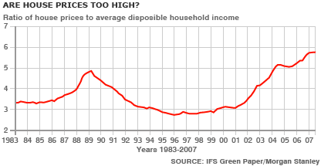
Roughly a quarter of the jobs created since the 2001 recession had been in construction, real estate, and mortgage finance and consumers had withdrawn $2.5 trillion in equity from their homes, spending as much as half of it, thus making huge contributions to the growth of the U.S. economy. However, such high asset prices could not be maintained and when the housing prices started falling in early 2007, vast damage to the U.S. economy was inevitable.
There are many different reasons stated for the current housing bubble. To see this, we should first look at why money pooled into the housing market and how the investment grew out of control.
From a domestic perspective, the crash of the dot-com bubble made investors shy away from risky stocks and prefer less risky investment such as houses and easy credit conditions made it easier for US households to finance their investments. After the dot-com bubble crash, investors had gained rationality in investing in assets they had little knowledge on. They, therefore, turned their heads to assets they knew quite well: houses. The Federal Reserve tried to help finance these investments to sustain economy growth since the economy’s growth had slowed after the dot-com bubble crash and 9-11 terrorist attack. From 2000 to 2003, the Federal Reserve lowered the federal funds rate target from 6.5% to 1.0% and thus borrowers could pay less interest to finance their investments in houses.
From an overseas perspective, the global capital imbalance, with the US having a large current account deficit, helped add more money to the housing markets of the US. According to Bernanke, between 1996 to 2004, the US current account deficit increased by $650 billion, from 1.5% to 5.8% of GDP. To finance the deficit, the US government borrowed from abroad, mainly from account surplus countries, including China and Japan. These countries supplied their funds through buying of US Treasury bonds. The foreign funds supplied were used by US households to maintain their overconsumption or to finance their investment in housing and financial institutions invested these funds in relatively ‘safe’ mortgage-backed securities.
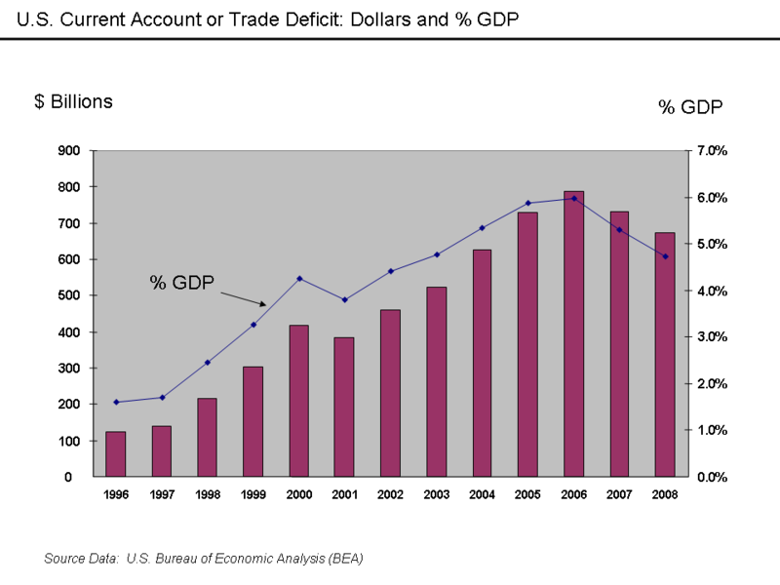

The final major reason, why so much money went into the housing market was due to public policies which pushed government-backed enterprises such as Fannie Mae and Freddie Mac to widen access to housing for the underprivileged through investments in high-risk sub-prime mortgages. People who did not have means to invest in houses before and had a greater risk of defaulting on loans, could now invest and more money was readily available in the housing market.
With a lot of money readily available in the housing market, a housing bubble was in sight. However, due to the massive rise of complex financial derivatives, flawed risk management system, over-reliance on self-regulation, the government failed to recognize the early warnings of a financial crisis looming. The development of the internet and computer systems gave rise to massive complex financial derivatives such as mortgage-backed securities (MBS), asset-backed securities (ABS), collateralized debt obligations (CDO). As financial derivatives became more complex, the nature and the magnitude of the risk involved or to locate those who bear the risk became increasingly difficult and few people understood the depth of these financial instruments. This less transparency of the market led to difficulties in assessing the true risks of these financial instruments and more reliance on mathematical risk-management systems or the ratings of credit agencies. However, mathematical models failed to incorporate fat-tail scenarios or the unpredictability of human nature and credit agencies also failed to give investors the true ratings due to wrong incentive schemes. A false sense of security was given to the investors and the housing bubble failed to correct itself. Finally the US government overly relied on self-regulation and failed to regulate the market before the bubble got out of hand. It believed that the market was self-correcting and that even if there was a housing bubble, it would soon correct itself.

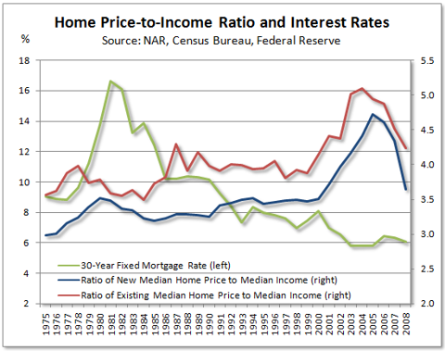

In 2007, the high level of housing prices could not be sustained and started falling. Moreover, the Federal Reserve also started to raise its federal funds reserve rate. Home-owners who had financed their mortgage loans through price appreciation found it harder to meet their payments and mortgage default levels increased sharply. This would lead to a rapid cycle of house price depreciation and higher levels of mortgage defaults. The housing bubble of US was in the initial stage of bursting.

  - Dot-com bubble in 1995

The Dot-Com Bubble started in about 1995 with the rise of the internet. Many Dot-com companies (companies that do most of their transactions through the internet) were founded during that period. Their motto was to get big as fast as possible even if they had to forego current profits in order to increase future profits. So their focus was on achieving a high growth rate. That’s why these firms started to issue IPOs to increase their capital and investments. Many investors saw the future in the internet and started to invest in those Dot-Com companies. As the demand for the stocks of the Dot-Com companies increased, also the stock prices of them skyrocketed after 1995.
The problem with the investment in these Dot-Com companies was though that, first, most of these companies lacked of fundamentals. They were engaged in daring and unusual business practices hoping to dominate the market. They presumed that in the name of internet anything can be sold online and one can become a market leader overnight. Many companies simply ignored the basic rules of due diligence of potential target market and customer base with respect to local market and needs. If an idea was successful in USA, it was assumed to be successful in other parts of the world, which turned out to be not correct. In combination to that they did not understand the concept of direct managing. Instead of basing their decisions of numbers and data, they based most of their decisions on intuition. As a result, many Dot-com companies had to go bankrupt some day. Second, many investors did not know much about technology. These investors were told that the internet would be the new frontier and that those companies that laid stake to it first would succeed. So many investors invested in these Dot-com companies although the management of these companies did not even have a proper business plan. From the irrational behavior point of view, many investors indicated a herd behavior with cognitive biases. For example, investors just followed the decisions of other investors without any reasonable reasons and invested in these Dot-Com companies just because many other investors did (irrational behavior in bubbles will be explained more in detail in the later parts of our paper). Third, the management of the Dot-com companies thought that the number of transactions would increase with the increasing number of visitors on their web page. In fact, they managed to lure on-line users to their web page, but the conversion rate was very low. The reason was that they did not want to submit their billing information through the internet because of internet security concerns. The bottom-line was that consumers did not want to pay online.
Further outside factors which led to the burst of the Dot-Com bubble was that the rise in outsourcing led to increasing unemployment among computer developers and programmers, and firms engaged in shoddy or questionable bookkeeping were caught by a series of government investigations.
After all, the bubble burst started in March 2000. The U.S. Federal Reserve increased the interest rate by six times and the economy began to slow down. The Nasdaq fell by about 10% in 5days probably resulting from a chain of sell orders of high tech stocks ( like Cisco, IBM, Dell, etc.). Before that, the Nasdaq had more than doubled its value in a year. The fall of the Nasdaq also might have been influenced by the decrease in business spending in the beginning of 2000 and by the poor results of internet retailers in the 1999 Christmas season. By 2001, the bubble was deflating at full speed. A majority of the dot-com companies ceased trading many of them never having made net profit.

  - Japan housing bubble in 1990

It is said that Japan housing bubble started because of the Plaza agreement with US in 1985. In 1980’s, US was suffering from dollar appreciation and in trouble with trade deficit. To correct the imbalance of international payments, US got representatives from 5 developed countries to gather in New York and derived a conclusion of Yen appreciation. The Japan government, fearing recession in export business fields, had implemented an easy money policy with a fall in the rate of interest since the agreement. The government also tried public investment expansion and private consumption promotion. But a series of those policies became the cause of serious housing bubble.
With so much money readily available for investment because of an easy money policy, speculation was inevitable, particularly in the Tokyo Stock Exchange and the real estate market. The Nikkei stock index hit its all-time high on December 29, 1989 when it reached an intra-day high of 38,957.44 before closing at 38,915.87. Additionally, banks granted increasingly risky loans. There were also demands for real-estates to have inheritance tax incentives.

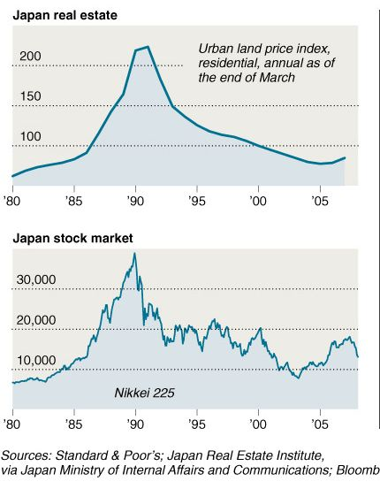

In 1986~1990, Japan was in the highest peak of bubbles. Japan was full of confidence in economic growth, and expected demands for real-estates would continuously grow. Extra capital began to enter the global real-estate market and resort developments were flourishing. But oversee investment was not successful and resort developers’ a rosy expectation of huge demand was wrong so they cannot help managing huge losses.
Sensing an abnormal situation in housing and real-estates, the Japan government tried to burst those bubbles artificially by raising the rate of interest in 1990. But that was the opening of tragedy. Bubble burst rapidly and financial systems deeply related to those bubbles collapsed followed by long recession for more than 10 years.

- Bubble Patterns

  - The beginning of bubbles: expectation for a rosy future

In the cases of US and Japan housing bubble, those who invested real-estates with leverage expected that housing price would never go down at least while they held the asset. The rising speed of price made investors impatient. If they had intention to buy the house anyway, it would be much better to have it as early as possible. So they rushed into investment and the price went much higher with increasing demands. Dot-com bubble case is similar with these cases in terms of the beginning. Investors thought Dot-com companies based on the new internet technology would guarantee high-rate profits. So they competitively bought stocks of companies going public and the price skyrocketed.

  - Bubble acceleration with blind investments

The high price of assets was formed with abnormal demand increases and huge risks, for example high leverage and risky stock investment. Despite of these risks, people persistently invested their money only believing the market price. They should have known the fact that those prices were made by lots of speculators or borrower who could run away if there is any weird signals and that the price would be collapse. Derivatives US investors bought had very complex system, so they did not want to know CDO or ABS well and just relied on “professionals.” They also should have examined what they invest thoroughly but many of those did not do that. But It might be natural for them to believe something good when everybody says it is good.

  - Ignored signals

Actually, there were some hints to find out that this is bubble and has possibilities to burst in the cases. In every case, few economists who said ‘this is bubble’ and forecast the cease of bubbles did always exist. But their voice was easy to be ignored because of main stream expectations. When people realize situation is strange and needs to be fixed, bubble already becomes too big to manage.

  - Drastic bubble bursts after raising interest

With overheated economy, the governments would consider a fall in rate of interest for stability. But before implement that policy, governments need to be careful of whether the economy is in bubble or not. Because three cases’ bubble bursts were triggered by governments’ policy to raise interest rate. Many investors who borrow money for investments could not afford to pay off their debts and that caused a chain reaction expressed with putting their asset for sale. Sudden increase in supply lowered the market price drastically and investors’ burden aggravated.

- Predictors who forecasted right or wrong

  - US Housing bubble case

It is true that the mainstream economists did not forecast the burst of the housing bubble. In fact they denied that there even existed a housing bubble. In 2003, in his presidential address to the American Economic Association, Robert Lucas of the University of Chicago declared “the “central problem of depression-prevention has been solved.” In 2004, Ben Bernanke, a former Princeton professor who is now the chairman of the Federal Reserve Board, celebrated the Great Moderation in economic performance over the previous two decades. Only a handful of heterodox economist recognized the housing bubble and forecasted that the bubble could not be sustained. (See Figure 1 for economist who forecasted the housing bubble)



  - Dot-com bubble case

Since its peak in year 2000, the Nasdaq still trades at less than its peak value and has failed to recover.
Many economists did not see it coming when the Dot-Com Bubble started to burst in March 2000 and kept plummeting during 2001. Mark Simon the Chief Executive of the Chemistry Club said after the bubble burst:”At the time, I thought there’s got to be a way of making money here, but of course I was wrong”. And another analyst, from the since collapsed Lehman Brothers, was equally eager to justify the Nasdaq's strength in March 2000: "It may ease off here and there, we may find the Nasdaq being a little overvalued at some point, but in general it's the way of the future". Even federal regulators like Alan Greenspan, who ought to know better, seemed to believe that the Nasdaq would continue to skyrocket.
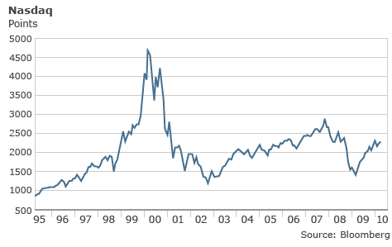
How did these “specialists” get it so wrong? One reason for the incorrect forecasting of bubbles or the burst of bubbles is the irrational behavior of Investors. In other words, it is the “human psychology” as Robert Schiller describes in his book “Irrational Exuberance” which forecasted the burst of the Dot-Com bubble accurately. In that book which was released right before the Dot-Com Bubble Burst he describes how human psychology effects economies much more than is generally recognized. He argues that people would not generally recognize that they are part of society when they are thinking about prices. They imagine that prices are determined by some esoteric forces rather than by themselves. As a consequence, the too optimistic attitudes towards the market and stock prices (expected increase in stock prices) really lead to an increase in stock prices.
David Schulman, a UCLA forecaster, argues in a similar way. He said that psychology would be at work among economic forecasters. There is supposed to be “a real reluctance to stop the party, especially the when the market is telling you that you are wrong. If you foresee a downturn and you’re right and early, you lose credibility, the vested interests want to keep the boom going. If you say no, you look dumb until the bust happens”.
Jeremy Grantham, the Chairman of Grantham Mayo Van Otterloo, on the other hand forecasted the bubble burst correctly with fundamental tools. He used the simple DDM model (Dividend Discount Model). His critical factor was that he assumed a mean-reversion. Over the long-term, each company was assumed to generate average returns. If profitability of an individual company were significantly above this norm, it would fall over time, and vice versa. The premise fore this mean-reversion process is derived from simple economics. If a firm earned above-market returns, competitors would enter the market and depress margins. This model would be especially a good estimator of future profitability over a five-year horizon.
Another reason that why the bubble burst was not predicted in forecast is that the mainstream did overhear the voices of doomsayers and optimists did not hear much bad news which is also known as the Overconfidence bias which will be explained in one of the later sections.

  - Japan Housing bubble case

Prominent economist Yukio Noguchi is one of the few who correctly predicted the collapse of Japan's bubble economy in 1987, warning the preceding euphoria was based on a major distortion in land prices. But many economists except him were optimistic with the future of Japan’s economy and could not get wind of bubble burst.

Ⅲ. Reasons making accurate economic forecasts harder

- Human irrationality

In order to understand human irrationality we have to be able to understand Behavioral Economics. Behavioral Economics is a study that tries to understand the economic decisions made by individuals and institutions using social, cognitive and emotional factors. These individuals and institutions are comprised of consumers, borrowers and investors who can affect the market prices, returns and the resource allocation depending on what decisions they make. Behavioral Economics questions the concept of “homo economicus” whose psychology was fundamentally rational.
As it was the case in the three bubbles mentioned in the first part of our paper, from the behavioral economics point of view investors usually show common irrational behaviors during a bubble. They all are affected by diverse cognitive biases and overconfidence which are closely related to each other. A cognitive bias is a pattern of deviation in judgment that occurs in particular situations. In our case it is the deviation of a rational judgment of participants in the stock market. Cognitive bias is a general term that is used to describe many distortions in the human mind that are difficult to eliminate and that lead to perceptual distortion, inaccurate judgment, or illogical interpretation. The existence of some of these cognitive biases has been verified empirically in the field of psychology.
Coming back to our cases, basically, the predictions were particularly affected by consensus-based methods where the forecasters drew predictive results from the study on what most people say or do. This was intertwined with cognitive biases like the “herd effect” or “bandwagon effect,” or “groupthink,” (which will be explained in more detail in the later paragraphs) where people believed or did things because many other people are doing or appear to be doing them. The only way to avoid groupthink is to isolate people from each other. But, of course, in the markets the player can see what others are doing. For example, when buying a “stock” that is getting more expensive they may be reassured that others are buying it too. That leads them to buy more, producing a classic herd-effect situation.
The bandwagon effect is similar to the herd effect. People often do and believe things merely because many other people do and believe the same things. The general rule is that beliefs spread among people and as more people come to believe in something, others also get on the “bandwagon" regardless of the underlying evidence. The tendency to follow the actions or beliefs of others can occur because individuals directly prefer to conform, or because individuals derive information from others (the same applies to groupthink).
These biases and many others (like the overconfidence bias where analysts overemphasize the impact of good news and underestimate bad news because they have forecasted positive earnings) are part and evidence of perception being active and constituent in understanding the world, and therefore of the future. Therefore, we have to question our assumptions and investigate the basis of our knowledge when making predictions and forecasts. However, no matter how astutely we look and how consciously we try to eliminate them, our paradigms exist, and they affect our forecasts and predictions. It is impossible to make them go away.

- Unpredictable government policy

Another major factor affecting making accurate economic forecasting harder is unpredictable government policies. In all three bubble cases, one of the major reasons for the bubble starting and the bubble bursting was government policy. In the case of Japan housing bubble, the housing bubble crashed due when the Japan government tried to burst those bubbles artificially by raising the rate of interest. The case was similar in the US housing bubble case. When the US government lowered its target federal rates to 1%, a lot of money became available in the housing bubble market and gave initial signs of a bubble. The cause of bubble burst was almost partly denoted to the government as the government started raising it target federal rates in 2004. Last but not least, in the case of the dot-com bubble, the crash of the bubble came when the U.S. Federal Reserve increased the interest rate by six times. In all three cases, government policies had a great impact in the creation and bursting of the bubble. This is not limited to the three bubbles but is a wide phenomenon in many bubbles. When the government intervenes in the national economy, it cannot foresee all the effects its intervention will have. Therefore, it cannot know the correct level of monetary or fiscal policies to use. Incorrect of expansionary monetary policies can lead to the creation of bubbles and retracting monetary policies lead to the bursting of bubbles. Furthermore, in many cases the monetary policies cannot be forecasted by the investors and they tend to react irrationally than usual which leads to more volatility in bubbles.
Ⅳ. Suggestions

The current economic forecasting has been said to have many problems. It could not forecast the US housing bubble or the bursting of it which resulted in the biggest financial crisis after the Great Depression. Economic forecasting has been a problem in the past as well in that it did could not forecast a bubble or even if it predicted a bubble, it had no means to predict when it would burst. The main reason for the faulty economic forecasting is that, in all cases, the economic forecasting did not take in the human irrationality factor or changes in government policies. Taking in these factors leads to a complication in the economic forecasting model. The economic forecasting becomes more expensive and complicated. Therefore, many institutions or government fail to take in the human irrationality factor or unpredictable changes in the macro-economy. However, as can be seen in the creation of the bubble and bursting of it which leads to financial crises, taking into these factors can be cost-saving and should be considered in the economic forecasting.

Ⅴ. Conclusion
Through this paper we examined three famous bubble cases – US housing bubble, Dot com bubble and Japan housing bubble. The objective was to find out reasons why economists could not recognize bubble bursts in advance and handle the crisis. There were some patterns among three cases; first, the beginning of the bubble phenomenon has a background of expectation for a rosy future. Those optimistic forecasts start to accelerate bubbles, which did not seem to be “bubble” at the first time. The acceleration of bubble is accompanied by blind investors who just follow and rely on what others do, because they believe human being’s rationality and efficient market mechanism. With this stream, it is very difficult to insist that ‘we are now in the bubble phase.’ As we saw in this paper, absolutely there were few economists who forecasted bubble burst in three cases. But their opinions were not considered importantly because they were minority. Therefore many investors, money borrowers and governments could not be ready enough to face the crisis. When people realize that it is bubble, it is too late. Moreover, if market receives some stimulus in this situation like raised interest rate, market becomes uncontrollable.
Economists believe human rationality. But like in many economic theories, it is only an assumption to make analysis simple. For “perfect” future economic forecasting, considering human irrational behavior such as group think or herd effect is strongly needed. In addition, grasping government polices clearly is necessary. Those two factors are disturbing us mainly in making the exact economic forecast.
The problem is that there are some trade-offs. When human irrationality factors are considered in forecasting, there might be more costs and complexity in exchange of getting more clear forecasting results. In addition, government decision cannot be expected exactly because it is influenced by so many external and internal factors including politics. Of course, it is clear that we need to consider more factors which classic economic forecasters ignored, to prevent huge economic crisis and save future cost for crisis recovery in the long-term. But how to handle those many and unclear variables effectively should be studied further.

Housing Bubble Trouble, Have we been living beyond our means? BY Andrew Laperriere April 10, 2006, Vol. 11, No. 28
The value of U.S. subprime mortgages was estimated at $1.3 trillion as of March 2007, with over 7.5 million first-lien subprime mortgages outstanding
표명영, “The process and the collapse of Japan's property bubble (일본의 부동산 버블의 전개과정과 붕괴 그리고 현황)”
http://en.wikipedia.org/wiki/Japanese_asset_price_bubble
Source: Standard & Poor’s; Japan Real Estate Institute via Japan Ministry of Internal Affairs and Communications; Bloomberg
The Great Moderation is a theory stating that the long boom in economy after the late 2000 recession is not a bubble but a reduction in economic volatility of output and inflation due to improved macroeconomic policies, improved monetary policy and smaller, infrequent shocks hitting the economy.
http://news.bbc.co.uk/2/hi/business/8558257.stm
http://news.bbc.co.uk/2/hi/business/672371.stm
http://www.foreignpolicy.com/articles/2007/08/28/seven_questions_how_to_deal_with_irrational_exuberance
J. Patrick Coolican & Michael Mishak, 『How did the Economist get is so wrong?』,Las Vegas Sun., 2008, p.3
http://search.japantimes.co.jp/cgi-bin/nn20100319f1.html
http://en.wikipedia.org/wiki/Behavioral_economics
http://futuresavvy.net/tag/paradigms/
http://en.wikipedia.org/wiki/Bandwagon_effect
Kaplan Schweser, 『Corporate Finance, Portfolio Management, and Equity Investments』, Kaplan Inc., 2009, p.185

