Analyze the crisis in Thailand based on the theory of Impossible Trinity

Nguyen Thi Thuy Chinh - Bui Hong Hanh - Nguyen Thi Loan
University of Economics and Business
Vietnam National University, Hanoi
Introduction
In an economy, a crisis can happen at any time and destroy all the achievement of a period. That is the reason why there are many economists who have done research on this problem to help countries give solutions to avoid or weaken the consequences of this phenomenon.
There are many theories raised to solve economic problems. In that circumstance, the impossible trinity was born. The formal model for this hypothesis is the Mundell-Fleming model developed in the 1960s by Robert Mundell and Marcus Fleming. The idea of the impossible trinity went from theoretical curiosity to becoming the foundation of open economy macroeconomics in the 1980s, by which time capital controls had broken down in many countries, and conflicts were visible between pegged exchange rates and monetary policy autonomy. In Asia, the crisis in Thailand is very well – known and had influence in the large scale on other countries in the area as well as in the world. This crisis can be explained clearly by the impossible trinity and we can draw some lessons from this case.

TABLE OF CONTENTS

Chapter 1 The theory of the Impossible Trinity 3
1.1 Definition 3
1.2 Factors of the impossible trinity 4
1.2.1 Fixed exchange rate 4
1.2.2 The independent monetary policy 5
1.2.3 The capital account liberalization 6
Chapter 2 Analyze the crisis in Thailand based on the impossible trinity 9
2.1 Overview of financial crisis in Thailand 1997-1998 9
2.1.1 The period before 1998 9
2.1.2 The period of 1997-1998 19
2.1.3 After 1998 20
2.2 Analyze the crisis in Thailand based on the theory of impossible trinity 22
Conclusion 26
References 26

- The theory of the Impossible Trinity
  - Definition
The Impossible Trinity (also known as the Inconsistent Trinity, Triangle of Impossibility or Unholy Trinity) is the Trilemma in international economics suggesting it is impossible to have all three of the following at the same time:
- A fixed exchange rate.
- Free capital movement (absence of capital controls).
- An independent monetary policy
The formal model for this hypothesis is the Mundell-Fleming model developed in the 1960s by Robert Mundell and Marcus Fleming. The idea of the impossible trinity went from theoretical curiosity to becoming the foundation of open economy macroeconomics in the 1980s, by which time capital controls had broken down in many countries, and conflicts were visible between pegged exchange rates and monetary policy autonomy. While one version of the impossible trinity is focused on the extreme case – with a perfectly fixed exchange rate and a perfectly open capital account, a country has absolutely no autonomous monetary policy – the real world has thrown up repeated examples where the capital controls are loosened, resulting in greater exchange rate rigidity and less monetary-policy autonomy.

  - Factors of the impossible trinity
    - Fixed exchange rate
Definition
A fixed exchange rate, sometimes called a pegged exchange rate, is a type of exchange rate regime where a currency's value is matched to the value of another single currency or to a basket of other currencies, or to another measure of value, such as gold.
Advantages of fixed exchange rate
Stability: With the objective of creating a stable atmosphere for foreign investment, a lot of countries apply fixed exchange rate policy to attract investors. In addition, fixed exchange rate can help reduce risk in international trade.
Easy to forecast: Because a currency's value is matched to the value of another single currency or to a basket of other currencies, or to another measure of value, such as gold, as a result, it is easier for investors as well as for other partners in economy to have forecast about the coming events.
Convenient to achieve other goals in economy: the fixed exchange rate might support for other goals to be achieved in an economy.
Disadvantages of fixed exchange rate
Besides the above – mentioned strong points, the fixed exchange rate exposes some disadvantages such as:
- Too rigid, make the market operate in wrong direction
- Take a pressure on national fund

    - The independent monetary policy
Definition
Monetary policy is the process by which the monetary authority of a country controls the supply of money, often targeting a rate of interest.
Independent monetary policy means policy makers can make decisions about a nation's money supply without interference from other elements of the government, such as the country's legislature or head of state. This independence allows monetary policy to be based on economic, rather than political, considerations.
Advantages of independence monetary policy
The most advantage of independence monetary policy is the ability of central bank in using the control of money supply to increase or decrease interest rate. In order to increase interest rate in a nation which has fixed exchange rate, it can reduce amount of money in the market by buying domestic currency. In contrast, decreasing interest rate is easily if a nation sells its own currency.
In addition, independence monetary policy brings central bank ability to achieve economic objectives. When the first central banks were set up, their main objectives were to print money, and to ensure that this money was delivered to their appropriate destinations. Now however, the duties of the central bank have changed. Central banks are now subject to a much wider economic usage, among other policy objectives central banks use for the reduction of inflation, and unemployment, as well as stability of the economic system. For examples, central bank reduces inflation which was cause of excess money supply by offers higher reserve requirement ratio to Commerce bank. Moreover, central bank maintains low interest rate to attract foreign investment and reduce unemployment.
The last advantage of independence monetary policy is in the case of flexible interest rate makes it convenient for investing activities. The trend of globalization over the world leads mobility of investment from nation to nation. Investors make decide to invest after comparing advantages of host country including interest rate. Low interest rate on a nation implicates that doing business here is lower opportunity cost than the rest of the world. Independent monetary policy can control interest rate as a key policy element to make advantage of investing activities
Disadvantages of independence monetary policy
Monetary policy ineffective under fixed exchange rates. With a fixed exchange rate, you give up on an independent policy. You cannot use monetary policy to target domestic inflation or try to smooth out the domestic business cycle. The only hope for independent monetary policy is capital controls to prevent traders buying or selling domestic currency. But capital controls reduce trade and foreign direct investment, and present opportunities for corruption.
    - The capital account liberalization
Definition:
Capital account liberalization, in broad terms, refers to easing restrictions on capital flows across a country’s borders
Advantages of the capital account liberalization
Higher degree of financial integration with the global economy through higher volumes of capital inflows and outflows.
When countries apply the regime of capital account liberalization, it becomes easier for them to move capital out of the borders to find higher profit as well as diversify the risks. Besides, due to the opening of regulation on movement of capital, the countries can attract more and more investment from outside because the cost of capital is reduced due to abandon of taxes relating to invest or lend money abroad. Both of two above point lead to a fact that with a higher volume and a loosened movement of capital, the cycle and the amount of capital will increase. This supports the domestic economy more investing resources to develop and afford financial activities of Government.
Capital account liberalization should allow for more efficient global allocation of capital, from capital-rich industrial countries to capital-poor developing economies. This should have widespread benefits by providing a higher rate of return on people’s savings in industrial countries and by increasing growth, employment opportunities, and living standards in developing countries.
It is true that capital moves from rich countries to poor countries. With movement of capital, it can raise more opportunities for developing countries and poor countries to approach capital from abroad. These capitals will be used to build infrastructure and invest in economic projects in the countries which are less developed. As a result, it will help these countries improve their situations, develop economy and the gap between developed and less developed countries will be reduced notably.
Disadvantages of the capital account liberalization
- Hard to control the income and outcome volumes of a country
Capital can come in or out of a country easily. It raises a problem to law makers and governors. On the side of law makers, the easy movement can lead to a fact that there is more illegal capital moving in or out the country. It can damage business activities in domestic market as well as international markets because people can use money illegally to make banned products such as drugs, toxics, etc. To governors, it becomes very hard for them to control the volumes of income or outcome of a country because of the flexibility of capital – it can come and go whenever and wherever. It becomes difficult for governments to raise any policies in the environment of capital liberalization and chase their own economic strategies.
- Easily lead to crisis
Loosening the regime of capital means that volume of capital in a country is not fixed. As a result capital can come at the same time and increase the amount of capital invested in country suddenly and after that period if there are any problems, the capital can be drawn no predictably. This can really hurt the economy especially of developing and poor countries because the economic systems here are very weak and cannot react smoothly with this kind of phenomenon. Afterward, it is easy to lead to a financial crisis as the case of Thailand in 1997 – 1998.

- Analyze the crisis in Thailand based on the impossible trinity

  - Overview of financial crisis in Thailand 1997-1998
Thailand is unique. Its conservative, yet open-minded, Buddhist customs have given the Thai economy a distinctive shape. The objective of this chapter is to describe the structure of the Thai economy, narrate its evolution, and tell the story of its notorious financial crisis. We will start with the success story of the continuous and extensive growth of the Thai economy during past 50 years. It will be shown that the structure of the Thai economy has evolved immensely throughout this period in various aspects. From a primitive agricultural economy, Thailand is now quickly becoming a newly industrialized country. Several economic factors that have framed the development of the economy will be discussed. Attention will be given to employment and productivity, capital accumulation and technological progress, international trade and foreign direct investment. These factors have helped the Thai economy grow over time. Thailand’s story of booms and bust will be told, and the chapter will be completed by a discussion of the financial crisis during 1997-1998.
    - The period before 1998
Thailand has been one of the fastest growing countries in the world. From 1951-2001, the average annual growth rate of real GDP was 6.5% per year. Per capita GDP has been increasing substantially during the past 50 years. Yet, a wealthy country is hardly built within a half century. Thailand is still searching for its way to become a strong and prosperous economy.
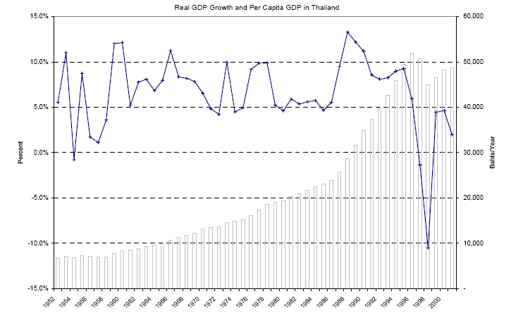
Figure 1. Real GDP growth and per capital GDP in Thailand during 1952 – 2001
(Source: SOMPRAWIN MANPRASERT, PH.D.)
Although Thailand does not abound with oil and ores, its abundance in other natural resources, such as timber and agricultural products, helped start its growth. Fifty years ago, Thailand was still a primitive economy whose main output was agricultural products, particularly rice. In 1960, agriculture accounted for 32% of the total GDP of the country. At the same time, the share of manufacturing was only 14%. Thailand (or, Siam at that time) was known as the ‘rice-economy’. This picture is somewhat reversed nowadays. During the past 40 years, the proportion of agricultural products in the total GDP has been decreasing continuously. In 2000, they provided only 12% of the total product, while manufactures took up 35% share.
Not only has the structure of production changed during the past four decades, but the structure of demand has also evolved. On the expenditure side, the structure of demands for domestic products has changed remarkably. Forty years ago, the main driving force of the economy came from private consumption expenditures. As much as 73% of the total GDP was absorbed by private consumer demand. In the recent decades, however, its role has been reduced. Although the private consumption expenditure is still the largest part of the GDP, private fixed investment has become an important factor. During 1990s, private fixed investment absorbed as much as 40% of the total output of the country. Table 1 below summarizes the structure of GDP in Thailand.

Table 1: Output growth and the structure of GDP
 | 1960s | 1970s | 1980s | 1990s | 2000s
Real GDP Growth* (Percent) | 6.0 | 7.8 | 6.7 | 7.8 | 4.4
Real Per Capita GDP* (Baths) | 8,329 | 13,143 | 19,558 | 34,839 | 48,159
Ratio of the Domestic Product by Industrial Origin (selected sectors) to GDP (Percent):
Agriculture | 32 | 27 | 20 | 14 | 12
Manufacturing | 14 | 17 | 23 | 28 | 35
Transportation and Communication | 8 | 7 | 7 | 8 | 10
Wholesale and Retail Trade | 16 | 18 | 18 | 17 | 15
Services | 11 | 12 | 13 | 12 | 12
Ratio of Expenditure to GDP (Percent):
Private Consumption | 73 | 70 | 65 | 57 | 56
Government Expenditure | 10 | 11 | 12 | 9 | 11
Fixed Investment | 14 | 24 | 28 | 40 | 22
Net Export | -1 | -4 | -6 | -8 | 9
Source: National Economic and Social
*10-year average of annual real GDP.
CAPITAL ACCUMULATION AND TECHNOLOGICAL PROGRESS
The effect of financial liberalization on private saving is theoretically ambiguous, as financial liberalization itself is a multidimensional and phased process, sometimes involving reversal.
Financial liberalization has a number of different dimensions: interest rates, credit allocation, bank ownership, prudential regulation, security markets and openness of capital account. Each of these changes can have different impacts on the domestic saving.
Table 2. Thailand´s financial liberalization from 1986-1993 process
Measures | Date
Reduced tax impediments for inflows of foreign portfolio investment | 1986
Promotion of foreign direct investment through authorized 100 percent foreign ownership for firms that exports all outputs | 1991
Repatriation of investment funds, interest and loan repayment by foreign investors was fully liberalized | 1991
Removal of interest rate control for commercial bank deposits and lending | 1989-199
Elimination of restrictions on purchases of foreign exchange by residents, and transfer of Baht overseas | 1993
Establishment of Bangkok International Banking Facilities (BIBFs) | 1993

Between 1987-1997, the total saving rates increased significantly during the initial period from 25 percent to GDP to 35 percent to GDP, and remained relatively stable thereafter. Nonetheless, the underlying composition of savings has changed remarkably: private sector savings (household and business) have declined relative to GDP from 14.9 percent to 12.1 percent of GDP, while public savings (government and state enterprises) have increased from 3.7 percent to 4.9 percent to GDP. This trend reached its peak in 1997 in which Baht 498.5 billion public savings were higher than Baht 434.8 billions private savings. Thus, it can be concluded that private savings to GDP in Thailand had declined significantly during 1987-1997.
Fixed investment has become increasingly important in domestic expenditure. Capital endowment is a crucial factor in economic growth, and part of the massive output growth in Thailand during the past decades has been contributed by capital accumulation. Gross capital stock in Thailand has been increasing continuously over the past three decades. A massive capital accumulation started to take off in the early 1990s. From 1985-1999, the values of gross capital stocks in Thailand have increased by about three times. Tinakorn and Sussangkarn (1994) suggest that capital endowment contributed to 37% of the average real GDP growth during 1978-1990.
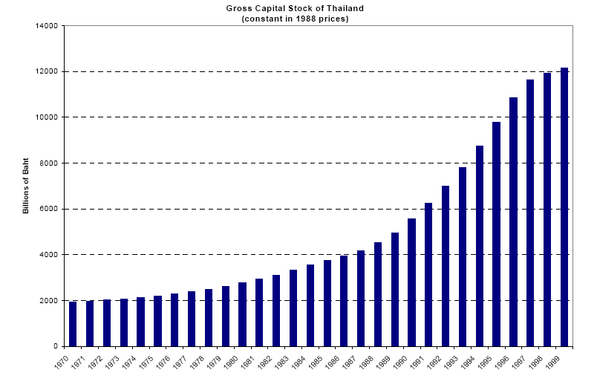
Figure 2. Gross capital stock in Thailand
(source: SOMPRAWIN MANPRASERT, PH.D.)
Capital endowment alone cannot keep a country growing over the long run. Economic growth theory suggests that sustainable long-term growth is energized by technological progress. There is very little literature that examines the role of technological progress on the output growth in Thailand. Among the few studies, Tinakorn and Sussangkarn (1994) employed the growth-accounting method to study the sources of economic growth in Thailand during 1978-1990. They found that technological progress has not been the major factor in the growth in Thai economy during the past decades. As they put it, “Thailand’s rapid growth in the past decade or so has been achieved by adding more labor, capital and land to production. Some productivity improvements have been achieved, but these may have been through importing more efficient and modern machinery and through the employment of better or more productive workers”. They reported that the total factor productivity (TFP) explained only 16% of the real GDP growth during 1978-1990, while labor and capital contributed to the GDP growth for 46% and 37%, respectively.
INTERNATIONAL TRADE AND FOREIGN DIRECT INVESTMENT
Thailand’s international trade has started to expand since the late 1980s. Important trading partners with Thailand include the U.S., the ASEAN (Association of SouthEast Asian Nations), EU, and Japan. The U.S. is the biggest market for Thai exports. However, there was also a change in the structure of exports worth mentioning. In 1992, the ASEAN countries signed the Free Trade Agreement (AFTA), aiming to reduce the regional trade tariffs to 0-5%. Consequently, the intra-trade within the Southeast Asia countries has expanded extensively. Since 1993, values of the exports to the ASEAN countries have surpassed those to EU and Japan.
In terms of the exported goods, the structure has also changed considerably. In early 1980s, 45% of the total exported goods were food products. However, the share of food products in exports is now replaced by machinery products. Currently, the exports of machinery products accounted for 43%, while food products account only for 14% of the total exports.
Net foreign direct investment (FDI) in Thailand has been significant since the early 1990s. Partly this rise in FDI is due to the abolition of the capital controls over financial capital markets, allowing foreign capital to move in and out of the country freely. The average annual FDI jumped from 13 billion baths per year during the 1980s to 83 billion baths per year in the 1990s. The most important sources of net capital inflows, in order of size, were Japan, ASEAN, the U.S., and the EU. Net capital inflows have been most important in manufacturing, trade, and services.
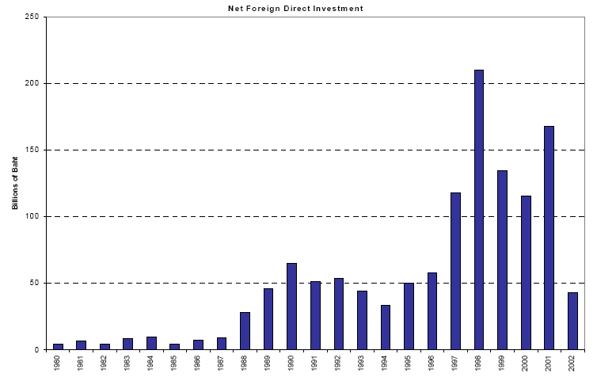
Figure 3. Net foreign direct investment
(source: SOMPRAWIN MANPRASERT, PH.D.)

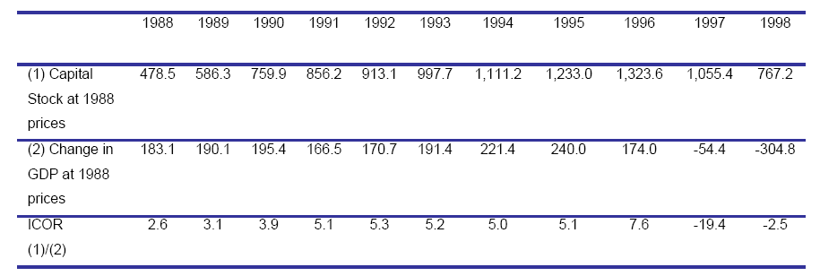
Table 2. Indicator of Investment Quality (1988-1998)(Billions of baht)
(Source: Office of the National Economic and Social Development Board.)

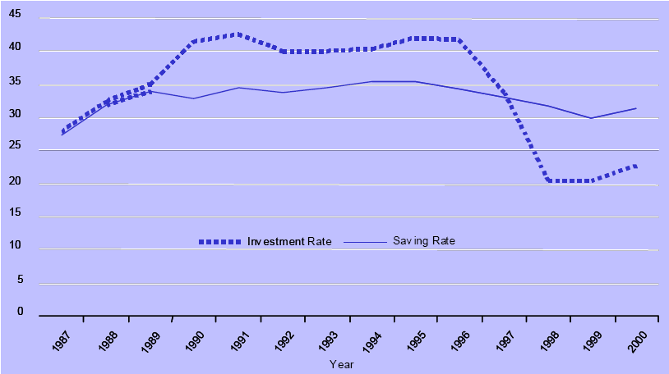
Figure 4. Saving and Investment in Thailand
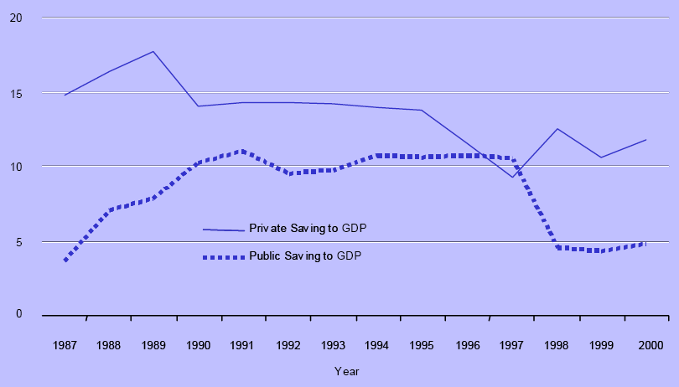
Figure 5. Private and Public Savings in Thailand

    - The period of 1997-1998
On 14 May and 15 May 1997, the Thai baht was hit by massive speculative attacks. On 30 June 1997, Prime Minister Chavalit Yongchaiyudh said that he would not devalue the baht. This was the spark that ignited the Asian financial crisis as the Thai government failed to defend the baht, which was pegged to the U.S. dollar, against international speculators. Thailand's booming economy came to a halt amid massive layoffs in finance, real estate, and construction that resulted in huge numbers of workers returning to their villages in the countryside and 600,000 foreign workers being sent back to their home countries. The baht devalued swiftly and lost more than half of its value. The baht reached its lowest point of 56 units to the US dollar in January 1998. The Thai stock market dropped 75%. Finance One, the largest Thai finance company until then, collapsed.
The Thai government was eventually forced to float the Baht, on 2 July 1997. On 11 August 1997, the IMF unveiled a rescue package for Thailand with more than $17 billion, subject to conditions such as passing laws relating to bankruptcy (reorganizing and restructuring) procedures and establishing strong regulation frameworks for banks and other financial institutions. The IMF approved on 20 August 1997, another bailout package of $3.9 billion.
Thai opposition parties claimed that former Prime Minister Thaksin Shinawatra had profited from the devaluation, It has been investigated by the court of justice and despite comments from former Thaksin cabinet member Sanoh that "There were four people who got involved in the Baht depreciation, i.e. Chavalit, Thaksin, Thanong and Pokin," no case has been filed against Thaksin for this or any other parties.
    - After 1998
Because of the large depreciation of the baht and the economic contraction, the current account turned from a pre- crisis deficit of about US$1 billion per month to a surplus of about US$1 billion per month toward the end of 1997. Thailand's foreign reserve position recovered fairly quickly. By the middle of 1999, the usable foreign reserves had increased to more than US$16 billion, from approximately US$2.8 billion in the middle of 1997, and Thailand did not need to draw any more from the IMF loan package.
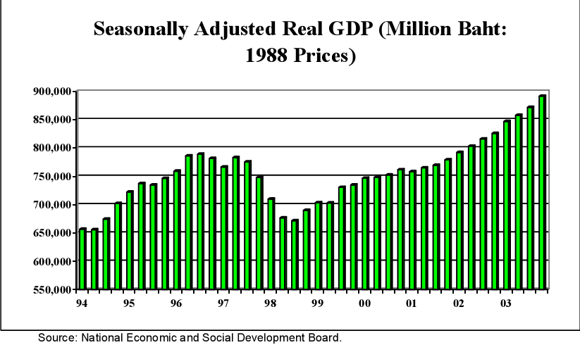
Figure 6. Real GDP Trend

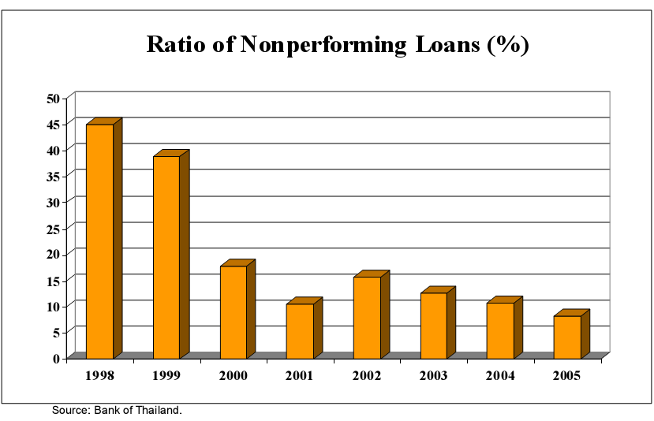
Figure 7. Ratio of Nonperforming Loans in the Financial System
Even though the foreign reserve position recovered fairly quickly, it took much longer for an overall economic recovery to be achieved. Fro Figure 6 it can be seen that the economy bottomed out around the third quarter of 1998. However, it took almost five years before output recovered to its pre - crisis peak. It took even longer to clean up non-performing loans in the financial system. After the crisis, the ratio of nonperforming loans in the financial system jumped to almost 50% by the end of 1998 (Figure 7). It took about eight years after the onset of the crisis before the NPL ratio declined below 10%.
  - Analyze the crisis in Thailand based on the theory of impossible trinity
With the establishment of the BIBF in 1993, Thai firms could have direct access to international financial markets. A notable feature of capital inflows was not only the acceleration of foreign loans but also a rising share of short-term loans, especially portfolio investment, nonresident deposits and trade credits. The total foreign debt of Thailand stood at $29 billion in 1990 but jumped to $65 billion in 1994 and further shot up to $92 billion in 1997, mostly incurred by the private sector. This is a more- than-threefold increase in seven years. The ratio of foreign debt to GDP grew considerably from 34% to 49% and the share of private debt rose from about 60% to around 80% before tapering off to about 73% in 1997. Even more frightening is the fact that these loans were not hedged as the THB was fixed by the monetary authority. A high proportion of short-term unhedged dollar loans in Thai foreign debt rendered the economy highly vulnerable to speculative attacks.
=>The liberalization of capital control led to a huge amount of loans of Thailand
The second mistake was that the BOT retained a fixed exchange rate regime alongside an open capital account (Siamwalla, 1997). Critics suggested that the BOT should widen the exchange rate band, but this was opposed by interested groups, especially bankers and financiers, who were trapped heavily in dollar debt. The BOT officials, in the same vein, pointed to a high level of foreign reserves and sound economic fundamentals as counter-arguments. However, they were blind to the fact that such high foreign reserves were largely accounted for by short-term inflows (borrowed reserves), not by the earning capability of Thai exports or overseas investment (earned reserves). The reserves were basically short-term and debtinduced reserves with a high degree of volatility.
Another misstep made by the BOT was its attempt to defend the THB because of its confidence in strong fundamentals. In November 1996, February and May 1997, the THB suffered a few rounds of speculative attacks. “The reserve depletion from these attacks was hidden from the public by the forward sale of its dollars to support the THB” (Siamwalla, 1997). It was reported that about $23 billion was sold forward in swap transactions to defend the THB. The intervention generated a loss of about $8 billion, compared to about $10 billion used by the British government to defend the pound in 1991.
Another error by the BOT was to maintain high interest rates in order to boost domestic savings and counter inflationary pressures. The widening interest rate spread attracted further capital inflows of the worst kind – hot money in pursuit of a quick profit. As the Thai economy got trapped in huge foreign loans, policy makers were unable to cut the interest rates for fear of igniting a reversal. In the aftermath of the 2 July 1997 devaluation of the THB, Thailand was under IMF conditionality which prescribed tight monetary policy with high interest rates in order to prevent severe outflows and avert possible speculative attacks on the THB despite its severe contractionary impacts on the economy.
=>As a result of rapid growth and high interest rates, Thailand and many other East Asian countries received a large inflow of hot money and experienced a dramatic boom in asset prices.
Fixed exchange rates also encouraged external borrowing and led to excessive exposure to foreign exchange risk in both the financial and corporate sectors. A fixed exchange rate regime, free capital mobility, inept regulatory authorities, a weak financial sector as well as reckless behaviour of both borrowers and lenders all combined to render the Thai economy extremely vulnerable to external financial shocks. In 1996, the global economic environment started to change. As the US economy recovered from a recession in the early 1990s, the Federal Reserve began to raise interest rates to head off inflation, making the United States relatively more attractive as an investment destination. At the same time, Thai export growth slowed down sharply, deteriorating its current account position. Loss of confidence in Thailand’s economic and financial system as well as the sustainability of the THB prompted speculators to attack the currency in 1996 and mid-1997. The rapid reversal of hot money flows often leaves little time for monetary authorities to respond, particularly among emerging economies whose financial market institutions are still at the budding stage. This process in broad sense can also be explained by the Frenkel-Neftci cycle (Taylor, 1999). During the crisis, large debt repayments demanded by creditors exerted substantial pressure on the THB. The BOT, caught off-guard, squandered substantial amounts of international reserves to defend the THB before giving up and adopting a floating exchange rate regime on 2 July 1997. In the aftermath, the THB lost half of its value and reached its lowest point of THB55.9 per dollar on 13 January 1998. The stock market dropped by 75% in 1997 alone. Massive devaluation of the THB, hikes in interest rates and a credit crunch resulted in widespread bankruptcies and mounting non-performing loans (NPLs) in the financial sector, with attendant consequences for the real economy. Output contracted 10% in 1998 with drastic drops in investment and consumption followed by massive lay-offs and sharply rising levels of unemployment. The episode is credited as the most severe post-war economic crisis in Thailand.

Conclusion
From the case of Thailand and the theory of impossible trinity, we can see that a country cannot have three objectives: fixed exchange rate, capital account liberalization and independence monetary policy at the same time. It can only pick two of them to achieve its goals. The case of Thailand also gave us some experiences in controlling the capital flow coming out of or into a nation. Moreover, the effective operation of banking system is very important in an economy where most of the transactions are completed through banks. Besides, the policies of government in controlling interest plays a major role, it has an influence not only on foreign exchange market but also on the volume of capital in or out of country. Any weakness in the above sectors can lead to a crisis easily.
References
- Bekaert, Geert; Harvey, Campbell and Lundblad, Christian, Does Financial Liberalization Spur Growth?, NBER, 2001,Working Paper No. 8245.
- Chari, Anusha and Henry, Peter Blair, Capital Account Liberalization: Allocative Efficiency or Animal Spirits, NBER, 2002, Working Paper No. 8908.
- Edison, Hali; Klein , Michael; Ricci, Luca and Sloek, Torsten, Capital Account Liberalization and Economic Peformance: Survey and Synthesis, NBER, 2002 Working Paper No. 9100.
- Henry, Peter Blair,Is Disinflation Good for the Stock Market?, Journal of Finance, 2002, Vol. LVII, No. 4, pp. 1617-1648
- http://en.wikipedia.org/wiki/1997_Asian_Financial_Crisis
- http://www.thailandguru.com/1997-asian-financial-crisis.html
- http://www.westga.edu/~bquest/2003/asian.htm

