VIETNAM NATIONAL UNIVERSITY, HANOI
UNIVERSITY OF ECONOMICS AND BUSINESS
  

GPAC 2010

MIGRATION IN VIETNAM WITH HEALTH AND MEDICAL ISSUES

Prepared by

NGUYEN MINH CUONG
PHAM DUC THANG
VU NGOC LAM
PHAM THI HOANG GIANG

Hanoi, August 2010
TABLE OF CONTENTS
CHAPTER 1: INTRODUCTION 3
1.1. RATIONAL 3
1.2. RESEARCH OBJECTIVES 4
1.3. STUDIES ON MIGRATION AND HEALTH 4
1.4. METHODOLOGY OF RESEARCH ABOUT MIGRATION AND HEALTH 6
CHAPTER 2. MIGRATION AND HEALTH ISSUES 7
2.1. HEALTH CONDITION 7
2.1.1. Health status at the time of investigation 7
2.1.2. Health status of immigrants before and after migration 8
2.1.3. Sick leave 9
2.2. HEALTH STATUS OF FAMILY MEMBERS 10
2.2.1. Migrants sending money to family member for health purposes 10
2.2.2. Health status of family members after migration 12
2.3. BEHAVIOURS AFFECTING HEALTH 13
2.3.1. Smoking 13
2.3.2. Drinking beer / wine 13
2.4. ASSESSMENT OF HIV/AIDS CONTAGIOUSNESS THREAT TO MIGRANTS 14
2.5. INOCULATION 16
CHAPTER 3. MIGRATION AND MEDICAL SERVICES 18
3.1. SICKNESS MEDICAL SERVICES 18
3.2. CHOICES OF MEDICAL OFFICES 23
3.3. MEDICAL SERVICE EXPENSES 27
3.4. PREVENTIVE HEALTH CARE 31
3.5. HEALTH INSURANCE 32
CHAPTER 4. CONCLUSIONS AND ADVICES ON HEALTH CARE POLICIES 38
REFERENCES 45
Vietnamese 45
English 47

CHAPTER 1: INTRODUCTION

1.1. RATIONAL

This research report bases on the data of Vietnam’s Migration survey in 2004 (implemented by General Statistics Office within the framework of the project VIE/01/P12TK and endowed by the United Nations Population Fund). Beside primary report results GSO, the UN Population Found, 2005, this research also based on a big range of reports of the relationship between migration and economic-social development. It focus on the causes of migration decisions and the impacts of migration on the economic - social development of each region and of the whole country.
The survey was conducted in areas (how many areas) with high immigration level:
- Ha Noi
- North East Economic zone, including Hai Phong, Hai Duong, Quang Ninh
- The West Highland
- Ho Chi Minh City
- South- East Industrial zone
In addition, the data collected ensure the research requirements in three main directions of migration: Migration to the key economic sector in rural areas, migration to big cities and migration to the Industrial zones. The information gathered from this survey was used as the basis for planning economic - social policies and also those that help migrants quickly integrate into the community.
In general view., this report analyzes and clarifies the influence of migration on health and medical issues in Vietnam and are the useful references for researchers and policy makers.

1.2. RESEARCH OBJECTIVES

The overall objective of this report is to examine the influence of migration on health and medical issues in Vietnam .For migrants, comparisons are made based on the type of migration, household registration status and length of residence in the destination. The comparison is made between migrants and non-migrants.

The specific objectives include:
- Describe the relationship between migration and health status;
- Analyze the impact of living conditions and population –social characteristics on migrants’ health and their access to health care services;
- Provide political suggestion to improve the quality of health care for migrants
It aims to answer three main questions below:
1/ The difference of health status between migrants and non- migrations and the reasons
2/ The difference of access to medical services between migrants and non-migrants
3/ Poltical suggestions to improve the health of migrants

1.3. STUDIES ON MIGRATION AND HEALTH
Currently, many published studies have analyzed the relationship between migration with health status (Salahudin, 2005, Arifin et al, 2005), mortality (Mazharul Islam et al, 2005), the possibility of infection (Zhenzhen Zheng et al, 2005), and HIV risk and STDs (Xiushi Yang et al, 2005). The results indicated that, on one hand, health may be the driving force or may be obstacle to migration by affecting directly and indirectly to the migration decisions (Findley, 1998; Landingham, 2003). On the other hand, the process of migration also affects the health of individuals and communities in levels (Brockerhoff, 1995; and Shtarkshall Soskolne, 2002). For the reason that the effects of health on migration carry not much economic – social matters and can only be seen through reasons for migration or the selectivity of migration, most studies mentioned focused on the impact of migration on health.
Although most studies of the impact of migration on health mainly aimed at fertility, conclusions about the relation between migration and fertility is not compatible. Some studies indicate that the fertility of migrants is lower than non-migrants in the departure and higher than who permanently live in the destination. (AS Oberai, 1988 and Mondain, 2005). However, other recent studies show that migrants have similar rate of fertility with non-migrants (Tungu, 2005).
In developing countries, children of women who migrated from the countryside have less chance of survival than children living in urban areas. Research by Mazharul, 2005 in Bangladesh showed that the mortality rate of children under 5 years migrating from rural areas is 1.6 times higher than that of children born and raised in urban areas.
The study about rural-urban migration in Ho Chi Minh City's by Van Landingham in 2004 said migration had significant effects on the welfare of migrants in various fields. Newcomers face more than disadvantages than indigenous people on six areas of health, including physiological, psychological, emotional, motion function, knowledge and the concept of health in general. It can be said that rural-urban migration often bring significant benefits in economy for their family at home while the contrary happens to the health of migrants (VanLandingham, 2005).
The survey "Migration and Health" in 1997 also discovered some interesting facts about reproduction health and family planning: Migrants might have difficulties accessing family planning services, the rate of using contraception of migrants and immigrants are similar. Perceptions of migrants on family planning are the same as non-migrants and the level of accepting to use contraception increased significantly after migration. This fact proves that there is less chance that migrants increased level of birth in places they move to. However, results also showed that although the rate of using contraception was relatively high, still 15% of female migrants had the abortion, one-third of which were unmarried (Institute of Sociology, 1998).
If health services, especially initial reproduction health services are low in quality, children will be affected first. Currently, inoculation programs for children have been conducted effectively so every child can be vaccinated with a very low cost or free of charge without resident registration or complex procedures. Thus, most migrant children under 5 were vaccinated (94.6% of temporary migrants, 96.7% long-term migrants). Most cases that children are not inoculated are because they were too small (Nguyen Duc Vinh, 1998).
Although there have been some studies on the relationship between health and migration conducted in Vietnam, most are small studies and this causes difficulties for the comprehensive analysis of this relationship. Understanding of the direction and magnitude of the relationship between migration and health in Vietnam is still limited. This topic is to contribute to overcome the situation above.

1.4. METHODOLOGY OF RESEARCH ABOUT MIGRATION AND HEALTH

-Collecting the data from different sources in migration and its influence on health and medical issues in Vietnam, as well as the latest reports of the relationship between migration and economic-social development

-Using the theorical foundation of migration to analyze the data

-Using the simple model of migration and health

Direct factors
Indirect factors
Health
of migrants

CHAPTER 2. MIGRATION AND HEALTH ISSUES
2.1. HEALTH CONDITION

2.1.1. Health status at the time of investigation
Figure showed that the health subjects of investigation is quite good with 93.8% responded "average" or higher, including up to 36.9% said "healthy" and "very healthy" (Figure 2.1)
Figure 2.1: Self assessment in percentage about health condition of objectives , varying by age and migration type2.1
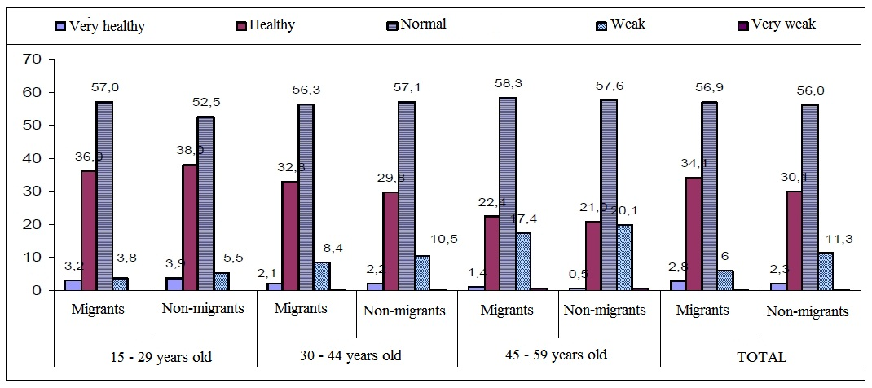

In general, male objectives assume that they have better health than female objectives, regardless they are migrants or not. Specifically, 41.3% of male migrants and 35.4% of male non-migrants considered themselves “strong”, while those rates in female were comparatively 28.7% and 25.5%.
Differences in health depend on areas: The highest rates of objectives considering themselves “healthy” and “very healthy” belong to Hanoi (with 50.1%), Ho Chi Minh City (with 44.8 %), Northeast Economics Area (with 38.8%), Southeast Industrial zone (with 30%) and Western Highlands (with 20/8%).

Figure 2.2: Self assessment in percentage about health condition of objectives at the time of the survey, varying by gender and migration type2.2
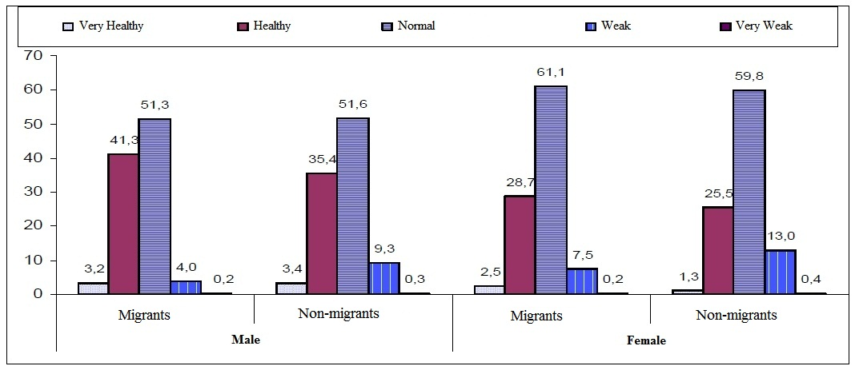

2.1.2. Health status of immigrants before and after migration

(Figure 2.3) It can be concluded that migration appears to bring better health. However, it should be noted that there may be a certain percentage of people whose health was weaker after the migration and has returned to the former place.

Figure 2.3: Current health condition in percentage of migrants in Comparison with before migration, varying by age and gender (self assessment)2.3
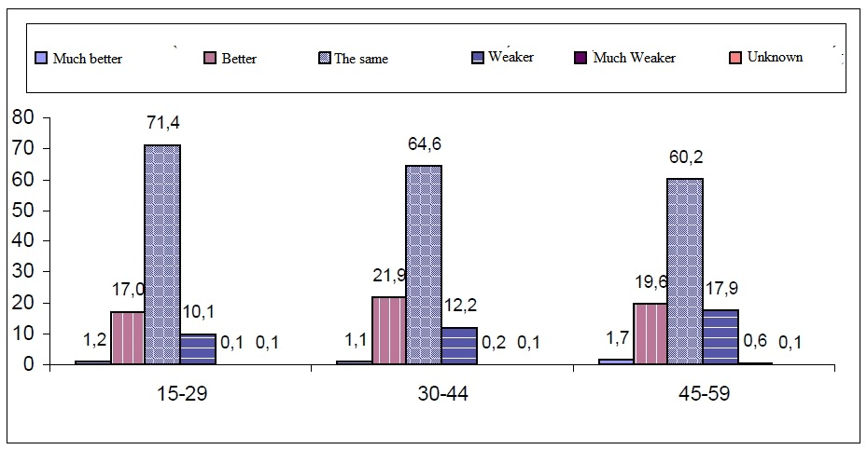

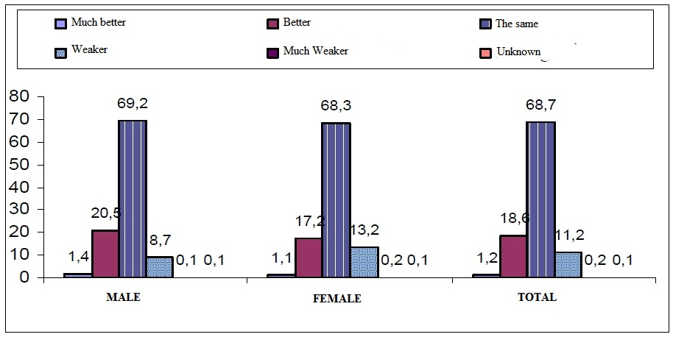
Overall, migration not only improved the income but also improved health status of migrants.

2.1.3. Sick leave
Figure 2.4: Time period in percentage from the most recent time of using medical services/ sickness leave to the time of the survey, varying by gender and migration type2.4
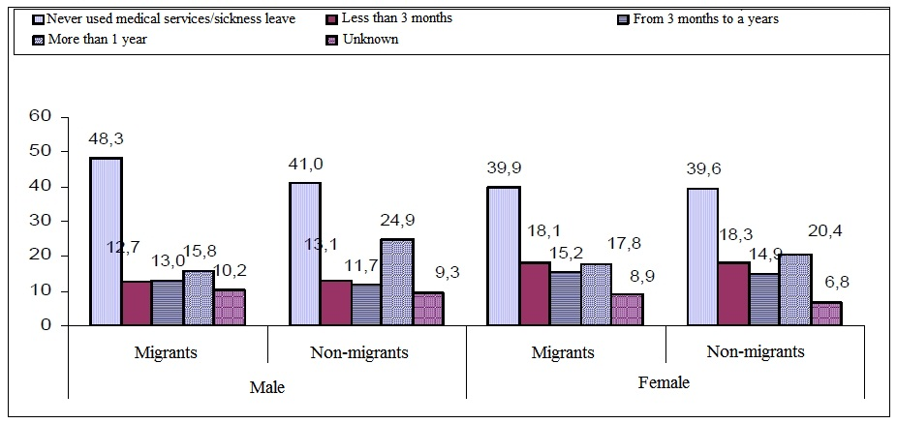
At the age of 15-29 and 30-44, the percentage of migrants who have sick leave is more than that of non-migrants. This may be due to that labor migrants had to work harder than non-migrants in the period under a year ago before the investigation. With age 45-59 group, the percentage of migrants who have no sick leave was greater than non-migrants, especially under 3 months before and the rate of people who were not sick enough to leave work was lower (32.4% compared to 33.3%). This could be caused by the selection of migrants: only healthy elder people decide to migrate.

2.2. HEALTH STATUS OF FAMILY MEMBERS

2.2.1. Migrants sending money to family member for health purposes
There were only very small differences in age and gender in the proportion of people sending money home to relatives for the purpose of health. At every age, the rate of migrants sending money to family members was around 17%. The number of male migrants doing this was slightly higher female ones (16.4% of male and 15.1 of female).
Figure 2.5: Migrants sending money to family members for medical purposes, varying by age and gender2.5
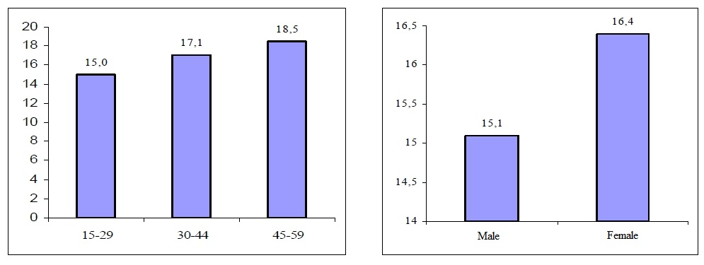
However, differences were relatively clear by region. Hanoi had the highest rate (33.3%), while only 3.9% of migrants to Western Highlands sent money home. This is probably because most migrants moving to Western Highlands accompanied their family.

Figure 2.6: Migrants sending money to family members for medical purposes, varying by current living area2.6
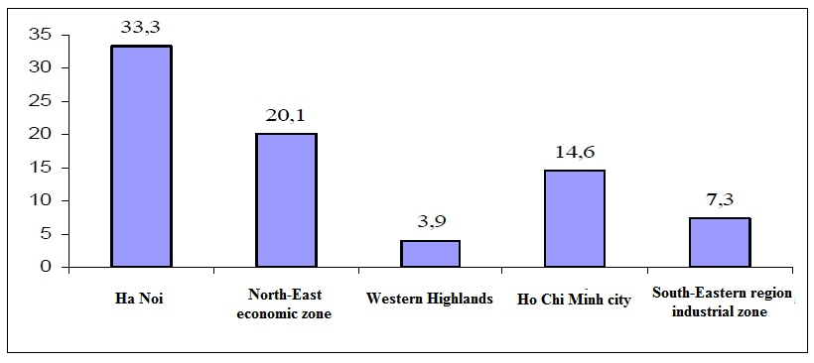
2.2.2. Health status of family members after migration

According to the migrants, in general, the health of their family members was in a positive change compared to before they moved: 19.3% tought it was "a lot better" or "better", 74.5% said "the same" and only 5.1% stated “less” (Table 2.7).

Table 2.1: Assessment of migrants in percentage about current health condition of family members in comparison with before migration, varying by age and gender2.1
Health condition of family members | Age |  |  | Gender |  | Total
Health condition of family members | 15-29 | 30-44 | 45-59 | Male | Female | Total
Much better | 0,8 | 1,5 | 1,1 | 1,3 | 0,8 | 1,0
Better | 15,8 | 22,2 | 25,5 | 18,1 | 18,5 | 18,3
Same | 77,5 | 69,8 | 67,2 | 75,2 | 74,0 | 74,5
Worse | 4,8 | 5,7 | 5,3 | 4,6 | 5,5 | 5,1
Much worse | 0,0 | 0,1 | 0,0 | 0,0 | 0,0 | 0,0
Unknown | 1,1 | 0,8 | 0,8 | 0,7 | 1,2 | 1,0
Total | 100,0 | 100,0 | 100,0 | 100,0 | 100,0 | 100,0
Quantity | 3201 | 1440 | 357 | 2151 | 2847 | 4998

It is possible that the improvement of living conditions in the destination (when the whole family moves), or the sending money to their families have good effects on the family members’ health.

2.3. BEHAVIOURS AFFECTING HEALTH

2.3.1. Smoking

49.9% of migrants smoke before the migration, and the rate after that is 52.0%. This indicates that migration does not affect smoking habit considerably.

Figure 2.7: Male objectives smoking before and after migration in percentage, varying by age and current living area2.7
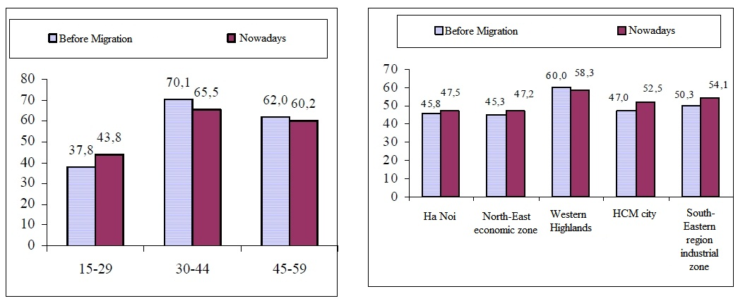

2.3.2. Drinking beer / wine

The majority (68.5%) of the objectives admit that there’s no change in their drinking habit, while 12.2% thought they consume alcohol less.

Table 2.2: Rate of migrants consuming alcohol before and after migration in percentage, varying by age, gender and current living area2.2

Characteristics | Time
Characteristics | Before | Current
Age
15-29 | 27,2 | 35,3
30-44 | 41,5 | 44,0
45-59 | 45,1 | 46,5
Gender
Male | 65,9 | 77,2
Female | 7,4 | 9,4
Current living area
Hanoi | 38,6 | 44,8
Northeast Economics Area | 39,3 | 44,4
Tay Nguyen | 33,6 | 37,0
Ho Chi Minh City | 26,0 | 35,6
Southeast Industrial zone | 25,5 | 31,3
Total | 32,6 | 38,6

2.4. ASSESSMENT OF HIV/AIDS CONTAGIOUSNESS THREAT TO MIGRANTS

Figure 2.8: Objectives consider migrants have higher risk of contracting HIV/AIDS than non-migrants in percentage, varying by age, migration status and gender2.8
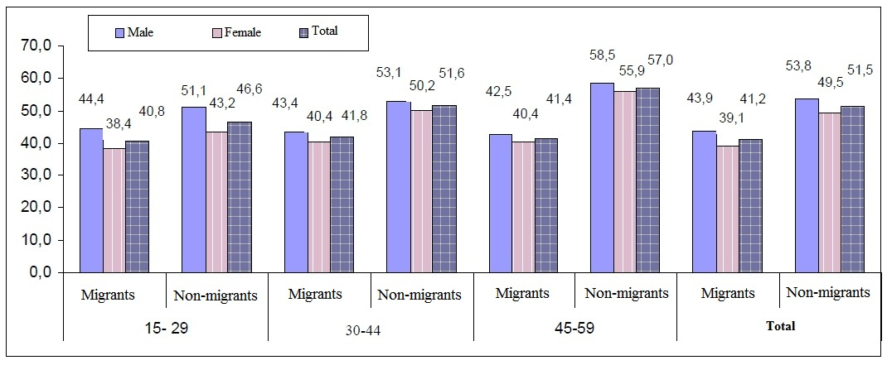

As can be seen in Figure 3.11, 51.5% of the non-migrants thought the risk of HIV/AIDS contracting of migrants was higher than non-migrants, while only 41.2% of migrants agreed with this opinion. Northeast economic zone and Hanoi are the two areas whose the highest percentage of who believed the risk of HIV/AIDS contracting of migrants were higher than migrants. Objectives in Western Highlands were the least to agree with that. (Table 3.11)
Overall, in all areas, the awareness of non-migrants about the risk of HIV/AIDS transmission was higher than migrants.

Figure 2.9: Objectives comparing risk of HIV/AIDS contracting between migrants and non-migrants, varying by household registration status in percentage2.9
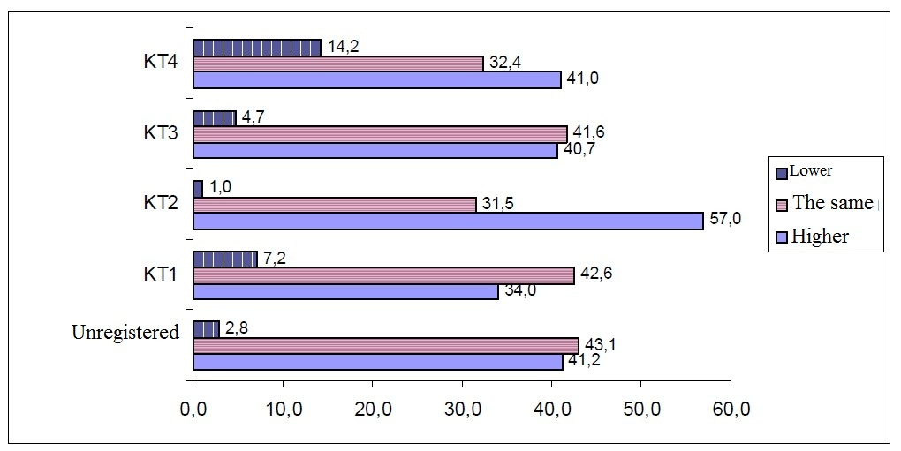

Analysis based on household registration status showed that the KT2 objectives were the most to think the risk of HIV/AIDS contracting of migrants was higher than non-migrants (Figure 3.12). However, up to 14.2% of KT4 migrants considered the possibility that transmission of HIV/AIDS of migrants was lower than non-migrants.

2.5. INOCULATION

The rate of children under age 5 who were vaccinated was very high (97% for immigrants and 98.5% for non-migrants).
Western Highlands was the area with the least number of children of migrants inoculated (94.8%), lower than that of children of non-migrants (96.7%). Next to that was the South East industrial zone with the corresponding ratio of 95.6% children of migrants and 98.3% of children of non-migrants.
Overall, up to 94.9% of migrants and 96.9% of non-migrants said that their children had inoculation cards.
Table 2.3: Objectives revealing that their under-5-year-old children have been inoculated in percentage, varying by migration type and current living area2.3
 | Hanoi |  | Northeast Economics Area |  | Tay Nguyen |  | Ho Chi Minh City |  | Southeast Industrial zone |  | Total
 | Migrants | Non-migrants | Migrants | Non-migrants | Migrants | Non-migrants | Migrants | Non-migrants | Migrants | Non-migrants | Migrants | Non-migrants
Inoculation
Yet | 100,0 | 99,6 | 99,4 | 99,3 | 94,8 | 96,7 | 99,3 | 99,6 | 95,6 | 98,3 | 97,0 | 98,5
Not yet | 0,0 | 0,0 | 0,6 | 0,7 | 4,8 | 3,3 | 0,7 | 0,4 | 4,4 | 1,4 | 2,9 | 1,4
Unknown | 0,0 | 0,4 | 0,0 | 0,0 | 0,4 | 0,0 | 0,0 | 0,0 | 0,0 | 0,3 | 0,2 | 0,1
Total | 100,0 | 100,0 | 100,0 | 100,0 | 100,0 | 100,0 | 100,0 | 100,0 | 100,0 | 100,0 | 100,0 | 100,0
Quantity | 203 | 259 | 172 | 275 | 459 | 424 | 139 | 277 | 248 | 293 | 1221 | 1528
Inoculation card
Have | 93,6 | 96,1 | 97,7 | 97,8 | 94,3 | 96,8 | 91,3 | 94,6 | 97,5 | 99,3 | 94,9 | 96,9
Don't have | 6,4 | 3,9 | 2,3 | 2,2 | 5,7 | 3,2 | 8,7 | 5,4 | 2,5 | 0,7 | 5,1 | 3,1
Total | 100,0 | 100,0 | 100,0 | 100,0 | 100,0 | 100,0 | 100,0 | 100,0 | 100,0 | 100,0 | 100,0 | 100,0
Quantity | 203 | 258 | 171 | 273 | 435 | 410 | 138 | 276 | 237 | 288 | 1184 | 1505

CHAPTER 3. MIGRATION AND MEDICAL SERVICES

What create migrants’ conception of medical issues can vary from age gap, gender differences, education status, attitude towards sickness and treatment, medical expenses, geography, access to medical offices and other information, health insurance and so on. This complex conception leads to a wide range of their choices regarding medical services.
In chapter 3, we focus on discussing some main aspects of medical services namely how migrants deal with sickness, their choices of medical offices, how they pay for the expenses and their response to preventive health care and health insurance. The differences between migrants and non-migrants as well as gender and other opposite objectives will also be specifically shown in this chapter.

3.1. SICKNESS MEDICAL SERVICES

Figure 4.1 shows that the most popular action both female and male migrants and non-migrants take at the time of sickness is to go to medical offices (around 76% with non-migrants and around 66% with migrants). Very few do nothing or call for a doctor, while there are a quarter of migrants questioned do self treatment, the number of which is slightly more than that of non-migrants (21.3%).

Figure 3.1: Treatment in the most recent time of sickness in percentage, varying by migration type and gender3.1

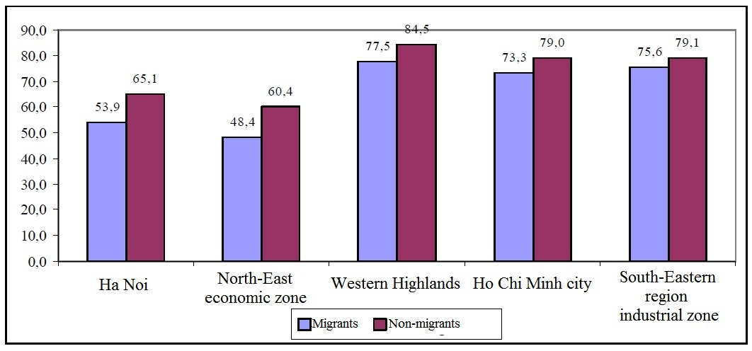

The living area appears to have impact on the choices of treatment. The rates of migrants to Hanoi and Northeast Economic zone who chose the medical offices are correlatively 53.9% and 48.4%, which are slightly lower than those of migrants to Western Highlands, Ho Chi Minh City and Southeast Industrial zone, specifically 77.5, 73.3 and 75.6%. Migrants to Hanoi and Northeast Economic zone seem to have the tendency of self treatment or ignoring the disease than seeking for doctor’s advice. Since the access to the medical services in every area has been made easier, the main reason for the difference in using the medical services between areas may be the differences in the households’ habit and conception of health care.
It is obvious that the number of migrants who used the medical services are lower than that of non-migrants. To be more precise, the gap is quite big in Hanoi (53.9% and 63.1%) and Northeast Economic zone (48.4% and 60.4%); the figure is smaller in Ho Chi Minh City, Western Highlands and Southeast Industrial zone. This can be explained by the paying capacity and the ease of access to medical services. The income of migrants to Hanoi Northeast Economic zone is lower than in Ho Chi Minh City and Southeast Industrial zone, while the distance from the living place to the medical offices in Western Highlands is meagerly longer than other areas. Another explanation for this situation is that the intellectual level of migrants in Hanoi and Northeast Economic zone is higher than that of non-migrants, which means they’re confident about their knowledge about diseases and treatment and do not need to go to medical offices.

Table 3.1: Patients not going to medical offices in the most recent time of sickness in percentage, varying by current living area, migration type and gender3.1
Reasons | Hanoi |  | Northeast Economic zone |  | Tay Nguyen |  | Ho Chi Minh City |  | Southeast Industrial zone
Reasons | Migrants | Non-migrants | Migrants | Non-migrants | Migrants | Non-migrants | Migrants | Non-migrants | Migrants | Non-migrants
Both gender
Meager sickness | 96,9 | 92,0 | 95,4 | 89,6 | 71,0 | 66,7 | 87,9 | 79,8 | 92,9 | 91,4
Not knowing where to go | 0,0 | 0,6 | 0,0 | 0,5 | 0,0 | 1,0 | 1,9 | 2,2 | 1,0 | 0,0
Expensive medical costs | 7,7 | 1,1 | 18,0 | 16,1 | 15,9 | 22,5 | 12,1 | 6,7 | 1,0 | 4,3
Long distance to medical offices | 0,0 | 0,0 | 1,0 | 0,0 | 31,2 | 26,5 | 1,9 | 2,2 | 5,1 | 2,2
Already have medicines | 11,3 | 27,6 | 18,6 | 23,4 | 11,6 | 7,8 | 6,5 | 12,4 | 10,1 | 6,5
Others | 2,1 | 2,3 | 5,2 | 5,2 | 13,8 | 11,8 | 4,7 | 7,9 | 3,0 | 7,5
Quantity | 195 | 174 | 194 | 192 | 138 | 102 | 107 | 89 | 99 | 93
Male
Meager sickness | 98,5 | 95,0 | 97,1 | 91,7 | 74,2 | 69,0 | 88,1 | 85,7 | 95,3 | 90,9
Not knowing where to go | 0,0 | 0,0 | 0,0 | 1,2 | 0,0 | 1,7 | 4,8 | 2,9 | 0,0 | 0,0
Expensive medical costs | 4,5 | 3,3 | 18,6 | 16,7 | 12,1 | 17,2 | 9,5 | 5,7 | 2,3 | 4,5
Long distance to medical offices | 0,0 | 0,0 | 1,4 | 0,0 | 31,8 | 27,6 | 4,8 | 2,9 | 2,3 | 4,5
Already have medicines | 9,1 | 21,7 | 15,7 | 23,8 | 15,2 | 8,6 | 2,4 | 14,3 | 14,0 | 4,5
Others | 1,5 | 1,7 | 2,9 | 4,8 | 10,6 | 12,1 | 2,4 | 5,7 | 2,3 | 11,4
Quantity | 66 | 60 | 70 | 84 | 66 | 58 | 42 | 35 | 43 | 44
Female
Meager sickness | 96,1 | 90,4 | 94,4 | 88,0 | 68,1 | 63,6 | 87,7 | 75,9 | 91,1 | 91,8
Not knowing where to go | 0,0 | 0,9 | 0,0 | 0,0 | 0,0 | 0,0 | 0,0 | 1,9 | 1,8 | 0,0
Expensive medical costs | 9,3 | 0,0 | 17,7 | 15,7 | 19,4 | 29,5 | 13,8 | 7,4 | 0,0 | 4,1
Long distance to medical offices | 0,0 | 0,0 | 0,8 | 0,0 | 30,6 | 25,0 | 0,0 | 1,9 | 7,1 | 0,0
Already have medicines | 12,4 | 30,7 | 20,2 | 23,1 | 8,3 | 6,8 | 9,2 | 11,1 | 7,1 | 8,2
Others | 2,3 | 2,6 | 6,5 | 5,6 | 16,7 | 11,4 | 6,2 | 9,3 | 3,6 | 4,1
Quantity | 129 | 114 | 124 | 108 | 72 | 44 | 65 | 54 | 56 | 49

The main reason that most of the objectives did not go to the medical offices is that they didn’t think they were seriously ill (89.8% of migrants and 85.5% of non-migrants). The next two reasons are that they had the medicine at home and that they thought the expenses were too high. The number of migrants thinking the distance to the medical offices is too long (7.1%) almost doubles that of non-migrants (4.8). The results indicate the agreement between migrants and non-migrants that they have problems with medical expenses. On the other hand, migrants have to face with some other issues such as lack of medicine at home and distance to the offices. However, those issues can vary by the living area.
From table 4.2, it can be concluded that in every area, the number of migrants thinking they do not need to go to the medical offices because the disease was not serious is bigger than that of non-migrants. Another conclusion is that male migrants tend to ignore the illness more than female migrants do in all of the surveyed areas.
Migrants to Hanoi and Ho Chi Minh City stated that “the medical costs are too high”, which are more than non-migrants (7.7% to 1.1% in Hanoi and 12.1% to 6.7% in Ho Chi Minh City). The contrary happened in Southeast Industrial zone and Western Highlands (1.0% to 4.3% in Southeast Industrial zone and 15.9% to 22.5% in Western Highlands). This may be the result of the difference in the income of migrants and the medical costs in each area.
More than 31% of migrants to Western Highlands couldn’t go to the medical offices in the most recent time of sickness because of long distance, while there were only 26.5% of non-migrants admitted so. The explanation is that the population density here is quite low, and so is the density of medical services. In other areas, the distance wasn’t mentioned as a main difficulty.
In big cities like Hanoi and Ho Chi Minh City, the rate of migrants not going to medical offices because they had medicine at home is a half of that of non-migrants (11.3% to 27.6% in Hanoi and 6.5% to 12.4 in Ho Chi Minh City). The gap is smaller in Northeast Economic zone, but it is totally reversed in Southeast Industrial zone and Western Highlands (10.1% of migrants to 6.5% of non-migrants in Southeast Industrial zone and 11.6% to 7.8% in Western Highlands).
In conclusion, the analyzation shows that the choices of medical treatment of migrants are affected by the trend in the area. However, in every area, migrants are less likely to go to medical offices than non-migrants. The reasons for this in each area appear to be different also. Another significant conclusion is that the medical expenses are a bigger concern to migrants than to non-migrants.

3.2. CHOICES OF MEDICAL OFFICES

In general, the choice of medical offices between migrants and non-migrants is not so different. The most popular choice is the state medical services, especially state hospitals. This leads to the problem that migration has put more pressure on state medical services in the migrating areas. The rate of objectives choosing public or private offices in migrants and non-migrants are also similar.
It is easily observed in table 4.3 that age groups have different choices of medical offices. 66.7% of migrants aged 45-59, 56.7% of migrants aged 15-29 and 56.0% of middle-age chose state hospitals. Young and middle-age migrants, on the contrary, tend to go to private doctors (correlatively 14% and 13.8%), which is more than the number of older migrants and non-migrants of the same age. Young migrants also receive more help from local medical offices than older ones.

Table 3.2: Choice of medical offices in the most recent time of sickness in percentage, varying by type of office, age, gender and migration type3.2
Type of office | Aged 15-29 |  | Aged 30-44 |  | Aged 45-59 |  | Total
Type of office | Migrants | Non-migrants | Migrants | Non-migrants | Migrants | Non-migrants | Migrants | Non-migrants
Both genders
State hospitals | 56,7 | 58,7 | 56,0 | 62,1 | 66,7 | 69,5 | 57,3 | 63,3
Local medical offices | 16,5 | 19,0 | 18,4 | 17,4 | 12,8 | 14,5 | 16,8 | 17,0
Other public medical offices | 5,5 | 3,2 | 4,7 | 3,1 | 9,9 | 5,1 | 5,6 | 3,7
Public medical offices | 1,6 | 1,1 | 1,0 | 1,2 | 0,0 | 1,0 | 1,2 | 1,1
Private hospitals | 8,2 | 10,4 | 9,5 | 11,5 | 12,1 | 8,6 | 9,0 | 10,4
Private doctors | 14,0 | 13,4 | 13,8 | 11,6 | 6,4 | 9,0 | 13,2 | 11,3
Other private medical offices | 1,9 | 0,4 | 2,9 | 1,1 | 0,7 | 1,0 | 2,1 | 0,9
Other sources | 1,1 | 1,1 | 0,8 | 0,6 | 0,7 | 0,8 | 1,0 | 0,8
Quantity | 960 | 463 | 516 | 969 | 141 | 511 | 1617 | 1943
Male
State hospitals | 50,0 | 62,0 | 56,0 | 66,6 | 70,3 | 71,2 | 54,2 | 66,9
Local medical offices | 21,0 | 17,3 | 20,8 | 14,1 | 12,5 | 14,6 | 20,0 | 14,9
Other public offices | 6,3 | 3,9 | 4,3 | 1,9 | 9,4 | 4,9 | 6,0 | 3,1
Public medical offices | 2,1 | 1,1 | 0,0 | 0,9 | 0,0 | 0,9 | 1,2 | 0,9
Private hospitals | 8,4 | 9,5 | 8,7 | 10,7 | 9,4 | 5,3 | 8,6 | 9,1
Private doctors | 13,8 | 11,2 | 14,5 | 10,3 | 4,7 | 6,6 | 13,1 | 9,5
Other private offices | 1,8 | 0,6 | 2,9 | 1,5 | 1,6 | 0,9 | 2,1 | 1,1
Other sources | 1,2 | 0,6 | 0,5 | 0,9 | 1,6 | 1,3 | 1,0 | 0,9
Quantity | 334 | 179 | 207 | 467 | 64 | 226 | 605 | 872
Female
State hospitals | 60,2 | 56,7 | 56,0 | 58,0 | 63,6 | 68,1 | 59,2 | 60,3
Local medical offices | 14,1 | 20,1 | 16,8 | 20,5 | 13,0 | 14,4 | 14,8 | 18,8
Other public offices | 5,1 | 2,8 | 4,9 | 4,2 | 10,4 | 5,3 | 5,4 | 4,1
Public medical offices | 1,3 | 1,1 | 1,6 | 1,6 | 0,0 | 1,1 | 1,3 | 1,3
Private hospitals | 8,1 | 10,9 | 10,0 | 12,2 | 14,3 | 11,2 | 9,2 | 11,6
Private doctors | 14,1 | 14,8 | 13,3 | 12,7 | 7,8 | 10,9 | 13,3 | 12,8
Other private offices | 1,9 | 0,4 | 2,9 | 0,8 | 0,0 | 1,1 | 2,1 | 0,7
Other sources | 1,1 | 1,4 | 1,0 | 0,4 | 0,0 | 0,4 | 1,0 | 0,7
Quantity | 626 | 284 | 309 | 502 | 77 | 285 | 1012 | 1071

Older migrants seem to choose the medical services from big centers like state hospitals and private doctors. The range of choices of younger migrants is wider. Another thing we can see from the data is that female migrants prefer state hospitals than male migrants do (59.2% female and 54.2% male), probably because female objectives go to hospitals to seek treatment to maternity diseases and more of them have health insurance than male patients (according to General Statistics Office, 2005).
Table 4.4 shows the variety of choices of medical offices in areas. 62.9% of migrants to Hanoi and 64.1% of migrants to Ho Chi Minh City chose state hospitals, which is more than those to Western Highlands, Northeast Economic zone and Southeast Industrial zone. Local medical offices receive approximately 10% of migrants, and in the Southeast Industrial zone there was only 5.8%. In Western Highlands, probably because of the low income and the long distance, 33.1% of migrants and 36.6% of non-migrants went to the local offices for treatment. The structure of choices of medical offices of migrants and non-migrants are identical, they both have the tendency of going to state hospitals, which causes the overload for the state medical services.

Table 3.3: Patients going to medical offices in the most recent time of sickness in percentage, varying by type of office, current living area and migration type3.3
Type of office | Hanoi |  | Northeast economic zone |  | Tay Nguyen |  | Ho Chi Minh City |  | Southeast Industrial zone
Type of office | Migrants | Non-migrants | Migrants | Non-migrants | Migrants | Non-migrants | Migrants | Non-migrants | Migrants | Non-migrants
Total
State hospitals | 62,9 | 68,3 | 61,4 | 75,7 | 52,1 | 52,4 | 64,1 | 66,3 | 53,2 | 63,2
Local medical offices | 10,8 | 9,4 | 8,2 | 6,7 | 33,1 | 36,6 | 12,2 | 14,2 | 5,8 | 4,2
Other public offices | 22,8 | 10,3 | 5,4 | 3,7 | 1,2 | 1,4 | 2,8 | 3,2 | 3,6 | 1,8
Public medical offices | 1,7 | 3,0 | 3,3 | 1,3 | 0,2 | 0,2 | 1,6 | 1,7 | 1,1 | 0,3
Private hospitals | 8,2 | 13,0 | 6,0 | 4,3 | 5,0 | 5,8 | 14,4 | 18,0 | 11,8 | 13,4
Private doctors | 3,0 | 5,7 | 17,9 | 9,7 | 9,7 | 8,2 | 11,6 | 10,5 | 23,8 | 23,2
Other private offices | 1,3 | 0,6 | 0,0 | 0,3 | 1,6 | 1,0 | 2,2 | 0,3 | 4,4 | 2,1
Other sources | 0,4 | 0,6 | 0,0 | 1,0 | 1,4 | 0,7 | 1,3 | 1,2 | 1,1 | 0,5
Quantity | 232 | 331 | 184 | 300 | 516 | 588 | 320 | 344 | 365 | 380

The biggest numbers of migrants using private services belong to Southeast Industrial zone, Ho Chi Minh City and Northeast Economic zone, where the trend of migrants and non-migrants are the same. In Hanoi, the tradition of using state services reduces the number of migrants going to private doctors.
The data in table 4.5 also point out that the households with household status registration of KT1 type are the most people to choose local medical offices (35.8%). Private doctors are prefered by temporarily household registered migrants than the ones who have permanent household registration.

Table 3.4: Patients going to medical offices in the most recent time of sickness in percentage, varying by type of office and residental registration status3.4
Type of office | Not registered | KT1 | KT2 | KT3 | KT4
Total
State hospitals | 50,0 | 51,1 | 56,9 | 61,8 | 56,9
Local medical offices | 14,1 | 35,8 | 12,5 | 15,6 | 10,7
Other public offices | 6,3 | 1,9 | 2,8 | 9,2 | 4,4
Public medical offices | 0,0 | 0,4 | 0,0 | 1,3 | 1,8
Private hospitals | 4,7 | 4,5 | 8,3 | 9,2 | 11,1
Private doctors | 21,9 | 8,6 | 22,2 | 9,3 | 16,6
Other private offices | 4,7 | 1,9 | 0,0 | 0,9 | 3,2
Other sources | 0,0 | 0,7 | 0,0 | 1,4 | 0,9
Quantity | 64 | 268 | 72 | 557 | 656

3.3. MEDICAL SERVICE EXPENSES

The sources of payment for medical services do not differ between migrants and non-migrants. The rate of female migrants using health insurance (23.9%) and receiving payment from family members (26.4%) is not much more than that of male migrants (19.8% and 20.2%). What is magnificent is that the number of male migrants receiving free treatment (9.3%) doubles that of female ones (6.5%), while there’s no difference between male and female non-migrants (10.2% male and 9.9% female).

Table 3.5: Sources of payment for medical expenses in the most recent time of sickness, varying by current living area, migration type and gender3.5
Source | Hanoi |  | Northeast economic zone |  | Tay Nguyen |  | Ho Chi Minh City |  | Southeast Industrial zone
Source | Migrants | Non-migrants | Migrants | Non-migrants | Migrants | Non-migrants | Migrants | Non-migrants | Migrants | Non-migrants
Total
Health insurance | 47,0 | 33,8 | 25,0 | 37,0 | 5,8 | 9,2 | 24,4 | 18,3 | 27,1 | 25,8
Free medical services | 1,3 | 1,2 | 4,9 | 2,0 | 20,2 | 29,1 | 0,9 | 1,7 | 0,8 | 2,1
Self payment | 73,3 | 78,5 | 79,3 | 90,3 | 77,5 | 72,6 | 70,6 | 77,9 | 76,2 | 79,5
Family members | 25,4 | 26,9 | 46,7 | 36,0 | 17,1 | 13,1 | 26,9 | 24,4 | 19,2 | 20,5
Organizations/Employers | 2,6 | 1,2 | 4,9 | 2,3 | 0,0 | 0,0 | 2,8 | 2,0 | 3,3 | 2,4
Others | 0,4 | 0,6 | 0,5 | 0,7 | 0,2 | 0,5 | 0,6 | 0,3 | 0,3 | 1,3
Quantity | 232 | 331 | 184 | 300 | 516 | 588 | 320 | 344 | 365 | 380
Male
Health insurance | 59,7 | 34,3 | 28,3 | 40,7 | 6,1 | 8,6 | 21,0 | 20,0 | 18,3 | 28,7
Free medical services
Free medical services | 1,5 | 1,5 | 6,7 | 2,4 | 21,9 | 24,1 | 0,8 | 1,4 | 0,0 | 0,7
Self payment | 77,6 | 76,6 | 73,3 | 88,6 | 74,6 | 74,7 | 67,2 | 73,6 | 78,6 | 78,7
Family members | 14,9 | 21,9 | 40,0 | 35,0 | 14,9 | 12,2 | 26,9 | 21,4 | 16,8 | 19,1
Organizations/Employers | 3,0 | 1,5 | 10,0 | 4,1 | 0,0 | 0,0 | 2,5 | 4,3 | 3,8 | 2,9
Others | 0,0 | 1,5 | 1,7 | 0,0 | 0,4 | 0,9 | 0,8 | 0,0 | 0,0 | 2,2
Quantity | 67 | 137 | 60 | 123 | 228 | 336 | 119 | 140 | 131 | 136
Female
Health insurance | 41,8 | 33,5 | 23,4 | 34,5 | 5,6 | 9,9 | 26,4 | 17,2 | 32,1 | 24,2
Free medical services | 1,2 | 1,0 | 4,0 | 1,7 | 18,8 | 35,7 | 1,0 | 2,0 | 1,3 | 2,9
Self payment | 71,5 | 79,9 | 82,3 | 91,5 | 79,9 | 69,8 | 72,6 | 80,9 | 74,8 | 79,9
Family members | 29,7 | 30,4 | 50,0 | 36,7 | 18,8 | 14,3 | 26,9 | 26,5 | 20,5 | 21,3
Organizations/Employers | 2,4 | 1,0 | 2,4 | 1,1 | 0,0 | 0,0 | 3,0 | 0,5 | 3,0 | 2,0
Others | 0,6 | 0,0 | 0,0 | 1,1 | 0,0 | 0,0 | 0,5 | 0,5 | 0,4 | 0,8
Quantity | 165 | 194 | 124 | 177 | 288 | 252 | 201 | 204 | 234 | 244

Table 4.6 shows that migrants to Hanoi use health insurance (47%) more than migrants to Northeast Economic zone (25.0%), Ho Chi Minh City (24.4%), Southeast Industrial zone (27.1%) and Western Highlands (5.8%). The number of migrants receiving free treatment is less than that of non-migrants, and the biggest number of migrants observed was in Western Highlands (20.2%) but still less than non-migrants (29.1%) Northeast Economic zone is the most to receive payment from family members (46.7%), even higher than non-migrants there (36.0%). The least figure belongs to Western Highlands 17.1% of migrants.
In general, more than 70% of the migrants pay for medical services themselves, which are less than that of non-migrants, except in Western Highlands. Especially, in Northeast Economic zone, the number of migrants did self payment is higher than other areas but still less than that of non-migrants (70.3% to 90.3%).
Male migrants to Hanoi and Northeast Economic zone use health insurance more than female ones (59.7% to 28,3% in Hanoi and 41,8% to 23,4% in Northeast Economic zone). The contrary exists in Ho Chi Minh City and Southeast Industrial zone (26.4% và 32,1% of female and 21,0% to 18,3% of male).
Table 4.7 gives a clear statement that migrants with household registration of KT2 type have a completely different source of payment to medical services from migrants of other types. Migrants of this type pay by themselves, receive from family members and use health insurance much more than any other type. Temporarily household registered migrants pay by health insurance more than permanently not registered ones. Migrants with KT1 type, mostly in Western Highlands, are the most to receive free treatment (22.4%).

Table 3.6: Sources of payment for medical expenses in the most recent time of sickness, varying by resident registration status3.6
Source | Non-registration | KT1 | KT2 | KT3 | KT4
Total
Health insurance | 7,8 | 16,8 | 40,3 | 22,6 | 23,9
Free medical expenses | 4,7 | 22,4 | 1,4 | 9,0 | 1,2
Self payment | 76,6 | 73,5 | 84,7 | 75,4 | 75,2
Family members | 31,3 | 21,3 | 55,6 | 20,8 | 23,8
Organizations/Employers | 4,7 | 0,7 | 0,0 | 2,3 | 2,7
Others | 3,1 | 0,7 | 0,0 | 0,0 | 0,3
Quantity | 64 | 268 | 72 | 557 | 656

3.4. PREVENTIVE HEALTH CARE

Only 25.5% of migrants had health check within 3 months of the survey, not much different from non-migrants (26.6%). The rate of female is higher than male (figure 4.7)

Figure 3.2: Health check within 3 months in percentage, varying by migration type and gender3.2
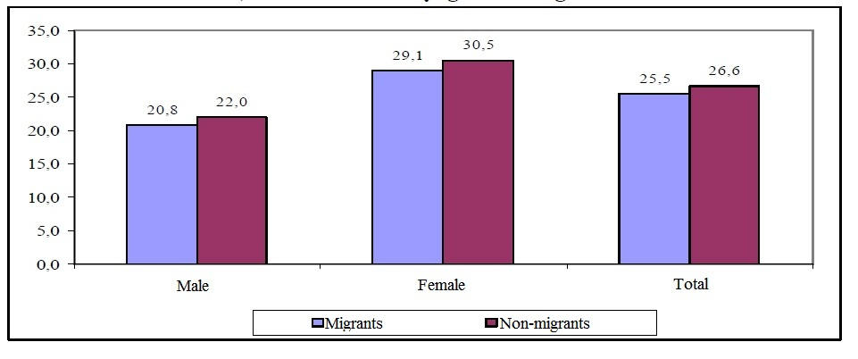

Young migrants had the biggest figure of people having health check, next to that was the oldest (45-59), the middle-age have the least percentage of health check. This is true to both migrants and non-migrants. Female migrants in young and oldest group had more health check than female in middle-age group.
Migrants to Hanoi and Ho Chi Minh City had health check more than those to other areas. In contrast to the trend of going to medical offices at the time of sickness, migrants to the North have more health checks than migrants to the South.

Figure 3.3: Health check in 3 months in percentage, varying by migration type and current living area3.3
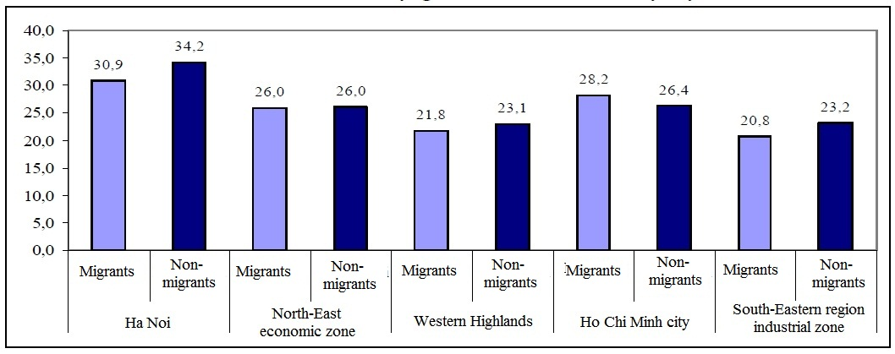

3.5. HEALTH INSURANCE

Figure 4.12 shows that only 36.4% of migrants have health insurance at the time of the survey. While that rate in male migrants is not different from male non-migrants (33.1% to 34.1%), the rate of female migrants having health insurance is comparatively higher than that of non-migrants (38.8% to 34.9%). When moving from countryside to city, female migrants turn from agricultural workers to non-agricultural workers and received social insurance including health insurance.

Figure 3.4: Health insurance in percentage, varying by migration type and gender3.4
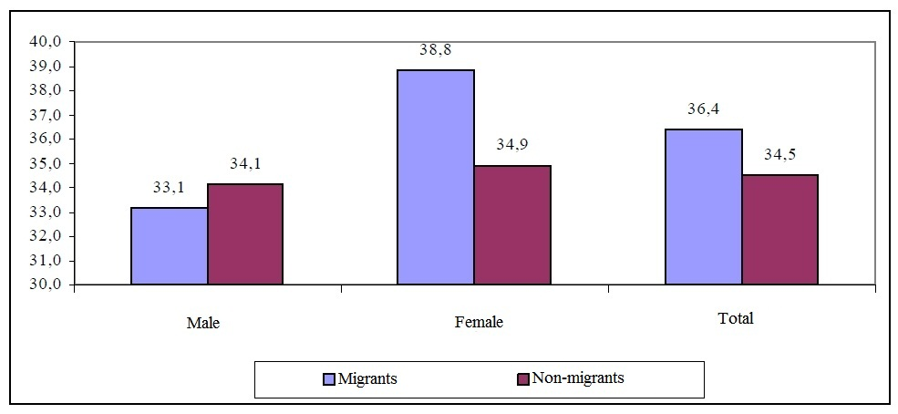

The rate of migrants to Southeast Industrial zone having health insurance is the highest (52.8%), because most of them work in the industry fields. Hanoi came the second with 48.8% of the migrants having insurance, and then Ho Chi Minh City (40.8%) and Northeast Economic zone (31.4%). The number of migrants having health insurance in Ho Chi Minh City and Southeast Industrial zone is higher than that of non-migrants, while the opposite happened in Hanoi, Northeast Economic zone and Western Highlands.

Figure 3.5: Health insurance in percentage, varying by migration type and current living area3.5
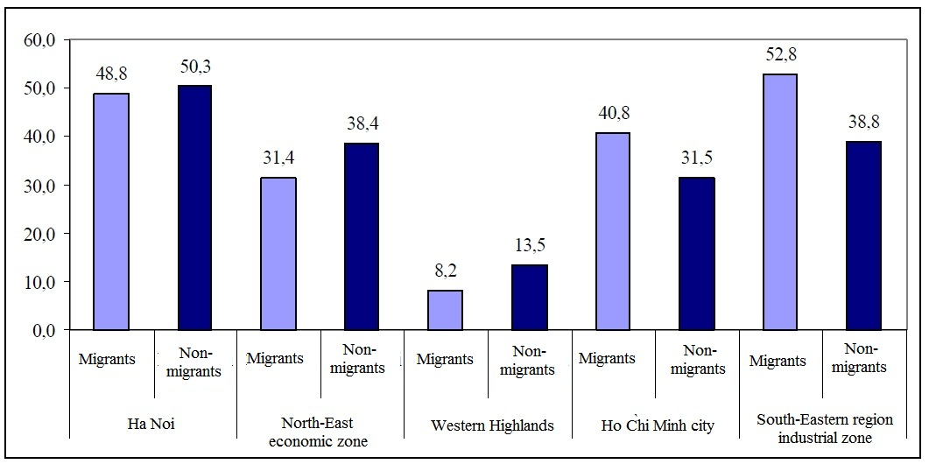

The gender difference is quite clear regarding health insurance. Female migrants to Hanoi and Northeast Economic zone having health insurance are less than male migrants, but it’s different in Ho Chi Minh City and Southeast Industrial zone where less male migrants have health insurance than female. There’s a similarity between male and female migrants with health insurance in Western Highlands. The explanation for this is that female migrants to Hanoi and Northeast Economic zone work mainly in private manufactures, while those to Ho Chi Minh City and Southeast Industrial zone work almost in big factories and foreign-invested companies who provide social insurance for them. (General Statistics Office, 2005)

Figure 3.6: Reasons for not having health insurance in percentage, varying by migration type3.6
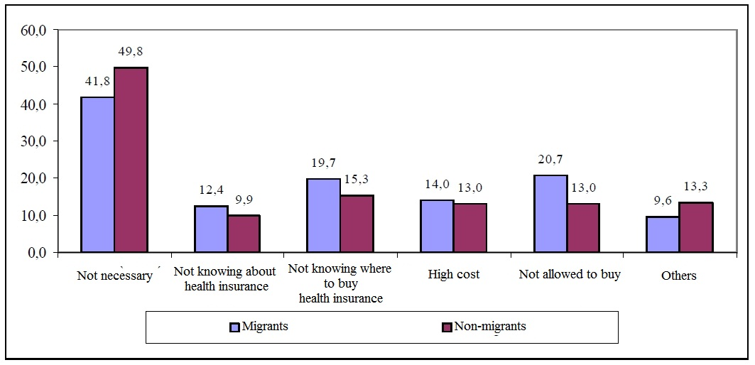

Figure 4.16 indicates that 41.8 migrants and 49.8% non-migrants considered health insurance “unnecessary”. Only 20.7% of migrants admitted that they were not bought health insurance, half of which occurred in non-migrants. 19.7% of migrants did not know where to buy and 12.4% are completely unaware of health insurance. The reason that “the cost is too high” is similar to migrants and non-migrants (14.0% and 13.0%).
Table 4.8 gives data about the reasons of not having health insurance in areas. The migrants in Northeast Economic zone and Ho Chi Minh City are the most to think health insurance is unnecessary (58% and 53%). The migrants to Western Highlands mainly gave th e reason of “not knowing” and “not knowing where to buy”. Many migrants to Hanoi and Northeast Economic zone said they were not bought health insurance for (38% and 35%). The rate of migrants who said “the cost is too high” in Hanoi and Ho Chi Minh City (17.6% and 18.7%) is much higher than in Northeast Economic zone and Southeast Industrial zone (5.4% and 8.5%).

Table 3.7: Reasons for not having health insurance in percentage, varying by migration type, current living area and gender3.7
Reason | Hanoi |  | Northeast economic area |  | Tay Nguyen |  | Ho Chi Minh City |  | Southeast Industrial Area
Reason | Migrants | Non-migrants | Migrants | Non-migrants | Migrants | Non-migrants | Migrants | Non-migrants | Migrants | Non-migrants
Both genders
Not necessary | 46,4 | 53,0 | 58,0 | 60,1 | 19,3 | 23,8 | 55,3 | 62,5 | 40,5 | 59,2
Not knowing about health insurance | 5,5 | 2,2 | 4,8 | 2,6 | 23,5 | 17,7 | 14,2 | 12,5 | 6,8 | 9,8
Not knowing where to buy health insurance | 15,7 | 14,9 | 11,1 | 11,5 | 32,8 | 21,5 | 12,1 | 11,0 | 20,3 | 15,4
High cost | 17,6 | 17,3 | 5,4 | 8,3 | 18,1 | 16,0 | 18,7 | 16,0 | 8,5 | 6,9
Not allowed to buy | 38,0 | 36,5 | 35,0 | 22,5 | 4,8 | 2,3 | 11,6 | 4,1 | 23,3 | 9,3
Others | 6,3 | 5,6 | 5,5 | 7,8 | 19,2 | 31,4 | 4,6 | 7,1 | 6,6 | 6,5
Quantity | 511 | 498 | 685 | 617 | 918 | 865 | 593 | 688 | 472 | 612
Male
Not necessary | 45,4 | 61,6 | 60,6 | 62,9 | 20,1 | 24,6 | 53,0 | 62,5 | 45,5 | 61,4
Not knowing about health insurance | 4,1 | 1,4 | 6,8 | 2,2 | 24,8 | 20,2 | 14,6 | 10,1 | 6,4 | 7,7
Not knowing where to buy health insurance | 9,7 | 11,1 | 12,0 | 9,1 | 34,3 | 20,3 | 14,3 | 10,5 | 18,2 | 15,9
High cost | 13,8 | 18,1 | 5,5 | 10,9 | 15,3 | 15,7 | 17,4 | 15,2 | 7,3 | 4,5
Not allowed to buy | 41,8 | 32,4 | 27,1 | 17,5 | 4,3 | 2,3 | 9,4 | 4,7 | 21,4 | 9,8
Others | 9,2 | 4,6 | 5,1 | 8,0 | 18,7 | 29,8 | 4,9 | 6,9 | 6,4 | 7,3
Quantity | 196 | 216 | 292 | 275 | 443 | 516 | 287 | 277 | 220 | 246
Female
Not necessary | 47,0 | 46,5 | 56,0 | 57,9 | 18,5 | 22,6 | 57,5 | 62,5 | 36,1 | 57,7
Not knowing about health insurance | 6,3 | 2,8 | 3,3 | 2,9 | 22,3 | 14,0 | 13,7 | 14,1 | 7,1 | 11,2
Not knowing where to buy health insurance | 19,4 | 17,7 | 10,4 | 13,5 | 31,4 | 23,2 | 10,1 | 11,4 | 22,2 | 15,0
High cost | 20,0 | 16,7 | 5,3 | 6,1 | 20,6 | 16,3 | 19,9 | 16,5 | 9,5 | 8,5
Not allowed to buy | 35,6 | 39,7 | 41,0 | 26,6 | 5,3 | 2,3 | 13,7 | 3,6 | 25,0 | 9,0
Others | 4,4 | 6,4 | 5,9 | 7,6 | 19,6 | 33,8 | 4,2 | 7,3 | 6,7 | 6,0
Quantity | 315 | 282 | 393 | 342 | 475 | 349 | 306 | 411 | 252 | 366

Figure 4.18 shows that 75% of migrants did not change the health insurance status after the migration, with 59.1% did not have it before and after the migration and 14.8% still keep the health insurance after migration. Only a meager rate of migrants (4.5%) had one before but didn’t keep it after the migration. In Ho Chi Minh City and Southeast Industrial zone, 32% and 37% of the migrants there have insurance after the migration. The rate of migrants who have insurance before and after the migration in Hanoi is magnificently higher than other areas, which proves the process of selection in migrations to Hanoi. The results also indicate that migration has positive influences on the health insurance aspect.

Figure 3.7: Changes in health insurance before and after migration in percentage, varying by gender3.7
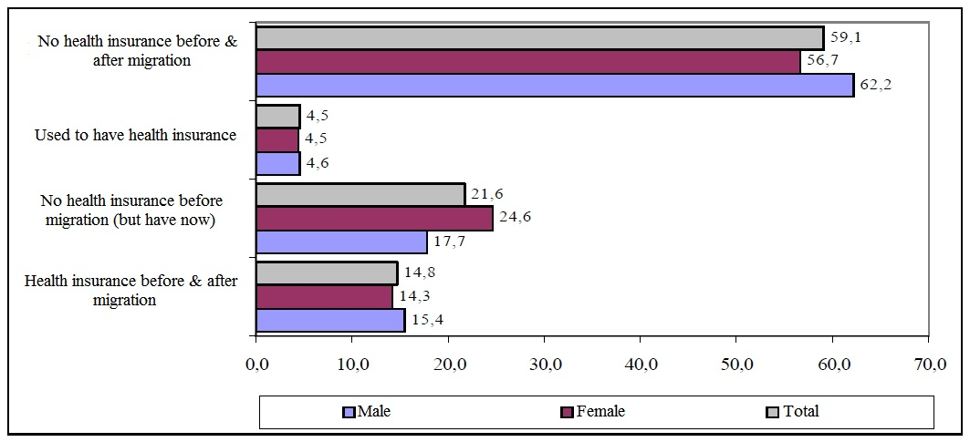
CHAPTER 4. CONCLUSIONS AND ADVICES ON HEALTH CARE POLICIES

Conclusion 1:
Migration is a selection process of health. Migrants have better health than non-migrants, although the difference is slight. This is true with ages, genders and living areas.
After the migration, women’s health gets worse clearly (from 44 to 59 years old)

Advice 1:
Attention needed to health care for female groups, especially middle age and migrants to Western Highlands.

Conclusion 2:
After the migration, the health of the migrants’ relatives gets better, especially migrants to Hanoi and Ho Chi Minh City. However, the support of migrants to their family in information and services are limited.

Advice 2:
Continue propagating about health care not only for migrants but also for their family members.
Advise families to take care of the migrants’ health, especially the one who is in charge of financially supporting the family.

Conclusion 3:
More than half of the male migrants smoke, and the smoking is more popular in the South, in which 75% of migrants smoke at the level of “average” or “heavy”. The smoking rate increases at the age of 15-29 and decrease at the middle-age and older age. Smoking is one of the reasons that exaggerate the poor condition of people’s health in general and migrants’ health in detail

Advice 3:
The government needs to construct a plan to maintain an environment without smoking. The propagation and education need to be put forward to persuade migrants to reduce and quit smoking. The “no smoking” system should be applied where attract many workers from other areas.

Conclusion 4:
Almost 80% of male migrants consume alcohol. The rate in female group is lower. The rate of drinking is higher in the North, however the rate of getting drunk is higher in the South. Among the male migrants, 30% has been drunk once in a month before the survey, which is higher than that of non-migrants (5%). Magnificently, the rate in Ho Chi Minh City is 38% and in Southeast Industrial zone is 48%.

Advice 4:
It is necessary that some solutions be implemented to get rid of drinking in the society.

Conclusion5:
There are many aspects that affect the health of migrants, including:
1. Age
2. Occupation
3. Water source
4. Hygiene constructions
5. Intellectual level
6. Smoking
7. Living condition
8. Living place

Advice 5:
To protect the health of migrants, we have to construct a system of solutions, not only the medical system. In places where the migrant density is high, the water source, hygiene construction and apartment must be taken care of.

Conclusion 6:
Nearly all of the migrants have knowledge about HIV/AIDS, but only 82-83% of whom know about STD. The rate of migrants having knowledge about causes, infection ways and the precaution is even lower. 2/3 of migrants know 6 or 7 ways of contracting HIV. The knowledge about preventing HIV/AIDS is at average level.

Advice 6:
Propel propagating and disseminating the knowledge of STD (including HIV/AIDS), focusing in both immigrants and emigrants.

Conclusion 7:
The rate of people who have prejudice against HIV/AIDS contractors is low, but the rate of sympathizing and supporting is not high.

Advice 7:
Change the strategy of propagating about HIV/AIDS into considering it as a situation where share and support are needed. Focus on educating so that migrants are willing to help and stop opposing HIV/AIDS contractors in the nationwide scale and especially the cities.

Conclusion 8:
The media, mostly the television, are the main methods for the people to have knowledge about STD and HIV/AIDS. The direct source (through friends and family members, medical officers) take up less than 20%.

Advice 8:
Enhance the ability of the media. Improve the opportunity for the good medical officers to propagate the knowledge of maternity in the media.
Support the foundation of organizations and groups among the migrant society to support each other. Accelerate the ability of maternity education of the group leaders.

Conclusion 9:
The people are indifferent to health insurance. The rate of objectives which have health insurance is low. Migration has positive influences on increasing the rate of workers who have health insurance. The rate of migrants having health insurance is higher than that of non-migrants.

Advice 9:
Continue propagating about the rights and duties when having health insurance.
Complete the legist basis of health insurance. Enhance the examination and supervision of health insurance law conduction, ban the law breakers.
Create the good opportunities for workers and employers to easily access to health insurance.
Migrants should be consulted about health insurance in the departure and destination.

Conclusion 10:
The rate of objectives going to the medical offices for treatments in the most recent time having disease is relatively high: 67% of migrants and 73% of non-migrants.
State hospitals and local offices are the most places the patients go to (74.1% of migrants and 80.3% of non-migrants). The choices of medical offices depend on many factors, including household registration status.

Advice 10:
The medical services must not involve discrimination, especially to who have the temporary household registration. It is recommended that the minor diseases be treated in local medical offices to lessen the pressure on state services.

Conclusion 11:
The rate of migrants who use birth control methods is relatively lower than that of non-migrants (65.8% to 71.7%). Migrants use a variety of birth control methods.
The rate of children under 5 years old of the migrants and non-migrants who have inoculation is very high. However, the rate of newly-migrated children is slightly lower.

Advice 11:
The departments of maternity health need to guide and support migrants, especially the young to use condoms to manipulate birth control and avoid STD.
While carrying out the “Spreading Inoculation”, we need to persuade the parents who have just moved to the new place take their under 5-year-old children to have inoculation.

Conclusion 12:
Migrants who buy and take the birth control methods in public medical offices and medicine stores and family members are more than non-migrants.

Advice 12:
In the plan of providing the methods and services in birth control in public services, the need of migrants should be taken care of. The private medical offices need to enhance the quality of the services and promote the advertising.

Conclusion 13:
25% of migrants have health check within 3 months of the interview, 36.4% of which have health insurance. The rate of women who have health insurance is lower than men, but the rate of female migrants with health check is higher. The factors affecting health care include household registration status, occupation, current living place, the economic structure of the area, living condition.
The migrants only have health check when they have problems, and the health check does not depend on financial status.

Advice 13:
Educate about the rights of Health Insurance and providing migrants easy access to medical services in the local areas.
Erase the fence of household registration in health care and basic social services

Conclusion 14:
The awareness, attitude and actions of protecting and caring about health in general and maternity health in detail are different in areas. The health care and protection for people in Western Highlands face more difficulties than other areas.

Advice 14:
The policies of protecting and taking care of health and maternity health should depend on the characteristics of each area.
Improve the support and focus on Western Highlands in developing the health care services.

Conclusion 15:
The factors that influence the situation of not using medical services in times of sickness include living place, gender, marital status, health insurance, household registration status, living condition.

Advice 15:
Improve the information and education plans as long as the projects about enhancing the awareness of protecting and taking care of health, especially to single male migrants.
There must be some improvements in policies about health insurance, household registration (especially KT2, KT3, KT4) and social policies towards the bigger number of people who have the medical services. The rate of the poor who have medical treatment is not much lower than that of average income. However, the quality of health care for the poor should be taken into consideration.

REFERENCES

Vietnamese

1. Dang Nguyen Anh (2005). Domestic migration: Opportunities and threats to reform and development in Vietnam. Asia-Pacific Economic Centre. World Publisher. Hanoi, Vietnam.
2. Initial Investigation of RHIYA Vietnam Program Report (2005), implemented by Center of Population - National Economics University with the endowment of UNFPA and EU. Hanoi, Vietnam.
3. The Ministry of Medicine, General Statistics Office (2003a). Investigation on national medicine 2001-2002 report: Assess the efficiency of using medical services. Medicine Publisher. Hanoi, Vietnam.
4. The Ministry of Medicine, General Statistics Office (2003b). Investigation on national medicine 2001-2002 report: The government policies in health care – The view from receiver. Medicine Publisher. Hanoi, Vietnam.
5. The Ministry of Medicine, General Statistics Office (2003). Investigation on national medicine 2001-2002 report (2003). Medicine Publisher. Hanoi, Vietnam.
6. The Ministry of Medicine, General Statistics Office (2003). Investigation on national medicine 2001-2002 report: The situation of national medical aims. Medicine Publisher. Hanoi, Vietnam.
7. The Ministry of Medicine, General Statistics Office, UNICEF, WHO (2005). National investigation on behaviours of teenagers and the youth of Vietnam.
8. UN (1993). Population study and methodology. Section 4, UNFPA, New York.
9. WB, Switzerland SIDA Organization (2001). Vietnam – Healthy towards a sustainable development: Overview study of Vietnam Medicine. Hanoi, Vietnam.
10. Nguyen Duc Vinh (1998). Health status and health care condition of migrants. Report for Migrants and health Conference. Institute of Sociology, Hanoi, Vietnam 15-17-12/1998.
11. Prof. Dr. Do Nguyen Phuong (1999). Vietnam Medicine in reform. Medicine Publisher. Hanoi, Vietnam.
12. General Statistics Office, UNDP (2001). Monograph: Domestic Migration and urbanization in Vietnam. Statistics Publisher. Hanoi, Vietnam.
13. UNFPA (2003). Initial investigation Report: Status of supplying and using maternity health care services in 12 provinces. (2003) Hanoi, Vietnam.
14. Population and Family Planning Commission, General Statistics Office (2003). Vietnam: Household Investigation and health, 2002. Hanoi, Vietnam.
15. Institute of Sociology, UNPFA University of Brown (1998). Migration and health in Vietnam. Report for conference. Hanoi, Vietnam. 15-17/12/1998.

English

16. Archan K. Roy and Parveen Anngia (2005). Reproductive health status of left behind wives of male out migrants: A study of rural Bihar, India. XXV International Population Conference - Tours, France - July, 2005.
17. Dang Nguyen Anh (2003). Migration and poverty in Asia: With reference to Bangladesh, China, The Philippines and Viet Nam. Paper presented at Expert Group Meeting on Migration and Dvelopment, Bangkok, 27-29 August.
18. Dang Nguyen Anh et al (2002). Sustainable urbanization, migration and living environment in Vietnam: Case study of Hanoi and Ho Chi Minh City. "Sustainable urbanization and human and environmental security in Asia: Final Report". National Institute of Population and Social security Research. Tokyo, Japan. March, 2002.
19. Djamba, Goldstein anf Goldstein (1999). "Permanent and temporary migration in Viet Nam during a period of economic change". Asia – Pacific Population Journal, 14 (3): 25-48.
20. Doan, M.D and Trinh K.T (1999). "Survey spontaneous Migration to a Rural and an Urban Area in Viet Nam". Asian Population Studies Series No. 142, Escap, United Nations, New York.
21. Evi N.Arifin, Aris Ananta and Sureeporn Punpuing (2005). Migration and health in Kanchanaburi, Thailan. XXV International Population Conference - Tours, France - July, 2005.
22. General Statistics Office (2003). Yearbook Data 2002. The Statistical Publishing House, Statistics Ofice in Ho Chi Minh City.
23. Gubry Patrick, Le Thi Huong, Nguyen Thi Thieng, Tran Thi Thanh Thuy (2004). Temporary migration in big Vietnam Cities: Hanoi and Ho Chi Minh City. The summary record of the PRUD’s international conference (Paris, UNESCO, 5-7, March 2004). Paris: International affair (The Department of International Cooperation and Development).
24. Guest Philip (1998). The Dynamics of Internal Migration in Vietnam. UNDP Discussion Paper 1. UNDP: Hanoi.
25. IER (1996). Survey on Spontanous Migration to Ho Chi Minh City. Institute of Economic Research: Ho Chi Minh City.
26. Institute for economic research of Ho Chi Minh City, VIE/89/P03 Project (1992). Migration to Ho Chi Minh City - Problems Issues and Resolutions. Ho Chi Minh City.
27. IOM (2005). World Migration 2005 – Cost and benefits of international migration. Session: "Migration and Health" – Chapter 19: Investing in Migration Health. International Organization for Migration. Genever.
28. Jean-Piere Zamwangana Tungu (2005). Migration and fertility in Kishasa (DRC): Evaluation Explanatory factors. XXV International Population Conference - Tours, France - July, 2005.
29. Lee, B.S. et al (1981). The influence of rural-urban migration on the fertility of migrants in developing countries: Analysis of Korean data. Baton Rouge, Louisiana State University and Research Triangle Institute.
30. Lee, E.S (1996). "A theory of migration", Demography, Vol 3, no. 1.
31. M. Mazharul Islam and Kazi Md. Abul Kalam Azad (2005). Rural - Urban migration, poverty and child survival in urban Bangladesh. XXV International Population Conference - Tours, France - July, 2005.
32. Mark VanLandingham (2005). Impacts of rural to urban migration on the health of working-age adult migrants in Ho Chi Minh city, Vietnam. XXV International Population Conference - Tours, France - July, 2005.
33. Obrai. A.S (1988). Migration, urbanization et Development. Formation en Matierde population, ressource humaines et planification du dộveloppement. No 5. Bureau international du travail - Geneve.
34. Population Council (1998). Proceedings of the International Seminar on Internal Migration Policies. Ministry of Agriculture and Rural Development (MARD) and UNDP: Ha Noi.
35. The centre for population and labor source study – Project VIE/93/P02 (1993). Overview report on spontaneous migration in Vietnam. Hanoi, Vietnam.
38. The centre for population and labor source study – Project VIE/93/P02 (1996). Spontaneous migration to Dong Nai and Vung Tau. National Politics Publishing House. Hanoi, Vietnam.
39. Vu Thi Hong, Patrick Gubry, Le Van Thanh (2003). The way to city – Migration to Hochiminh city form Cuu Long delta region. Economics Institute, Ho Chi Minh City and Population and Development Centre, France. Ho Chi Minh City Publishing House.
40. Xiushi Yang, Valerian Derlega and Huasong Luo (2005). Migration and HIV/STD risk in China. XXV International Population Conference - Tours, France - July, 2005.
41. Yan Wei, Xusong Yang and Yukun Zhang (2005). Impact of social network on contraceptive use among rural floating people in Shanghai China. XXV International Population Conference - Tours, France - July, 2005.
42. Zhenzhen Zheng and Pengling Lian (2005) Health vulnerability among temporary migrants in urban China. XXV International Population Conference - Tours, France -July, 2005.

2.1 Vietnam’s Migration survey in 2004 ,General Statistics Office
2.2 Vietnam’s Migration survey in 2004 ,General Statistics Office
2.3 Vietnam’s Migration survey in 2004 ,General Statistics Office
2.4 Vietnam’s Migration survey in 2004 ,General Statistics Office
2.5 Vietnam’s Migration survey in 2004 ,General Statistics Office
2.6 Vietnam’s Migration survey in 2004 ,General Statistics Office
2.1 Mark VanLandingham , Impacts of Rural to Urban Migration on the Health of Young Adult Migrants in Ho Chi Minh City - Vietnam , 2005
2.7 Vietnam’s Migration survey in 2004 ,General Statistics Office
2.2 Mark VanLandingham , Impacts of Rural to Urban Migration on the Health of Young Adult Migrants in Ho Chi Minh City - Vietnam , 2005
2.8 Vietnam’s Migration survey in 2004 ,General Statistics Office
2.9 Vietnam’s Migration survey in 2004 ,General Statistics Office
2.3 Mark VanLandingham , Impacts of Rural to Urban Migration on the Health of Young Adult Migrants in Ho Chi Minh City - Vietnam , 2005
3.1 Vietnam’s Migration survey in 2004 ,General Statistics Office
3.1 Mark VanLandingham , Impacts of Rural to Urban Migration on the Health of Young Adult Migrants in Ho Chi Minh City - Vietnam , 2005
3.2 Mark VanLandingham , Impacts of Rural to Urban Migration on the Health of Young Adult Migrants in Ho Chi Minh City - Vietnam , 2005
3.3 Mark VanLandingham , Impacts of Rural to Urban Migration on the Health of Young Adult Migrants in Ho Chi Minh City - Vietnam , 2005
3.4 Mark VanLandingham , Impacts of Rural to Urban Migration on the Health of Young Adult Migrants in Ho Chi Minh City - Vietnam , 2005
3.5 Mark VanLandingham , Impacts of Rural to Urban Migration on the Health of Young Adult Migrants in Ho Chi Minh City - Vietnam , 2005
3.6 Mark VanLandingham , Impacts of Rural to Urban Migration on the Health of Young Adult Migrants in Ho Chi Minh City - Vietnam , 2005
3.2 Vietnam’s Migration survey in 2004 ,General Statistics Office
3.3 Vietnam’s Migration survey in 2004 ,General Statistics Office
3.4 Vietnam’s Migration survey in 2004 ,General Statistics Office
3.5 Vietnam’s Migration survey in 2004 ,General Statistics Office
3.6 Vietnam’s Migration survey in 2004 ,General Statistics Office
3.7 Mark VanLandingham , Impacts of Rural to Urban Migration on the Health of Young Adult Migrants in Ho Chi Minh City - Vietnam , 2005
3.7 Vietnam’s Migration survey in 2004 ,General Statistics Office

